Lead and drinking water
Lead is a metal that has been used widely in plumbing and a range of other common household substances, such as paint products, ceramics, petrol, batteries, electronics, ammunition and cosmetics. Lead is also present naturally in soils and rocks at low levels.
Lead can cause serious health problems and is a known hazard in drinking water around the world due the use of lead in pipes, taps and other plumbing materials. While older homes are at higher risk, some plumbing products currently on sale still contain lead.
What are the health impacts of lead exposure?
Exposure to lead is associated with various neurodevelopmental effects (impact on the brain and nervous system), heart and kidney problems and fertility issues. It is also linked to negative pregnancy outcomes.
Infants, particularly bottle-fed infants, are at risk from lead in drinking water. This is because their nervous systems are still developing, and they absorb lead more easily. They also consume more drinking water relative to their body weight.
To reduce any potential exposure to lead in drinking water, you should:
- only use water from cold taps for drinking and cooking
- flush cold taps used for drinking and cooking for at least 10 seconds first thing in the morning to draw fresh water through the tap
- flush cold taps used for drinking and cooking for at least two minutes if they have not been used for more than two days.

Causes of lead in water
- Lead primarily enters drinking water within homes and buildings from pipes, taps and plumbing connections that contain lead. This is the most common source of lead in drinking water.
- Lead can also enter drinking water through materials in networks that distribute water to homes and buildings.
- Lead can enter a water source through contamination. Contamination in source water can be reduced through treatment.

Plumbosolvency
Plumbosolvency describes the ability of water to absorb lead and other metals. In New Zealand, most drinking water is plumbosolvent. This means the water can dissolve small amounts of metals it comes in contact with, like lead and copper in pipes and taps. Drinking water suppliers, consumers and building owners all need to take steps to protect against the risk of contamination by lead and other metals.

The ‘maximum acceptable value’ for lead in drinking water
- New Zealand’s Drinking Water Standards list the maximum concentration of certain substances that are acceptable in drinking water for health or other reasons. These are called Maximum Acceptable Values, or MAVs.
- The Drinking Water Standards for New Zealand set a MAV of 0.01mg/L for lead.
- This aligns with the guideline value set by the World Health Organization (WHO). The WHO states that concentrations of lead should be kept as low as possible.

Managing the risk of lead in drinking water
- The most effective way to manage the risk to health from lead is to remove it from drinking water systems.
- Ensure you use “lead free” products when fitting or replacing plumbing. Some plumbing products on sale today still contain lead so it is important to look for lead-free products.
- If you have lead plumbing for your drinking water or are unsure if you do, you can reduce the risk by using only cold taps for water for drinking and cooking, and to put in your kettle. You should flush water through these taps for 10 seconds each morning and for two minutes if the property has been unoccupied for more than two days. You can save this water and use it for washing or in the garden but not on fruits and vegetables.
- Drinking water suppliers have a responsibility to ensure the water they supply is safe and meets New Zealand’s Drinking Water Standards.
- Drinking water suppliers are responsible for the quality of drinking water up to the point of supply which is normally at the property boundary. The property owner is responsible for the risks to water safety after it passes the boundary.
- There are devices fitted at the boundary of properties which are designed to control the flow of water, which are often referred to as a toby. Boundary devices are normally owned by the supplier but can belong to the property. Boundary devices can contain lead. Property owners should check with their supplier on who is responsible for the boundary device.
- If you are concerned, you can have your water tested for lead. Contact details for an accredited laboratory can be found on the Water Services Authority website at https://hinekorako.taumataarowai.govt.nz/publicregister/laboratories. It is important that you take the sample as instructed by the laboratory.

Choosing plumbing products
- Speak to your plumber about ensuring your drinking water plumbing is lead free.
- Low lead plumbing fittings are available and will become mandatory under the Building Code from 1 May 2026. International product certification scheme markings can indicate low lead or lead-free plumbing products.
- Lead content for these plumbing products can be verified through a test report from an accredited laboratory in accordance with the standard NSF/ANSI/CAN 372. You should talk to your plumber to get lead-free plumbing products.
Example: The Australian Lead Free WaterMark Mark of Conformity
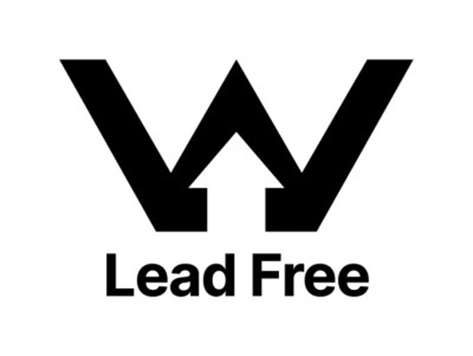
- Some plumbing products are certified to AS/NZS 4020:2018 Australian/ New Zealand Standard; Testing of products for use in contact with drinking water. These products are tested for leaching of lead over 72 hours. If water is likely to sit in a plumbing fitting for more than 72 hours, then the lead-free certification gives greater protection.
- If you are installing a device on your property boundary (e.g. a backflow prevention device), you should install a low lead or lead-free product.

Domestic supplies
If you have your own domestic drinking water supply (e.g. a bore, well or roof supply on your property), you are responsible for the safety of your supply. These supplies are not regulated under the Water Services Act 2021 but are covered by the requirements of the Building Act.
Small supplies serving fewer than 25 people in domestic properties are also covered by the Building Act requirements rather than the Water Services Act.
Rainwater can become contaminated from lead flashings and fittings on roofs.
It is recommended that you have your water tested for bacteria and common chemicals such as lead. You can find contact details for an accredited laboratory at https://hinekorako.taumataarowai.govt.nz/publicregister/laboratories.

What action is being taken in relation to lead?
New Zealand does not have extensive lead piping in our water supply systems. However, lead may be present in solder and fixtures in the networks that distribute water to homes and buildings, and within building plumbing.
While removing existing lead plumbing is the goal, this is complex. Many sources of lead are on private properties and are the responsibility of individual property owners.

Responsibilities of drinking water suppliers
The Water Services Act 2021 requires that registered drinking water suppliers provide drinking water that is safe and complies with the Drinking Water Standards. This means that suppliers are responsible for managing lead contamination within their supplies.
The Drinking Water Quality Assurance Rules 2022 required most water suppliers to undertake routine testing for lead for the first time. This helped us to understand where there are high levels of lead in drinking water supplies in New Zealand and ensure a suitable response if high levels are detected.

Responsibilities of property owners
Property owners are responsible for the safety of drinking water within their property. This is regulated under the Building Act. In 2023, the Building Code was updated so any product that contains copper alloys, intended for use in contact with potable water for human consumption, must be lead free (contain less than 0.25%). This comes into effect in May 2026.
However, many lead-free products are already available, and labelling of these products has improved.

Information on lead and health
For information around lead poisoning, refer to https://info.health.nz/conditions-treatments/emergencies-and-first-aid/lead-poisoning
If you have any health concerns related to lead, please contact your family GP, health provider or call Healthline on 0800 611 116.

