

Water Supply National Engineering Design Standards

Working Draft version 1 – August 2023

Work to develop a technical code for drinking, waste and stormwater infrastructure has been known as the Code of Practice. This name is now changing to the National Engineering Design Standards. This name is more reflective of The Water Services Entities Amendment Bill, which requires Water Services Entities to have a development code. A subset of the development code requires entities to ensure they specify applicable engineering design standards to water infrastructure.

Water Supply National Engineering
Design Standards

Revision | Date | Details | Author | Checked | Approved
Working Draft | 25 August 23 | Issue 1, v1.0 | TWG | SJ | NSG

TWG Water Sub Group:
Kelly Nikora, Eugene Kroukam, Evan Vaughters, Andrew Pascoe, Michael Galambos

Table of Contents
FRONTMATTER 1
FOREWORD 1
National Engineering Design Standards Development 1
Acknowledgements 1
Publication History 2
Disclaimer 2
Copyright 2
INTRODUCTION 3
The Need for a National Engineering Design Standard 3
The Benefits of National Engineering Design Standards 3
Purpose 3
Scope 3
Requirements and Informative NEDS 4
Te Mana o te Wai 4
Water Services Entities Amendment Bill 5
ADDITIONAL CONSIDERATIONS 6
Safety in Design (SiD) 6
Technical and guideline publications 6
Products and Material Information and Guidance 6
Approach to Innovation 7
Natural Hazards 7
NEDS Approach to Climate Change 7
NEDS Approach to Sustainability 8
APPENDICES 9
GLOSSARY, ABBREVIATIONS AND REFERENCES 10
GLOSSARY OF TERMS 10
ABBREVIATIONS 12
REFERENCED DOCUMENTS 13
PART ONE - PLANNING AND DESIGN 15
1 GENERAL 16
1.1 SCOPE 16
1.2 PLANNING AND DESIGN 16
1.2.1 Scope and requirements 16
1.2.2 Concept Design Statement 17
1.2.3 Detailed design 17
1.2.4 Design life 18
1.2.5 Carbon Reduction 18
2 SYSTEM PLANNING 19
2.1 GENERAL 19
2.1.1 Structure plan/Infrastructure Master Plan 19
2.1.2 Future development 19
2.2 SYSTEM CONFIGURATION 19
2.2.1 Point of Supply 19
2.3 SYSTEM PLANNING PROCESS 20
2.3.1 General 20
2.3.2 Extending / upgrading an existing water supply system 20
2.3.3 Providing a new water supply 21
2.3.4 Non-drinking water as drinking water substitution 21
2.4 DEMANDS 21
2.4.1 General 21
2.4.2 Dual water supply systems 21
2.4.3 Demand assessment 22
2.4.4 Peak demands 25
2.5 SYSTEM HYDRAULICS 26
2.5.1 General 26
2.5.2 Network analysis 26
2.5.3 Operating pressures 26
2.5.4 Pressure variation analysis 28
2.5.5 Determining supply zones 28
2.6 WATER QUALITY 29
2.6.1 General 29
2.6.2 Prevention of Backflow 29
2.6.3 Water age 30
2.6.4 Disinfection 30
2.7 PUMPING STATIONS 31
2.8 SERVICE RESERVOIRS 31
2.9 TRENCHLESS TECHNIQUES FOR PIPELAYING 31
2.10 FUTURE SYSTEM EXPANSION 31
2.11 SYSTEM REVIEW 31
3 HYDRAULIC DESIGN 31
3.1 SIZING 31
3.1.1 General 31
3.1.2 Minimum pipe sizes 32
3.1.3 Empirical sizing of reticulation mains 32
3.1.4 Fire flows 33
3.1.5 Sizing by analysis 33
3.2 DESIGN PRESSURES 34
3.3 PRESSURE CLASS OF SYSTEM COMPONENTS 35
3.3.1 Reticulation systems 35
3.3.2 Systems subjected to dynamic pressures 35
3.4 THRUST AND ANCHOR BLOCK DESIGN 35
3.5 SYSTEM TEST PRESSURE 35
3.6 DESIGN FOR DYNAMIC STRESSES 35
3.6.1 Fatigue 35
3.7 TEMPERATURE DE-RATING OF PLASTICS PIPES AND FITTINGS 36
3.8 DE-RATING OF MANUFACTURED PE COMPONENTS 37
4 PRODUCTS AND MATERIALS 37
4.1 GENERAL 37
4.1.1 Pipe selection 37
4.1.2 Standard pipe sizes 37
4.1.3 Minimum pipe sizes 38
4.1.4 Pipe PN class (pressure rating) 38
4.1.5 Design pressure 38
4.1.6 Minimum pipe PN 38
4.1.7 Nominated pipe PN 38
4.1.8 Pumped mains 38
4.1.9 Pipe materials 39
4.1.10 Steel mains considerations 39
4.2 PROTECTION AGAINST DEGRADATION 39
4.2.1 Protection against contaminated ground 39
4.2.2 Bolted connections 39
5 GENERAL DESIGN 39
5.1 GENERAL REQUIREMENTS 39
5.1.1 Design tolerances 39
5.1.2 Levels 40
5.1.3 Water main renewals electrical safety and earthing to water services 40
5.1.4 Survey Control 40
5.2 RETICULATION DESIGN FOR WATER QUALITY 40
5.2.1 Layout of water mains 40
5.2.2 Looped mains 41
5.2.3 Link mains 41
5.2.4 Reduced size mains 41
5.3 WATER MAIN ACCESS 41
5.4 LOCATION OF WATER MAINS 41
5.4.1 General 41
5.4.2 Water mains in road reserves 42
5.4.3 Location in other than dedicated public road reserves 42
5.4.4 Effect on vegetation 42
5.4.5 Water mains near trees 43
5.4.6 Contaminated sites 43
5.4.7 Safety in Design 44
5.4.8 Location markers 44
5.4.9 Marking tape 44
5.5 CROSSINGS 45
5.5.1 Location of water mains on bridges 45
5.5.2 Crossings 45
5.6 VALVES 46
5.6.1 Valves 46
5.6.2 Valving design 46
5.6.3 Pressure reducing valves (PRV) 48
5.6.4 Pressure relief valves (PRelV) 48
5.6.5 Pump control valves 49
5.6.6 Pressure sustaining valves (PSV) 49
5.6.7 Air valves (AV) 49
5.6.8 NON-RETURN VALVES 49
5.6.9 SCOURS AND PUMP-OUT BRANCHES 50
5.7 SWABBING POINTS 51
5.8 HYDRANTS 51
5.8.1 Purposes 51
5.8.2 Hydrant siting principles 51
5.9 DISINFECTION FACILITIES 52
5.9.1 General 52
5.10 TRENCHLESS TECHNOLOGY 52
5.11 SHARED TRENCHING 53
5.12 RIDER MAINS 53
5.12.1 Principal and rider mains layout 53
5.12.2 Rider mains and duplicate principal mains 53
5.13 CONNECTION OF NEW MAINS TO EXISTING MAINS 53
5.13.1 General 53
5.14 TERMINATION POINTS 54
5.14.1 Permanent ends of water mains 54
5.14.2 Temporary ends of water mains 55
5.14.3 Flushing points 56
5.15 PROPERTY SERVICES 56
5.15.1 General 56
5.15.2 Multiple Dwellings 57
5.15.3 Service line connections 57
5.16 OBSTRUCTIONS AND CLEARANCES 58
5.16.1 Clearance from structures and property boundaries 58
5.16.2 Underground obstructions and services 59
5.16.3 Clearance from transmission towers 61
5.16.4 Deviation of water mains 61
6 SYSTEM PRESSURE MANAGEMENT 62
6.1 GENERAL 62
6.2 IN-LINE PRESSURE BOOSTER PUMPING STATIONS 62
6.3 PRESSURE REDUCING VALVE INSTALLATIONS 62
6.4 PRESSURE SUSTAINING VALVE INSTALLATIONS 63
7 STRUCTURAL DESIGN 63
7.1 GENERAL 63
7.2 STRUCTURAL CONSIDERATIONS 63
7.3 INTERNAL FORCES 63
7.4 EXTERNAL FORCES 63
7.4.1 General 63
7.4.2 Pipe cover 63
7.4.3 Embedment zone dimensions 64
7.4.4 Pipe embedment 64
7.4.5 Buoyancy 64
7.5 GEOTECHNICAL CONSIDERATIONS 64
7.5.1 General 64
7.5.2 Water mains in engineered or controlled fill 65
7.5.3 Water mains in non-engineered fill 65
7.5.4 Construction of an embankment 65
7.6 CONCRETE ENCASEMENT 66
7.6.1 General 66
7.6.2 Encased steel pipelines 66
7.7 WATER MAINS IN UNSTABLE GROUND 66
7.8 ABOVE-GROUND WATER MAINS 67
7.9 PIPELINE ANCHORAGE 67
7.9.1 General 67
7.9.2 Thrust blocks 67
7.9.3 Anchor blocks 67
7.9.4 Restrained elastomeric seal joint water mains 67
7.9.5 Restraint requirements for special situations 68
7.10 BULKHEADS AND TRENCHSTOPS 68
7.11 UNFORESEEN GROUND CONDITIONS 68
7.12 SEISMIC DESIGN 69
7.12.1 General 69
7.12.2 Buried Linear Assets 70
7.12.3 Above Ground and Non-Linear Structures 71
7.12.4 Connections Between Structures and Buried Assets 72
8 DESIGN REVIEW AND DRAWINGS 72
8.1 DESIGN REVIEW 72
8.2 DESIGN DRAWINGS 72
8.2.1 General 73
8.2.2 Composition of Design Drawings 73
8.2.3 Scale 73
8.2.4 Contents of Design Drawings 73
8.2.5 Pipeline system acronyms 73
8.3 SPECIFICATIONS 73
8.4 RECORDING OF WORK AS CONSTRUCTED INFORMATION 73
PART TWO – CONSTRUCTION 75
9 GENERAL 76
9.1 SCOPE 76
9.2 HEALTH AND SAFETY 76
10 GENERAL CONSTRUCTION 76
10.1 GENERAL 76
10.2 ORDER OF CONSTRUCTION, TESTING AND COMMISSIONING 77
10.3 CUSTOMER FOCUS 77
10.3.1 General 77
10.3.2 Resolution of complaints 77
10.4 PROTECTION OF PROPERTY AND ENVIRONMENT 77
10.4.1 Protection of other services 78
10.4.2 Road reserves or other thoroughfares 79
10.4.3 Private and public lands 79
10.4.4 Protection of the environment and heritage areas 80
10.5 DISUSED WATER, WASTEWATER AND STORMWATER PIPES 80
10.6 OPERATION OF WATER SUPPLY NETWORK 81
10.7 CONCRETE WORKS 82
10.8 SUPPLY OF WATER TO THE WORKS 82
10.9 SUPPLY OF WATER TO EXISTING PROPERTIES 82
10.10 ALTERATION OF EXISTING SERVICES 82
10.11 SURVEY MARKS 82
10.12 LATENT CONDITIONS 82
10.13 SERVICE CONFLICTS 82
10.13.1 Abandoned Services 82
10.13.2 Live Laterals Fouled by the Proposed Pipeline 83
10.13.3 Unavoidable Diversion of Services 83
10.13.4 Clearance to Other Services 83
10.13.5 Separation from Structures 83
11 PRODUCTS AND MATERIALS 84
11.1 AUTHORISED PRODUCTS AND MATERIALS 84
11.1.1 General 84
11.2 DELIVERY INSPECTION OF PRODUCTS AND MATERIALS 84
11.3 TRANSPORTATION, HANDLING AND STORAGE OF PRODUCTS AND MATERIALS 85
11.3.1 General 85
11.3.2 Transportation 85
11.3.3 Unloading and handling 85
11.3.4 On-site storage 85
11.4 REJECTED PRODUCTS AND MATERIALS 86
12 EXCAVATION 86
12.1 EARTHWORKS GENERAL 86
12.2 PRECAUTIONS 86
12.3 LIMITS OF CLEARING AND EXCAVATION 87
12.3.1 Topsoil stripping 87
12.3.2 Stockpiling 87
12.4 Health & Safety During Earthworks 87
12.5 PROTECTION OF TREES 88
12.5.1 General precautions 88
12.5.2 Protection of roots 88
12.6 BLASTING 88
12.7 SUPPORT OF EXCAVATIONS 89
12.8 DRAINAGE AND DEWATERING 89
12.9 EXCAVATION ACROSS IMPROVED SURFACES 89
12.10 TRENCH EXCAVATION 90
12.10.1 General 90
12.10.2 Construction of embankment 90
12.10.3 Clearances for on-site works 90
12.11 REFILL OF EXCESSIVE EXCAVATION 90
12.12 FOUNDATIONS AND FOUNDATION STABILISATION 90
12.13 SURPLUS EXCAVATED MATERIAL 91
13 BEDDING FOR PIPES 91
13.1 TRENCH FLOOR PREPARATION 91
13.2 BEDDING AND PIPE SUPPORT 91
13.3 SPECIAL PIPE SUPPORT FOR NON-SUPPORTIVE SOILS 92
14 PIPE LAYING, JOINTING AND CONNECTING 92
14.1 INSTALLATION OF PIPES 92
14.1.1 General 92
14.1.2 Cleaning, inspection, and joint preparation 93
14.1.3 Laying 93
14.1.4 Lift and re-lay construction 94
14.2 HORIZONTAL AND VERTICAL DEFLECTIONS OF PIPES 94
14.2.1 General 94
14.2.2 Deflection at a pipe joint 94
14.2.3 Curving of pipe 94
14.3 HORIZONTAL AND VERTICAL SEPARATION OF CROSSING PIPELINES 94
14.4 VALVES, HYDRANTS AND OTHER APPURTENANCES 94
14.5 UNDER PRESSURE CUT-IN CONNECTION TO PRESSURE PIPES ≥DN 80 95
14.5.1 Inspection of host pipe 95
14.5.2 Inspection of valve to be installed 95
14.5.3 Disinfection of fittings and equipment 95
14.5.4 Installation of off-take clamp 95
14.5.5 Installation of the valve 96
14.5.6 Cut-in operation 96
14.5.7 Recording and reporting 96
14.6 FLOTATION CONTROL 96
14.7 THRUST AND ANCHOR BLOCKS AND RESTRAINED JOINTS 97
14.8 TAPPING OF MAINS, PROPERTY SERVICES AND WATER METERS 97
14.9 TRENCH STOPS 98
14.10 BULKHEADS 98
14.11 CORROSION PROTECTION OF DUCTILE IRON 99
14.12 MARKING TAPES 99
14.12.1 Detectable marking tape 99
14.12.2 Tracer wire 99
14.13 VALVES, HYDRANTS AND SURFACE BOXES AND FITTINGS 99
14.13.1 Installation 99
14.14 PIPES IN DUCTS UNDER ROADS, RAILWAYS AND ELSEWHERE 100
14.15 BRIDGE CROSSINGS 101
14.16 APPURTENANCE LOCATION MARKING 101
14.17 FLANGED JOINTS 101
14.18 WELDING OF STEEL PIPELINES 101
14.18.1 General 101
14.18.2 Field welding of flanges 101
14.18.3 Reinstatement of cement mortar lining 102
14.18.4 Reinstatement of external corrosion protection at joints using a heat-shrinkable sleeve system 103
14.19 WELDING OF PE PIPELINES 103
14.19.1 General 103
14.19.2 Welder qualifications 104
14.19.3 Connections to pipes of other materials 104
14.19.4 Thermoplastic jointing of Polyethylene by electrofusion welding 104
14.19.5 Site butt fusion welding of Polyethylene pipe and fittings 106
14.19.6 Polyethylene Pipe Weld Test 109
15 PIPE EMBEDMENT AND SUPPORT 112
15.1 GENERAL 112
15.2 EMBEDMENT MATERIALS 113
15.2.1 General 113
15.2.2 Recycled, reused and waste materials 113
15.3 COMPACTION OF EMBEDMENT 113
15.3.1 Methods 113
15.3.2 Compaction trials / Pre-qualification of embedment compaction method 114
15.3.3 Compaction control 114
15.3.4 Surplus material 114
15.4 SPECIAL BEDDING AND EMBEDMENTS / GEOTEXTILE SURROUND AND PILLOW 116
15.5 REMOVAL OF TRENCH SUPPORTS 116
15.6 CONCRETE EMBEDMENT AND ENCASEMENT 116
16 TRENCHLESS INSTALLLATION FOR BORED PIPES UNDER ROADS, DRIVEWAYS AND ELSEWHERE 116
16.1 GENERAL 116
16.2 HORIZONTAL DIRECTIONAL DRILLING (HDD) 116
16.2.1 Calculations 117
16.2.2 Construction plan 117
16.2.3 Tracking systems 118
16.2.4 Drilling fluids and cuttings management plan 118
16.2.5 Contingency plans 118
16.2.6 Grouting 118
16.2.7 Record keeping 118
17 FILL 121
17.1 BACKFILL AND FILL IN GENERAL 121
17.2 GENERAL COMPACTION OF BACKFILL 121
17.3 BACKFILL MATERIAL CLASSIFICATION 121
17.4 TRENCH FILL 122
17.4.1 General 122
17.4.2 Material requirements 122
17.5 EMBANKMENT FILL 122
17.6 DRIVES AND TUNNEL FILL 123
17.7 HAUNCHING AND BACKFILL 123
17.7.1 Difficult ground conditions 123
17.7.2 Scour 124
18 SWABBING 124
18.1 GENERAL 124
18.1.1 Cleaning 124
18.1.2 Disinfection by chlorination 124
18.2 SWABS 124
18.2.1 SWABBING PROCEDURE 124
19 ACCEPTANCE TESTING 125
19.1 GENERAL 125
19.2 VISUAL INSPECTION 125
19.3 COMPACTION TESTING 126
19.3.1 General 126
19.3.2 Embedment compaction testing 127
19.3.3 Trench fill compaction testing 127
19.3.4 Other fill compaction testing 128
19.4 HYDROSTATIC PRESSURE TESTING 128
19.4.1 General 128
19.4.2 Hydrostatic test 128
19.4.3 Hydrostatic test procedure 128
19.4.4 Pressure pipelines general requirements – Field hydrostatic pressure testing 129
19.4.5 Selection of test pressure 129
19.4.6 Selecting test lengths 129
19.4.7 Pre-test procedures 130
19.4.8 Post-test procedures 131
19.4.9 Constant pressure test (water loss method) – PVC, DI, GRP, and steel pipelines 132
19.4.10 Pressure decay test for PE pipe larger than DN200 or longer than 250m 133
19.4.11 Pressure rebound test for PE up to DN 200 134
19.4.12 Visual test for small pressure pipelines 135
19.4.13 Hydrostatic pressure test for PE pressure pipelines 135
20 DISINFECTION 135
20.1 APPLICATION 135
20.2 CLEANING 136
20.3 DISINFECTION BY CHLORINATION 137
20.3.1 Testing 137
20.4 DISINFECTION PROCEDURE FOR WATERMAINS TO BE CAPPED AND PUT INTO SERVICE IN THE FUTURE 138
20.5 FLUSHING OF DISINFECTION WATER 138
21 TOLERANCES ON AS-CONSTRUCTED WORK 139
21.1 GENERAL 139
21.2 HORIZONTAL TOLERANCES 139
21.2.1 Water mains and in-line structures 139
21.2.2 Property services and meters 139
21.3 VERTICAL TOLERANCES 140
21.3.1 Water mains, property connections and structures 140
21.3.2 Verticality ("plumb") 140
21.4 TOLERANCES ON FINISHED SURFACE STRUCTURES AND FITTINGS 140
21.5 CAST IN-SITU CONCRETE STRUCTURES AND SLABS 140
22 CONNECTIONS TO EXISTING WATER MAINS 140
22.1 GENERAL 140
22.1.1 UNDER PRESSURE CONNECTIONS 141
22.2 INSERTED TEE CONNECTIONS 141
22.2.1 Shutdown of existing water mains 141
22.2.2 Making the connection to existing water main 141
22.2.3 Re-charging the shutdown water main 142
22.3 CONNECTION AND/OR CHARGING THE NEW WATER MAINS 142
22.4 RECONNECTION OF PROPERTIES SUPPLIED BY TEMPORARY PRIVATE SERVICES 142
23 RESTORATION 142
23.1 GENERAL 142
23.2 PAVEMENTS 143
23.3 LAWNS 143
23.4 GRASSED AREAS 143
23.5 PROVISION FOR AND RECTIFICATION OF SETTLEMENT 144
23.6 MAINTENANCE OF RESTORED SURFACES 144
24 WORK AS CONSTRUCTED DETAILS 144
Appendices 145
Appendix A - Water Standard Drawings 146
Appendix B - Water Design Guide Matrix 167
Appendix C - Safety in Design Risk Register 168
Appendix D - Omissions & Opportunities Register 169
Appendix E – Concrete Construction Checklist 170
Appendix F - General Requirements for Site Butt Fusion Jointing 171
Appendix G - Electrofusion Welding Check Sheet 172
Appendix H - Compliance Requirement Check Sheet 173
Appendix I - Pipe Butt Weld Record Log Sheet 174
Appendix J - Pipe Electrofusion Weld Record Log Sheet 175
Appendix K - PE Weld testing Information Requirements 176

GLOSSARY, ABBREVIATIONS AND REFERENCES

GLOSSARY OF TERMS
Table 1-1 - Glossary
Glossary
BPD | Backflow Prevention Device
Backflow | The unwanted reverse flow of water in a drinking water system, potentially carrying pollutants or contaminants, and is defined in the Water Services Act 2021 as ‘the unplanned reversal of flow of water or mixtures of water and contaminants into the water supply system’.
BFP | Backflow Prevention
Backflow prevention assembly (BFPA) | The complete valve train compiled from the water suppliers Approved Product Register - upstream isolation valve, strainer, BFP device, downstream isolation valve. A water meter may be included in this assembly, if required by the water supplier.
Cross-connection | As defined in AS/NZS 3500.0 Definitions as any connection or arrangement, physical or otherwise, between any drinking water supply system either directly or indirectly connected to a water main, and any fixture, storage tank, receptacle, equipment or device through which it may be possible for any non-drinking water, used, unclean, polluted or contaminated water, or any other substance, to enter any part of such drinking water system under any conditions.
BSP | Bulk Supply Point
CAR | Corridor Access Request
CCTV | Closed Circuit Television
Charging [the watermain] | Filling the watermain with potable water from the Entity’s supply network
Chlorination | Increasing the concentration of free available chlorine to  achieve disinfection over a 24-hour period. Concentration range of 5-10ppm
DWSNZ | Drinking Water Standards for New Zealand referencing Water Services (Drinking Water Standards for New Zealand) Regulations 2022
ESF | Engineering Standards Framework
FAC | Free Available Chlorine or Chlorine Residual
HSNO Act | Hazardous Substances and New Organisms Act 1996 and associated regulations
IQP | Independent Qualified Person - a person approved by a territorial authority as qualified to inspect a specified building system and ensure that necessary maintenance occurs (under the Building Warrant of Fitness process). “Independent” means they have no financial interest in the building. This is defined in Section 7 of the Building Act 2004.
kPa | Kilo Pascal
Local Network / Reticulation | The reticulated distribution system from the transmission system to the point of supply to the customer (the water meter), less than 300mm in diameter
L or l | Litre
L/s | Litres per second
m | Metre
mg/L | Milligrams per litre (equivalent to ppm)
mL | Millilitres
MPN | Most Probable Number
Plumber | A plumber is trained, assessed and qualified to either a Licenced or Certified level, then authorised to practice by the Plumbers, Gasfitters and Drainlayers Board to the Plumbers, Gasfitters and Drainlayers Act 2006.
PPE | Personal Protective Equipment
ppm | Parts per million (equivalent to mg/L)
SDS | Safety Data Sheet
Superchlorination | Increasing the concentration of free available chlorine (FAC) to achieve disinfection over a 1-hour period.  Concentration of FAC will be at 80-100ppm
SiD | Safety in Design
Transmission Network | The bulk distribution system from water treatment plants to reservoir storage and/or bulk supply points. Transmission mains can be differentiated from Local Networks mains in that customer connections are generally only on Local Networks mains, and they are >300mm in diameter. There may be some exceptions, in which case the Entity should be contacted for clarification.
Water Supply System | The combined transmission and local network drinking water supply system
WTPs | Water Treatment Plants
Annual exceedance probability (AEP) | The probability of exceedance of a given occurrence, generally a storm, in a period of 1 year (1% AEP is equal to 1 in 100 year storm).
Assets | Water, wastewater, and stormwater infrastructure owned and operated by a water service entity WSE.
Brownfield | A land area that has existing or legacy infrastructure, or land that has been contaminated.
Developer | An individual or organisation having the financial responsibility for the development project. Developer includes the owner.
Designer | The developer’s professional advisor, appointed by the developer to complete the investigation, design, contract administration, construction supervision, and certification of the works on completion.
Dwelling | Any building or group of buildings, or part thereof used, or intended to be used principally for residential purposes and occupied or intended to be occupied by not more than one household.
Dwelling unit equivalent (DUE) | A unit of water demand of 220 kilolitres per year on average, or,  where a wastewater meter is installed, a unit of wastewater discharge of 209 kilolitres per year on average. The number of DUE’s is based on the additional demand for water and/or wastewater at the property and will be rounded to the nearest whole number.
Greenfield | A land area that has no prior infrastructure development and is not contaminated.
Infill | Development within a previously developed area.
Local water network | The reticulated distribution system from the water transmission systems to each property. Pipelines are generally less than DN300.
Water transmission | The water transmission system covers the bulk conveyance of water to reservoir storage or to bulk supply points. Customers are not supplied directly from transmission systems.
Peet valve | A gate valve that is installed on a rider main, sometimes referred to as an isolation valve
Point of supply | The ‘point of supply’ is the point where the public network connects with a private network. At this point, the responsibility for ownership and maintenance of assets and equipment transfers from a WSE to the customer.
Drinking Water | Term used in the Water Services Act 2021 to denote potable water.
Private connection | Private connection is the pipe connection from the private property up to the point of connection, usually a meter box.
Principal main | A watermain that is DN100 or greater. Fire hydrants may be installed on a principal main.
Rider main | A water supply main that is supplied from a principal watermain. A rider main is smaller than the principal main, but not less than DN50.
Service lead | The lateral pipe connection up to the point of supply is installed in public road reserve and is owned by the WSE. The service lead is also commonly referred to as the “service connection” or “lateral connection”
Structure | A piece of infrastructure (excluding pipework), that may be constructed from various types of materials that includes something built or arranged such as underground chambers or pits, a building or building components such as foundations, piles or retaining walls.
Sluice valve | A gate valve used for sluicing or scouring debris from a water main.
System (water/network/ reticulation) | The interconnected hydrological engineered layout of hydraulic components such as pipes, valves and pumps.
Toby Valve | A small isolation valve <DN50 installed on a service lead. Referred to as a Toby in the Water Services Act 2021.

ABBREVIATIONS
Table 1-2 – Abbreviations

Abbreviations
AEP | Annual exceedance probability
CBD | Central business district
CCO | Council controlled organisation
CoP | Code of Practice
CLS | Concrete lined steel (pipe)
DN | Nominal diameter
EPDM | ethylene propylene diene monomer rubber
ESF | Engineering standards framework
FENZ | Fire and Emergency New Zealand
ha | hectare
L/d | Litres per day
L/p/d | Litres per person per day
L/m²/d | Litres per square metre area per day
L/s | Litres per second
HGL | Hydraulic grade level
H&S | Heath and Safety
IQP | Independent qualified person
m | metre
m² | square metre (area)
mm | millimetres
MPa | megapascal
m/s | metres per second
NB | Nominal bore. The inside diameter of a pipe
NEDS | National Engineering Design Standards
NPS-FM | National Policy Statement Freshwater Management
OD | Outside diameter
PE | Polyethylene
PF | Peaking factor
PN | Pressure nominal. Maximum rated operating pressure
PE 100 | Polyethylene with MRS=10MPa
PE 80 | Polyethylene with MRS = 8MPa
PVC-U | Unplasticised PVC
PVC-M | Modified PVC
PVC-O | Orientated PVC
PP | Polypropylene
PB | Polybutylene
ABS | Acrylonitrile Butadiene Styrene
PE-X | Cross-linked Polyethylene
PTFE | Polytetrafluorethylene
RPZD | Reduced Pressure Zone Device used for backflow prevention in some circumstances
SBR | Styrene-butadiene rubber
NBR | Nitrile-butadiene rubber
WSE | Water Services Entity

REFERENCED DOCUMENTS
RELEVANT LEGISLATION, REGULATIONS AND STANDARDS:
Resource Management Act (RMA, 1991)
District Plans
Regional Plans
Water Services Act 2021
Water Services Entities Act 2022
Water Services Entities Amendment Act 2023
Water Services Legislation Act 2023
Drinking Water Quality Assurance Rules 2022
Building Act 2004
Building Code (Schedule 1 of the Building Regulations 1992)
Building Code Acceptable Solutions and Verification Methods
Health and Safety at Work Act 2015
Hazardous Substances and New Organisms Act 1996 and associated regulations (HSNO)

Data Quality / Quality of Work/ Electronic Data / As Built Plans
AS5488-2013 AS 5488-2013 Subsurface Utility Engineering (S.U.E.)
Earthworks and roading
NZS 4404:2010. Land development and subdivision infrastructure
NZS4402 Methods of testing soils for civil engineering purposes
AS 1289.6.9.1 Methods for testing soils for engineering purposes – Soil strength and consolidation test – Determination of stiffness of soil – Clegg impact value
Approved Code of Practice HSNOCOP 55 Storage of Explosives
BS 5930 Code of Practice for ground investigations
NZTA F2 (New Zealand Transport Agency) – Specification for pipe subsoil drain construction
TNZ B/02 (New Zealand Transport Agency) – Specification for construction of unbound granular pavement layers
NZTA M1 (New Zealand Transport Agency) – Specification for roading bitumens
NZTA M10 (New Zealand Transport Agency) – Specification for dense graded and stone mastic asphalts
Pipe and duct laying
AS/NZS 2566 Buried flexible pipelines, Part 1: Structural design
AS/NZS 2566 Buried flexible pipelines, Part 2: Installation
AS/NZS 2032 Installation of PVC pipe systems
AS/NZS 2033 Installation of polyethylene pipe systems
AS/NZS 4130 Polyethylene (PE) pipes for pressure applications
POP001 Electrofusion jointing of PE pipes and fittings for pressure applications
POP003 Butt fusion jointing of PE pipes and fittings – recommended parameters
POP005 Packaging, handling and storage of polyethylene pipes and fittings
AWWA C209 Cold-applied tape coatings for steel water pipe, special sections, connections and fittings
Pipe and Fittings Standards
AS/NZS 1254:2010 PVC-U pipes and fittings for stormwater and surface water applications
AS/NZS 1260:2009 PVC-U pipes and fittings for drain, waste and vent application
AS/NZS 1477:2006 PVC pipes and fittings for pressure applications
AS/NZS 2032:2006 Installation of PVC pipe systems
AS/NZS 2033:2023 Installation of polyethylene pipe systems
AS/NZS 2041:1998 Buried corrugated metal structures
AS/NZS 2280:2004 Ductile iron pipes and fittings
AS/NZS 4441:2017 Oriented PVC (PVC-O) pipes for pressure applications
AS/NZS 4765:2017 Modified PVC (PVC-M) pipes for pressure applications
AS/NZS 5065:2005 Polyethylene and polypropylene pipes and fittings for drainage and sewerage applications
AS/NZS 4020:2005 Testing of products for use in contact with drinking water
AS/NZS 4058:2007 Precast concrete pipes (pressure and non-pressure)
AS/NZS 4087:2011 Metallic flanges for water works purposes
AS/NZS 4129:2008 Fittings for polyethylene (PE) pipes for pressure applications
AS/NZS 4130:2018 Polyethylene (PE) pipes for pressure applications
AS/NZS 4131:2010Polyethylene (PE) compounds for pressure pipes and fittings
AS/NZS 4158:2003 Thermal-bonded polymeric coatings on valves and fittings for water industry purposes
AS/NZS 4793:2009 Mechanical tapping bands for waterworks purposes
AS/NZS 4998:2009 Bolted unrestrained mechanical couplings for waterworks purposes
AS/NZS 5065:2005 Polyethylene and polypropylene pipes and fittings for drainage and sewerage applications

Trenchless Pipe Installation
ISO 21225.1 Plastics Piping Systems for the trenchless replacement of underground networks
Replacement on the line by pipe bursting and pipe extraction
ISO 21225.2 Plastics Piping Systems for the trenchless replacement of underground networks
Replacement off the line by horizontal direction drilling and impact moling
Trenchless Renovation Techniques using PE Pipes
(ISO 11296 series)
Non-pressure drainage and sewerage networks
(ISO 11297 series)
Drainage and sewerage networks under pressure
(ISO 11298 series)
Water supply networks
ISO 11298 Plastic piping systems for renovation of underground water supply systems
Part 1 – General
Part 2 – Lining with continuous pipes
Part 3 – Lining with close fit pipes
AS 2200-2006 Design charts for water supply and sewerage
AS/NZS 1516 The cement mortar lining of pipes in-situ
AS 1012 part 24 Methods of testing concrete – Determination of the tensile bond strength of concrete – Repairs and strengthening systems
Concrete
AS/NZS 1554 part 3 Welding of reinforcing steel
NZS 3104 Specification for concrete production
NZS 3109 Concrete construction
NZS 3111 Methods of test for water and aggregate for concrete
NZS 3112 Methods of test for concrete
Part 1 Tests relating to fresh concrete
Part 2 Tests relating to the determination of strength of concrete
Part 3 Tests on hardened concrete other than strength
Part 4 Tests relating to grout
AS/NZS 1170:2004 – Structural Design Actions
NZS 3106:2009 – Design of Concrete Structures for the Storage of Liquids
NZS 3114 Specification for concrete surface finishes
NZS 3121 Specification for water and aggregate for concrete
NZS 3152 Specification for the manufacture and use of structural and insulating lightweight concrete
NZS 4219:2009 – Seismic Performance of Engineering Systems in Buildings
AS/NZS 4671 Steel reinforcing materials
AS/NZS 4672 part 1 and part 2 Steel pre-stressing materials
AS/NZS 3679 part 1 Structural steel – Hot-rolled bars and sections
Formwork and temporary works
AS 3610 Formwork for concrete
AS/NZS 4994.4 Temporary edge protection – Part 4 Perimeter protection screens
AS/NZS 5131 Structural steelwork – Fabrication and Erection Painting
BS5252 Framework for colour co-ordination for building purposes
ASTM D-610-08 Method of evaluating degree of rusting on painted steel surfaces
AS/NZS 2311 Guide to the painting of buildings
AS/NZS 2312 part 1 Guidelines for the protection of iron and steel against exterior atmospheric corrosion
Steel Structures Painting Council (SSPC) Painting manual
Volume 1: Good painting practice
Volume 2: Systems and specifications
Demolition
AS2601 Demolition of structures
Masonry
NZS 4210 Masonry construction: materials and workmanship
AS 1316 Masonry cement
AS/NZS 2699 part 1 and 2 Built-in components for masonry construction
AS/NZS 2904 Damp-proof courses and flashings
Building Code Schedule 1 of the Building Regulations 1992
Plumbing and Network Reticulation
AS/NZS 2845 Water Supply – Backflow prevention devices
Part 1: 2022 Materials, design and performance requirements
Part 2: 2010 Water supply - Backflow prevention devices, registered air gaps and registered break tanks
Part 3: 2020 Field testing and maintenance of testable devices
BS EN 12502-3 Galvanised coatings
NZS/BS 1387 Steel tubes for threading to BS21 pipe threads
New Zealand Building Code G12/AS1 (Water Supplies Acceptable Solution)
AS/NZS 3500.0:2021 Plumbing and drainage, Part 0: Glossary of terms
AS/NZS 3500.1:2021 Plumbing & drainage, Part 1: Water services
ASSE 1060:2017 Performance requirements for outdoor enclosures for fluid conveying components.
AS/NZS 4020:2018 Testing of products for use in contact with drinking water

Electrical

AS/NZS 3000: 2018 Electrical installations – known as the Australian/New Zealand Wiring Rules
AS/NZS 4853: 2012 Electrical hazards on metallic pipelines
Fire Fighting
SNZ PAS 4509:2008 New Zealand Fire Service Firefighting Water Supplies Code of Practice

PART ONE - PLANNING AND DESIGN

GENERAL
This volume sets out requirements for the planning and design of water networks for network renewals, upgrades, land development, and subdivision. It also guides the assessment and upgrade of existing water systems to service brownfield and infill developments. It covers the design of water pipes for the purpose of supplying water for drinking, including restricted flow supply, and firefighting purposes up to and including 300mm diameter. All trunk mains, booster pump stations, reservoirs and pressure management devices will require specific design in conjunction with the WSE and are excluded.
Where investigations and reports are required by a suitably qualified person, this person or persons will have nationally recognised qualifications and accreditation, such as Chartered Professional Engineer (CPEng), Certified Professional Land Development Engineer or Certified Professional Engineering Surveyor.
The person or persons will normally be expected to be professionally recognised in the area of competence claimed and to carry professional indemnity insurance to a level suitable for the purpose.
The Water Services Entity (WSE) reserves the right to have any work peer reviewed regardless of any prior approval as to the acceptability of the suitably qualified person. The cost of all peer review work will be borne by the developer as referenced in the WSE Development Code.
Without limiting the Entity’s rights to require the use of suitably qualified persons the following are examples of areas of expertise, together with the expected minimum qualifications where such people may be required:
- Potable water supply engineering (CPEng with recognised Water engineering discipline competence);
- Geotechnical engineering (CPEng with recognised discipline competence);
- Traffic and transportation engineering (CPEng with recognised discipline competence);
- Landscape design and practice (Registered Landscape Architect);
- Land surveyor (subdivision plans and Land legalisation) (Certified Professional Land Development Engineer (CPLDEng) or a Certified Professional Engineering Surveyor (CPESurv))
- Fire Engineering (CPEng with recognised discipline completence)

SCOPE
This NEDS covers the design of water pipes for the purpose of supplying water for drinking, including restricted flow supply, and firefighting purposes up to and including 300mm diameter. All trunk mains, booster pump stations, reservoirs and pressure management devices will require specific design in conjunction with the WSE and are excluded.

PLANNING AND DESIGN

Scope and requirements
To supply the required quality and quantity of water to all customers as required by legislation and to the WSE’s minimum level of service. The design of the water network must be designed to meet:
- An acceptable water supply for each property, , by providing a service connection from the watermain to each property; and
- Where the area is in an urban fire district, the required firefighting water supply to the general area, including fire flows for each property.
Designers must consider the hydraulic adequacy of the network including the specified levels of service, water quality and impact on the existing network.
The water network must meet the minimum design life requirements of 100 years taking into account structural strength, design loadings, seismic resilience, pressure transients, soil conditions and water conditions (internal and external corrosion). The designer must ensure the water network is cost efficient over its design life while accounting for environmental and community impacts through integrated three waters management and water conservation. The designer shall ensure the WSE’s requirements for condition assessment to assess its condition when nearing the end of its design life are met to optimize future renewal strategies.

Stage 1 Concept Plan Approval
A concept plan shall be developed for each project complying with the Entity’s three stage approval process set out in its Development Code, section 3 Figure 1 and 3.2 Information Requirements.
Depending on a WSE’s requirements and/or scope of a project, the plan format may vary from a layout sketch for a single dwelling connection to a complete system specification. For example, a plan for a reticulation system may simply require notification of the point of connection, service pressure and any special system requirements.
The concept plan for developments that trigger the Development Code criteria for Stage 2 and Stage 3 approvals processes shall also:
- Satisfy requirements of relevant Health & Safety, Environmental Legislation and/or Regulations;
- Address route and/or layout of reticulation, the operations and maintenance of which have the potential to cause traffic disruption especially in potentially congested areas such as CBDs and commercial areas;
- Address the safe shutdown and maintenance of the system for maintenance;
- Minimise the likelihood of pipe, fitting and appurtenance failures;
- Early engagement with FENZ is recommended to address matters that relate to firefighting water supply
- Identify any special requirements of the WSE or Regional or District Plan including, but not limited to:
- Provision for future expansion of the system and/or required augmentation of the existing system; and
- The plan shall also consider and address as necessary:
  - Heritage and archaeological aspects.
  - Land ownership and planning requirements.
  - Impacts on community.
  - Water quality performance.

Stage 2 Engineering Plan Approval

Designer’s needs and responsibilities
For developments requiring a Stage 2 Approval under the Water Services Act 2023 the Designer shall satisfy themselves at an early stage of the adequacy and accuracy of the Approved Concept Plan. The Designer should liaise with the WSE, prior to commencement of design, to ensure that sufficient planning is completed in order to undertake the design.
Drawings and Figures included in this NEDS a“d "typical drawi”gs" made available to Designers by the WSE shall be considered “s "typi”al" “r "conc”pt" and are not suitable for construction without further engineering design detail and being made project specific as part of the Construction drawings.
The Designer requires information such as:
- Concept Plan capacity assessment including:
  - Details of acceptable connection point(s);
  - Details of available flow (Q) at the connection point
  - Details of available pressure / head (H) at the connection point
  - Minimum and maximum allowable operating (working) pressure
Infrastructure servicing repo
- rt
- Details of any larg“r "through ma”ns" required for future expansion
- Special requirements for firefighting purposes
- Backflow risks
- Water supply zone boundaries; and
- Options to be considered for security of supply or alternative supply arrangements

Requirements to be addressed
The design shall provide a water supply to each property by way of a connection point to a water main or a pre-laid property service from a water main and shall address- the following, but not limited to:
- WSE’s policies, customer charters and contracts
- WSE’s standards, specifications, design guides not otherwise contained or referenced by this NEDS, including pre-existing documents pre-reform included in the table in Appendix B. Whichever is the more onerous shall take precedence unless the WSE allow a dispensation;
- Applicable consents, District Plan & Regional Plan Rules
- Hydraulic adequacy of the system
- Ability of the water system to maintain acceptable water quality to the NZDWS and protect against backflow risk
- Structural adequacy of system components for the design life
- Ground conditions expected to be experienced during construction and over it’s design life
- Ease of operation and maintenance of pipeline system components
- Health and Safety (H&S) requirements, including safe access for operators and during maintenance
- Environmental requirements including community impact of the works
- Give effect to Te Mana o Te Wai principles including minimum practicable adverse environmental and community effects
- Consider any environmental and climate changes through the life of the asset in terms of sustainability, asset renewal, future access, and levels of service
- A Safety in Design review and register shall be produced
- Easement requirements
- Minimisation of life cycle costs
- Consideration of low carbon solutions
- Resistance of each component to internal and external corrosion or degradation for the design life
- System flexibility and robustness to functional changes
- Constructability and methods of construction
- Climate requirements (e.g., Alpine and/or frost areas)

Design outputs
The design output shall include, but not be limited to:
- Design Drawings showing, as appropriate, location of pipelines, valves, hydrants, metering, backflow prevention devices, pipe materials, size, pressure class, jointing methods, and corrosion protection measures. Pipelines of and greater than 250mm diameter require long section drawings.
- Detailed construction drawings including the location of all relevant obstructions, services, and structures.
- Specifications for products, materials, site investigation, excavation / trench details and other technical matters.
- Design Documentation of assumptions, constraints, and issues relevant to the design and not otherwise noted in the Concept Plan Approval or Design Drawings or Specifications for construction.
- The Safety in Design register.
- Other documents if required by WSE such as a construction inspection and testing plan, a whole of life cost estimate for the asset

Design life
All water supply system buried assets shall be designed and constructed for an asset life of at least 100 years.
Surface boxes shall have a minimum design life of 50 years.
Some components such as metering, control valves, and control equipment may require earlier renovation or replacement.
The WSE list a number of accepted and standardised materials. The use of components not listed on the material supply standards or approved products registers requires specific approval from the WSE prior to their use through an application for a dispensation.

Carbon Reduction
The Climate Change Response (Zero Carbon) Amendment Act 2019 sets a domestic greenhouse gas emission target for Aotearoa New Zealand to reduce net emissions. To help achieve this target the WSEs will specifically encourage innovative solutions that reduce operational and embedded carbon emissions while maintaining secure, safe, resilient and enduring water reticulation assets.

SYSTEM PLANNING

GENERAL

Structure plan/Infrastructure Master Plan
The Unitary, City or District Authority may live zone land or facilitate a district or structure plan setting out certain information to be used in design, such as population to be served, flows, sizing, upstream controls, roading, recommended pipe route layout, or particular requirements of the WSE. Where a district or structure plan is not provided, the designer shall determine this information by investigation using this National Engineering Design Standards (NEDS), engineering principles and by discussion with the WSE as necessary.

Future development
Where further subdivision, adjacent to the one under consideration, is provided for in the District or Unitary Plan, or the developments is staged, the water supply infrastructure must be designed to cater for future development and incorporate such additional infrastructure as may be required to enable a staged development.

Planning horizon
This shall be determined by the Entity.

Concept plan
This shall be submitted for Stage 1 Concept Plan Approval to the Consenting authority and the Entity.

SYSTEM CONFIGURATION

Point of Supply
Points of connection shall conform to WSEs requirements and any relevant Bylaw or other legislative instrument. The Entity may issue an indicative layout plan with functional design requirements for any specific project. Provision for a meter, whether required by the Entity or not, shall be included in the design to enable easy retro-fitting in the future.
The design of the reticulation shall be such that one water supply connection can be readily provided to the ‘front’ of each allotment but avoid the potential driveway or vehicle crossing location.
The point of supply is after the last fitting of the master meter, manifold or WSE owned backflow prevention assembly at the property boundary. All equipment and fittings upstream of this point are owned by the water supply entity and are considered part of the water supply entity’s network.
For front properties, service connections shall be located at the centre of the road frontage or adjacent to vehicle entrances, outside of the property boundary. For a rear lot serviced by an access strip or ROW, the service connection shall be located adjacent to the vehicle crossing entrance, outside the property boundary.
The point of supply to the consumer is shown on Drawing WS-01 which contains examples of these from across the country.
- The service connection shall have a meter (if required by the Entity), a manifold incorporating a toby valve and non testable backflow preventer under a WSE accepted meter box located in the road reserve, 300mm from the boundary and the supply connection shall be extended a minimum of 1m inside the boundary (refer to Drawing WS-18, etc). Note: All testable BPD shall be installed above ground as part of a backflow prevention assembly.
- Where there are between two and four lots on a right of way, or in certain cross lease or duplex situations an appropriately sized manifold box and lid is to be used. The manifold box shall be located in the right of way clear of vehicle traffic movements and adjacent to the vehicle crossing
- Where five or more service connections will be required in an access lot or right of way, a single pipe shall be used, subject to the following design criteria:
- A rider main of DN63 PE shall be used, or the rider main diameter shall be determined by firefighting requirements if applicable.
- Service pipes crossing the access lot shall be DN25 PE and shall be placed in a DN50 duct
- The service pipe connections to the rider main shall be in the grass berm
- Service connections, meters (where applicable), manifold boxes and gate valves shall be constructed to Drawings WS-16 to 20
- The rider main shall have a 50NB flushing valve of the furthest point from the reticulation. Refer Drawing WS-01
- Metallic detector tape, laid directly above the rider main at a maximum depth of 200mm is required where the alignment of the pipe is not clearly defined as a straight line between valve box lids and in other circumstances as required by Council
- An "Easement in Gross" over the right of way shall be granted in favour of the entity for water supply purposes to allow access for maintenance of the rider main and connections
- Ownership of the rider main shall transfer to the water supply entity. The Entity’s responsibility for maintenance of the service pipes shall cease at the boundary to each individual lot
- Refer to Drawing WS-01 for connection layouts
- In some cases, if a fire hydrant is required to comply with NZ Fire Service Firefighting Water Supplies Code of Practice PAS NZS 4509, then the Entity will own the hydrant and the main up to the hydrant and be provided with an easement over these assets.
- With the exception of c) and d) above, the Water Supply Entity does not own or operate pipelines on private property. Unit Title developments are recommended to conform to service connection layouts described above in order to facilitate for subsequent sub-division should this be required as a future development of the site.
- Isolation valves for individual units are required to comply with Building Code Acceptable Solutions G12/AS1 Paragraph 5.5.1 and G12/AS3, which cites AS/NZS 3500 Part 1: 2021 Clause 5.4.4 Water services. They ) shall be located outside of the building platform but within the property. For avoidance of doubt, these shall be considered to be private.
- The connection should be designed to suit the existing reticulation layout, and any future development, and be supported with an approved Concept Plan as described herein and the Development Code.
- Connection of a new development may require upgrading or extending the existing water network so that the existing levels of service are maintained.
- Cross connections between any other water supply are prohibited.

SYSTEM PLANNING PROCESS

General
System planning shall ensure sufficient supply is provided for the land area, number of properties and population projections in the area of supply
The water demand allowance in the subdivision design shall include provision for:
- Population targets
- The area to be serviced; or
- Individual properties proposed by the developer.
- NZS 4509 - New Zealand Fire Service Firefighting Water Supplies Code of Practice (where required by the WSE).
Adjustment may be required to cater for the known performance (demand-based flows) of the existing parts of the water system.

Extending / upgrading an existing water supply system
Alteration to existing infrastructure
The connection of new developments may require upgrading or extending the existing water network and must maintain the minimum level of service for the existing infrastructure. Alteration to the existing water network to achieve the required level of service and standards for development outside of the on-demand water supply areas, the water supply area or restricted flow area must be at no cost to the WSE.
In order to extend a water supply into an adjacent development, the Developer shall undertake the following actions working closely with the WSE who may undertake some or all of these actions with their own models and staff:
- Assess the system capacity and operating characteristics at potential connection points by considering:
- available pressure head, H;
- available flow, Q; and
- water quality performance of the system
- firefighting capacity of the system.
- Perform a network analysis to:
- assess the adequacy of the existing system to service the new development
- determine the impacts of the new development proposal upon the existing system, including local and associated remote system elements
- determine capacity augmentation / replacement and/or operational requirements e.g., changed controls
- determine additional water quality infrastructure and/or operational measures required; and
- assess options of alternative supply and continuity of supply.
- Assess proposed works in the light of future stages of the development and other separate (contiguous and/or adjacent) developments.
- Plan the distribution network e.g., layout, hydraulic design (Refer to sections 3 and 5 of this NEDS)
- Plan the localised reticulation networks for the new development (Refer sections 3 and 5 of this NEDS).

Providing a new water supply
New water sources are not in the scope of this NEDS.

Non-drinking water as drinking water substitution
Grey water or non drinking water systems are not in the scope of this NEDS.

DEMANDS

General
Water reticulation systems shall be designed to supply peak flow requirements for residential, non-residential, and firefighting water demands. Residential and non-residential demands shall be calculated following sections 2.4.3.3 and 2.4.3.4 while firefighting requirements shall comply with NZS PAS 4509.
As development continues or demand management initiatives are enacted, pressures in water supply networks are likely to reduce over time. To accommodate these future changes water supply networks shall be designed to maintain appropriate nominated pressures but also to meet demand at the minimum network service pressures from Section 2.5.3.3 or a100kPa minimum head under firefighting flow conditions.
Any shortfall between the fire flow and pressure required by the proposed development and the minimum design supply pressures and flows shall be the responsibility of the site owner. In such cases the site owner shall provide alternative fire protection services, such as private storage and pumps, at the cost of the site owner.
Many commercial and industrial developments require installation of special fire protection services. While it is the responsibility of the site owner to provide these fire services, the developer shall design the water reticulation system with consideration to the required demands, where these are known in advance, by taking into account land zonings, SNZ PAS 4509 requirements and the minimum design flows and pressures as stated in sections 3.1 and 2.5.3.3. The site owner shall ensure that if any special fire protection services require supply of water from the WSE’s reticulation network, the design shall include the protection of existing WSE assets and consider the existing and future available pressure and flow during normal operations.

Multiple water supply systems
These are not in the scope of this NEDS as this situation will require engineering design. However, developments that include an additional water supply source or sources shall use design criteria from sections 2.4.3 and 2.4.4 to calculate peak and average residential and non-residential demands.
Where a property has an additional water supply system, or systems, the property shall be considered high hazard for backflow prevention and require a RPZ backflow prevention assembly (or suitable backflow prevention solution) at the point of supply from the drinking water system. This applies irrespective of if the additional source is reticulated, a rainwater tank, a private bore or other source..

Rainwater tanks
Rainwater tanks are not in the scope of this NEDS.

Demand assessment

General
The water reticulation system shall be designed to comply with SNZ PAS 4509, where required by the WSE.
Any shortfall between the fire flow required by the proposed development outside the WSE’s minimum design supply pressure and flow is the responsibility of the site owner, who is to provide alternative fire protection services, at their own cost. (refer to Section 3.1 for more details).
Demand assessment shall include the peak and average daily residential and non-residential flows excluding any firefighting water requirements. Each development shall have individual calculations for the demands. However the full analysis must include a fire flow scenario as defined in SNZ PAS 4509 clause 4.2.
Future changes shall be considered during design. Should a development include large properties that could potentially be subdivided further in the short to medium term the design shall be based on the future number of properties.
Overall average demand shall be the sum of residential and non-residential demands.

Minimum flows
The minimum flow shall be the greater of:
- 25 L/min at the customer point of supply
- Hydrant fire flow, refer to SNZ PAS 4509
The network shall be designed to maintain appropriate nominated pressures at the minimum design flows. For water mains (typically 100mm or greater nominal bore fitted with fire hydrants) the minimum design flow rates for reticulation to serve a development shall be calculated following the equation:
$$Minimum Flow \left(L/s\right)=Maximum of \left\{\begin{aligned}Peak Hour Flow OR \\ \frac{2}{3}×Peak Hour Flow+Firefighting Flow\end{aligned}\right.$$

Where firefighting flows are determined by SNZ PAS 4509 - New Zealand Fire Service Firefighting Water Supplies Code of Practice, submains and other pipes smaller than 100mm nominal bore shall use the peak hour flow as the minimum design flow.

Residential
Average daily residential demand calculations shall include the number of properties, number of residents at each property and the average daily water demand per person following the equation:
$$Average Residential Demand \left({m^{3}}/d\right)=Number of Properties ×Occupancy × \frac{Consumption}{1000}$$

The number of properties shall include the total number of residential zoned properties proposed in the development, or for large properties that may be subdivided further in the short to medium term, the design shall be based on the future number of properties.
Occupancy numbers from the Table 2-1 below shall be applied.
Table 2-1 - Residential Design Occupancy Allowances
Number of Bedrooms | Occupancy for Design Purposes
1 | 2
2-4 | 3
5+ | Specific agreement with Entity
Unknown | Assume a design occupancy of 3 per dwelling unit
Notes:
Where large dwellings are proposed, which have additional rooms beyond those allocated as dining, lounge, and bedroom e.g., family, office, study or sleep outs which have the potential to be used as bedrooms, an additional occupancy allowance should be made on the basis of 1 extra person times the ratio of the total floor area of the additional room(s) to that of the smallest designated bedroom.
For residential retirement villages without a hospital facility and that have single bedroom units then a design occupancy rate of 1.5 may be considered for all units.

- Average daily consumption figures for the specific network shall be provided by the WSE.
- Where figures for the network are not available assume:
- 275 L/person/d for networks with universal metering and volumetric water billing
- 325 L/person/d for networks with no controls on water use
- 200 L/person/d for residential apartment buildings

Non-residential
Non-residential (commercial, industrial, or reserve) area design flow rates shall consider land area, lot sizes, land use type and requirements of individual businesses. Reserve, park, and sports field flows shall consider climate and rainfall and may require expert advice on irrigation requirements for plants or grass. Non-residential design flows require WSE approval prior to commencing detailed design.
Table 2-2 - Non-Residential / Other Facility Design Occupancy Allowances
Commercial Facility Types | Design Water Flow Allowance
Hospitals | Day Facility (treatment facilities, wards) | 320 Litres per bed per day
 | Night and Day Facility (24-hour operation) | 630 Litres per bed per day
 | Staff | 50 Litres per employee per day
Child Day Care | Children | 45 Litres per child per day
 | Staff | 50 Litres per employee per day
School (day students) | Primary School | 20 Litres per student per day
 | Secondary School | 25 Litres per student per day
 | Staff | 50 Litres per employee per day
School (boarding) | Secondary School | 160 Litres per student and staff member per day
Student Accommodation |  | 160 Litres per student per day
Motels and Hotels | Guests | 200 Litres per room per day
 | Staff | 50 Litres per employee per day
Community halls and churches and/or facilities with intermittent use |  | 12 Litres per seat per day
Note:
For activities where a large number of people can be expected to use multiple water fixtures simultaneously e.g., community halls and conference halls, the Peaking Factor shall be based on the number of water fixtures / appliances, as per NZS 3500.1 Plumbing and Drainage: Part 1: Water Services. Water consumption allowances in this table include general irrigation (but not specific irrigation systems) and grounds upkeep.

Table 2-3 – Other Facility Design Occupancy Allowances
Number of Bedrooms | Occupancy for Design Purposes
Dry retail (Note 1) (where kitchen/toilets are not normally made available to customers) | 1 person per 50m² nett floor area at 65 litres per person per day.
Office buildings and dry retail where toilet facilities, etc. are provided to customers. | 1 person per 15m² nett floor area at 65 litres per person per day.
Wet retail (Note 2): Food and or beverage retail/preparation e.g., coffee shop, restaurant, bar, butcher, fresh fruit, and vegetable retail. | 15 litres per day per nett m2 of floor area (including kitchen and dining areas).
Notes:
1) Dry retail is where water is normally only used by staff for their own personal food preparation/toileting needs. Examples include clothes shops, hardware retail.
2) Wet retail is where water is used to prepare food product for customers. Examples include cafés, lunch bars, restaurants, butcheries, fresh fruit and vegetable retailers, food courts, bars and supermarkets.
3) Assuming no significant irrigation.
Important: Nett floor area is the total floor area of the building (exclude any open land areas), less non-productive areas, such as: lobbies; lifts; machine rooms; electrical services; stairwells; fire escapes; corridors and other passages used in common with other occupiers; car parking areas; etc. If the nett area is unknown, and the type of buildings are unknown, it can be assumed that the nett floor area is = 80% of the gross floor area of the building.
As a guide to how activities will be assessed, commercial washing activities such as car / boat washing activities, etc. would be regarded as a “wet-industry” and not as a commercial wet retail activity, as the water is being used as a part of a process (washing). Large-scale food-processing (i.e., for supply to commercial customers, as opposed to on-site retail customers) would be regarded as an industrial activity. Preparation / manufacture of non-food based products is also regarded as an industrial activity. Industry design flows are detailed in the section below.

Table 2-4 – Wet & Dry Industrial assumed Design Allowances
Industry Activity Type | Routine Peak Daily Usage  Litres per square metre per day (L/m²/d)
Light water users, or up to 2 storeys (Note 1) | 4.5
Medium Water users, or 2 to 5 storeys (Note 2) | 6
Heavy water users, or 5 to 10 storeys (Note 3) | 11
Very heavy water users (Note 4) | >11  Specific design required
Notes:
1) A light water usage industry is a relatively dry and clean trade where industrial practices do not include process water usage. Showers provided for personnel’s ad-hoc use would still fall into the ‘light water user’ category.
2) A medium water use industry is a dirty trade where good practice requires regular water usage. Showers are in daily use because commercial activities require staff to have washing facilities. There is no process water usage.
3) A heavy water use industry uses water as a part of commercial activities in moderate quantities, but is not a Wet Industry, as defined in note 4 below. Wherever possible, the design flow for a heavy water usage industry should be checked against known water consumption rates. The Design Engineer shall submit evidence of these checks as a part of the application.
4) A very heavy water usage industry is a trade using in excess of 12 L/m2 of nett floor area/d on a routine basis.
5) This table assumes no significant irrigation.

Peak demands
Water demands vary on a regional basis depending on climate conditions and consumer use patterns. The WSE may provide historically-based demand information appropriate as the basis for design. Where such flow data is not available the Designer shall agree the method for calculating peak flows with the Entity. The following may be used as default values.
Peak Day Demand (over a 12-month period) = Average Day Demand x Annual Day Peaking Factor (ADPF)
Unless specified otherwise by the WSE:
- ADPF = 1.5 for populations over 10,000
- ADPF = 2 for populations below 2,000
- Interpolated between 1.5 and 2 for populations between 10,000 and 2,000
Peak Hourly Demand = Average Hourly Demand (on peak day) x Peak Hour Peaking Factor (PHPF) over a 24-hour period
Unless specified otherwise by the WSE, the PHPF shall be 2.5.
Peak flow calculation example:
For a new land subdivision of 50 three bedroom dwellings use:
Design Population = 50 dwellings x 3 people = 150 people
Average daily demand = 150 x 275 = 41,250 L/d
Peak day demand = 41,250 x 2 =82,500 L/d
Peak hourly demand = (82,500 / 24) x 2.5 = 8,594 L/h
= 8,594 / 3,600 = 2.4 L/s

SYSTEM HYDRAULICS

General
The diameter, material type(s), and pressure class of the water main shall be selected to ensure that:
- The main has sufficient capacity to meet peak demands while maintaining minimum pressure
- All consumers connected to the main receive at all times an adequate water supply flow and pressure
- The appropriate fire flows and pressures can be achieved (see Section 2.4.3)
- Flow velocities are sufficiently low to minimise pressure losses
- Flow velocities are sufficiently high to minimise water age
A properly designed hydrant flow test can provide information about the current capacity of the water supply system to the area where the development is proposed and the capability of the hydrant asset to deliver required flows. This information is essential to support the capacity assessment process regardless of the fire-fighting requirement of a building. However if the WSE have a fully calibrated and up to date model this test may not be required.
For the design of all commercial, industrial, and residential small developments as deemed required by the WSE, actual hydrant flow tests shall be carried out by an approved person at peak hour, with pressure recorded at the nearest public hydrant and the next available hydrant flowing in a fully open position. All at the developers cost.
The design of hydrant flow test shall not extract flow from hydrants beyond minimum flow targets. Refer to Section 2.4.3.2.
All hydrant flow tests require WSE approval prior to conducting in the field. The WSE may require the hydrant flow test to be observed in the field by an approved independent observer to audit the readings. If at any time during a hydrant flow test the observed pressure drops to or below 10m, the hydrant flow test shall be ended. The hydrant flow test shall also follow a procedure to:
- Maintain public safety and damage to property
- Prevent contamination incidents
- Prevent discharge of excessive amount of chlorinated water into the environment
- Prevent suspension of sediment and its discharge to stormwater systems
- Prevent scouring of surfaces
No hydrant check is to be planned without that plan being approved by the Entity. Note that generally only hydrants painted yellow can be used for hydrant flow tests.

Network analysis
Where required by the WSE, a network analysis of the system shall be undertaken at a developer’s cost to ensure adequate water supply is available to all consumers connected to the system for all defined modes of operation. The analysis shall include all elements within the system, including current and future development stages in a multi-staged development site, and the analysis shall address all demand periods including peak demand, low demand flows, and fire flows. Future demand should be assessed separately to the staged development scenarios to account for potential maximum infill development (refer to section 2.4.3.1. The analysis should also ensure interruptions to supplies are limited during cut-ins and network extension activities. The network analysis shall be provided in the design documentation report (refer 1.2.3) detailing any assumptions.

Operating pressures

Service pressure
Service pressure is location and flow-rate dependent. At any point in the system, service pressure is dependent on the available static head or steady state pumping pressure less hydraulic losses due to demand flows. Service pressure should be specified by the WSE. Where service pressure limits are not specified, the limits in Table 2-5 shall be adopted for reticulation mains.

Maximum allowable service pressure
An upper limit on service pressure is generally imposed to reduce wastage of water through leakage and to minimise the risk of damage to consumer appliances connected to the water supply. Transfer mains and those distribution mains that do not supply directly to consumers may operate at higher pressures than reticulation mains, e.g., up to 3500 kPa (350 m head). An operating pressure limit may be specified by the WSE. Where a transfer or distribution main supplies directly to the reticulation system, the maximum allowable operating pressure is set by the maximum service pressure and shall be as specified by the WSE or in accordance with the requirements of Table 2-5, whichever is applicable.
Where the maximum service pressure exceeds that in Table 2-5 the Designer shall address the need for pressure reducing facilities.

Minimum service pressure
A lower limit on service pressure is usually specified to provide sufficient pressure for the design flow to be delivered onto properties. This includes an allowance for overcoming the basic head losses in the water service, associated fittings, meters, and backflow prevention devices. An additional minimum head for industrial/commercial area shall be included to allow for the likely requirement to install (high-head loss) backflow prevention devices on these properties' services and to provide some allowance for greater water service head losses in these generally larger properties.
Table 2-5 - Service Pressure Limits for Drinking Water Supply
Pressure | Application
 | Residential | Industrial/Commercial
Maximum Service Pressure (see Notes 1 & 2) | 800 kPa (80 m head) | 800 kPa (80 m head)
Minimum Service Pressure (see Note 3) | 250 kPa (25 m head) | 250 kPa (25 m head)
Notes:
- AS/NZS 3500.1 requires that the maximum static pressure at any outlet, other than a fire service outlet, within a building does not exceed 500kPa (50m head).
- Pressure into properties is dealt with in the Building Code, not in the NEDS which refers to public infrastructure only. Maximum allowable service pressures may be different in each supply zone based on operations and leakage minimisation.
- The WSE may specify alternative minimum allowable service pressures to provide a different service standard. A higher minimum service pressure may be specified in Central Business Districts (CBDs)s or for industrial / commercial areas. Where flows from fire hydrants are a major component of the flow, a lower minimum pressure but no less than 100kPa may be accepted. Near reservoirs or diurnally in rural areas, the minimum service pressure may be reduced to ensure an economical system design. In these cases, larger pipe sizes may be required to ensure reasonable flow to each property. In some cases, the property owner may be required to install a private storage tank and an on-property pressurising system.

Average service pressure

General
Service pressures within supply zones may vary widely between properties, in maintaining these pressures within the limits specified inTable 2-5, depending on the relative levels of the properties compared to that at the supply source (such as Bottom Water Level (BWL) of a reservoir or the level setting of a Pressure Reducing Valve (PRV). For example, service pressures may always be close to the maximum for relatively low levels close to the source but always close to the minimum for relatively high properties. Various measures may be included in the system design to either limit the high pressures or ensure a reasonable range of pressures are available under average operational conditions.

Limiting High Average Service Pressures
Where large portions of a network will be subject to pressures close to or above 80m head, the WSE may also set a maximum value for an average service pressure to reduce potential system leakage. Typically, this would apply when pressure can be reduced by relatively simple infrastructure measures and at reasonable incremental cost.

Ensuring a Suitable Range of Service Pressures
The WSE may specify a limiting ground level, related to the supply source level, such that relatively high properties within the supply zone will receive pressures a defined amount above the minimum values, at some time within the diurnal operation of the supply. This ground level may be defined by the WSE using concepts such as Minimum Static Head (typically subtracted from the Bottom Water Level (BWL) of a reservoir) or consideration of typical head losses through the supply network (subtracted from a defined low operating level of a reservoir) to achieve the required minimum pressure (including, as required, an extra pressure allowance above the design minimum pressure). If the WSE uses the minimum static head concept and does not specify the limit to be used, consult the Entity for clarification e.g., use the values in Table 2-5.

Pressure variation analysis
An assessment shall also be made of diurnal pressure variations occurring under normal operating conditions with a view to minimising impacts on customer service, system leakage and minimise the risk of pipe failures.
Where required by the WSE, water distribution and reticulation systems shall be designed to control diurnal pressure variations. The restriction of diurnal pressure variations may be specified by the WSE within a set percentage of the normal operating head of the system, or other limit. Variations may be reduced by measures such as:
- Supplying a sufficiently large and interlinked network to reduce the effect of demand peaks
- Limiting the range of elevations served from each water main
- For PRV zones, ensuring a sufficient number of customers to maintain sufficient minimum flow for the PRV to operate effectively.
The cause of any significant pressure surges or high-pressure areas in an existing or proposed supply system shall be identified and design solutions proposed. Excessive surges can reduce the life of some products and increase customer complaints.

The WSE shall specify whether a surge analysis is required in any functional design requirements. A surge analysis of the system shall be undertaken for zones affected by pressure variations e.g., pumped mains, locations affected by control valves, downstream of pressure reducing valves. The system shall be analysed for the full range of anticipated rates of change of flow to determine the magnitude and frequency of surge pressure in the system.
Determining supply zones
All areas will have limits of acceptable site ground elevation and/or pressure requirements in a water district zone due to hydraulic grade line (HGL) constraints. In some cases, the installation of a pressure reducing valve to create a pressure reduced zone or the installation of a pump station to create a pressure-boosted zone may be considered to control the pressure delivered to an area. In these cases, the Designer shall consult the WSE to confirm if the proposal is acceptable for long term operations.
Pressure management in the water network supports longevity of assets and reduces the need for reactive repairs or increased unaccounted for water losses resulting from excessive operating pressures. PRVs may require pressure and flow monitors and actuation of the valve to eliminate pressure transients.
Long-term cost/benefit analysis of a PRV or booster pump station may be required by the WSE for assessment of the proposal.

WATER QUALITY

General
A number of factors in a network can adversely affect the quality of the water in the system. The network design shall ensure that the water quality supplied at each property maintains applicable compliance with the Water Services Drinking Water Standards for New Zealand Regulations 2022. The design shall include backflow prevention measures as required by Taumata Arowai Drinking Water Quality Assurance Rules, 2022.
All parts of the water supply system in contact with drinking water shall be designed and constructed using components and materials that comply with AS/NZS 4020 (Revised 2018) and are on the Entity’s Approved Products Register.

Prevention of Backflow
Drinking water supply systems shall be designed and equipped to prevent backflow. The location and operation of hydrants, air valves, and scours shall ensure no external water enters the system through negative pressure from normal operation.
Testable backflow preventers must be tested by a registered independent qualified person (IQP) under the Building Act 2004 Health (Drinking Water) Amendment Act 2007, and Water Services Act 2021R Backflow prevention shall be installed on all water supplies at the boundary proximity between public and private pipe ownership (point of supply).
Standards and guidance on this topic are contained in the following documents:
- AS/NZS 2845.1 (2022) Backflow prevention devices, Part 1: Materials and design performance requirements
- Boundary Backflow Prevention for Drinking Water Supplies. Water NZ. 2019. https://www.waternz.org.nz/Article?Action=View&Article_id=48
- Acceptable Solutions and Verification Methods for New Zealand Building Code Clause G12- Water Supplies
The preferred location of backflow devices is within 500mm of the property boundary in the public road reserve to allow access for ongoing maintenance and inspection. Where this is not practicable the backflow prevention device may be installed in private property within 1m of the property boundary. There may be no other connection upstream of the backflow preventer. Source backflow prevention requires special certification and must consider suitable accessibility for maintenance and certification.
Ownership of the backflow prevention device will be as agreed with the WSE. Any agreements shall include arrangements that will allow the WSE access to test the device upon request at any time. Where access is prevented, the WSE may act in accordance with this clause. Regardless of ownership or location, the cost of installation, maintenance and annual certification is borne by the private property owner.
Any service lead shall be installed with, as a minimum, a dual check valve. Depending on the property risk profile the backflow prevention device may need to be upgraded accordingly at time of connection/meter installation, or at any time when the supply risk level changes.
All private fire supply systems shall be fitted with a suitable backflow prevention device. The minimum risk level for fire systems shall be medium, but considered high risk level for fire suppression systems with chemical additives.
Cross connection hazards and hazard rating shall be to G12/AS1, Section 3.0 of the Building Code. The complete site must be surveyed to determine the backflow hazard rating level.
The types of devices shall be considered based on a risk assessment undertaken according to the Building Code clause G12, Water Supplies. The table below, is taken from guidance provided in Boundary Backflow Prevention for Drinking Water Supplies, Water NZ May 2019 (residential households may be considered in the very low risk category):
Table 2-6 -Device types to be considered for backflow prevention
Hazard Level | Boundary Device | Source Device (special certification with WSE)
Very Low Risk | Non testable dual check valve
Low hazard | Dual check valve | Dual check valve  Vacuum breaker
Medium hazard | Double check valve  Double check detector | Double check valve  Spill proof vacuum breaker
High hazard | Reduced pressure zone  Reduced pressure zone detector | Reduced pressure zone  Registered air gap

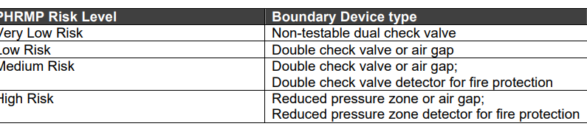
Backflow preventer devices shall comply with the requirements of the WSE’s material supply standard. When a connection is made to the WSE’s local water supply network an approved IQP shall test and certify the backflow preventer.
The WSE will intervene and the water supply shall be restricted in accordance with the Local Government Act 2002, the Building Act, Water Services Act 2021 and the relevant WSE Network Bylaw or other legislative instrument under the following circumstance, but not limited to:
- Unprotected supply with direct or indirect connection to possible contaminants
- Where the level of risk increases (change of use) and the device is not upgraded accordingly
- Where the device is not suitable or suitably installed for the level of hazard protection
- Expired backflow prevention device certification
If there is a risk of backflow in a reticulated drinking water supply, the drinking water supplier may—
- install a backflow prevention device and require the owner of the premises to reimburse the supplier for the cost of installation, maintenance, and ongoing testing of the device; or
- require the owner of the premises to install, maintain, and test a backflow prevention device that incorporates a verifiable monitoring system in accordance with any requirements imposed by the supplier.

Water age
Drinking water supply systems shall be designed to minimise water age in the network to ensure no unacceptable deterioration of water quality. This shall include:
- Mains with dead ends (or termination points) shall be avoided by the provision of looped watermains. Particular care shall be taken at the boundaries between supply zones where dead ends shall be avoided or minimised whilst maintaining existing district zone boundaries
- Mains for short runs shall be reduced in size or looped, for example no-exit roads (see Figure 5-6)
- The WSE may at its discretion require the developer to implement a system to improve the water quality where development uptake versus overall size affects the water grade of the area. This may be in the form of temporary dosing systems and flushing. A development staging strategy shall be provided to the WSE with commitment to provide for any associated costs before connecting to the Entity’s system.
- Water sampling points shall be provided as required by the WSE.

Disinfection
Each WSE will instruct on disinfection procedures to be followed. Part Two of this NEDS provides guidance in Chapter 20, which is based on Watercare’s Code of Practice for Disinfection of Water Systems No.COP-04, Version 4, August 2022.

PUMPING STATIONS
Pumping stations require specialist designs and require significant lifetime operations and maintenance expenditure by the WSE. Any proposal and design shall be prepared in consultation with and meeting the particular requirements of the WSE. Therefore, they are not included in the scope of this reticulation NEDS. In any case pumping should not be used a s solution for meeting fire fighting requirements.

SERVICE RESERVOIRS
Service Reservoirs require specialist designs and require significant lifetime operations and maintenance expenditure by the WSE. Any proposal and design shall be prepared in consultation with, and meeting the requirements of, the WSE. Therefore, they are not included in the scope of this reticulation NEDS.

TRENCHLESS TECHNIQUES FOR PIPELAYING
Trenchless techniques for pipelaying in both greenfield and brownfield developments can improve sustainability outcomes, reduce greenhouse gas emissions by reducing fuel consumption and reduce traffic impacts.
Various methods are available, and Guidelines and Specifications are in AS/NZS2033:2023 Installation of polyethylene pipe system. Horizontal directional drilling (HDD), Pipe bursting, microtunnelling, pipe jacking, thrust boring are all potential methods to lay pipelines without the need for long, deep, disruptive excavations which may be considered. However, any trenchless technique shall be evaluated against at least the following effects before a decision on its suitability is reached by the WSE:
- Effect on Te Mana o te Wai principles and values described in the Frontmatter to this NEDS
- Effects on environmentally sensitive areas
- Impact on built up or congested areas where minimizing traffic disruption is critical
- Suitability for crossings
- Sustainability outcomes
- Long term maintenance
- Ground conditions
- Presence of other buried services

FUTURE SYSTEM EXPANSION
Any proposed reticulation system that is large may have long term issues to be resolved in the initial concept stage, such as staging, water quality with low initial demands, future stages requiring a different water source, storage, pumping which all need to be understood before the first reticulation is designed and built.
The developer will provide the WSE with a concept plan covering all stages of a planned development before any approval process may begin.

SYSTEM REVIEW
To be written after the LD group report on the 3 stage approval process is available

HYDRAULIC DESIGN

SIZING

General
Inputs to the design process shall include:
- Hydraulic grades (HGL) at point of connection to existing WSE’s network
- Existing system hydraulic capacity
- Proposed land use, zoning, area to be serviced, and water use activities
- Water demand (low, average, peak) in l/s and m3/day, including diurnal profiles
- Fire flow requirements for the proposed site
- Hydraulic head loss, including backflow prevention
- An understanding of the general operating philosophy and design constraints of the water district zone the proposed development is connecting to; and
- Elevation assumptions at proposed water points of connection (also customer meter locations).
The outputs of water main hydraulic design shall include:
- Size of watermains (nominal diameter);
- Maximum, average and minimum design pressure at each of the points of connection (also water meter locations)
- The pressure class/rating of pipeline system components
- Surge analysis results, if required
- Pipe head loss (m/km) and velocity (m/s) compliance with low, average, peak demand, and firefighting demand scenarios
- Specification of the maximum and minimum allowable operating pressure
- Flow and pressure compliance with low, average, peak demand, and firefighting demand scenarios
- Reticulation layout that provides security of supply to end users.

Minimum pipe sizes
By convention, most pressure pipes in New Zealand are usually referred to by their nominal internal diameter (i.e. DN50, 100, 150, etc.) whereas the equivalent size ISO dimension PE pipes are usually referred to and specified by their nominal outer diameter (i.e. 63, 125, 180 OD).
For general application, WSE’s have standard sizes for all watermains as shown in the Table 3-1 below. Pipe sizes other than those listed below must not be used on the water supply network. All trunk mains will require specific design in collaboration with the WSE.
Table 3-1 - Standard sizes for watermains
Pipe type | Size and material
Connections | DN20, DN25, PE80, PN12.5
Ridermains | 63 OD, PE80, PN12.5
Principal mains | DN150 PVC or 180 OD PE100 , PN12.5.
Trunk mains | DN250 Series 2 PVC-O or DN315, PE100 (see note 2 below).
Notes:
a) Trunk Mains >DN250 requires specific design in consultation with WSE.
b) Some small/rural water supply schemes may allow 100mm diameter principal mains, only as agreed by the WSE.

Empirical sizing of reticulation mains
Table 3-2 and Table 3-3 may be used as a guide for sizing mains.
Table 3-2 - Empirical guide for principal main sizing
Nominal Internal diameter | Capacity of main (single direction feed only)
Nominal Internal diameter | Residential (lots) | Rural Residential  (lots) | General/light industrial  (ha) | High usage industrial  (ha)
 |  |  | - | -
150 | 160 | 125 | 23 | -
200 | 400 | 290 | 52 | 10
225 | 550 | 370 | 66 | 18
250 | 650 | 470 | 84 | 24

Table 3-3 – Empirical guide for sizing rider mains
63OD Rider mains
Pressure | Maximum number of dwelling units
 | One end Supply | Two end supply*
High > 600 kPa | 20 | 40
Medium 400 – 600 kPa | 15 | 30
Low < 400 kPa | 7 | 15

Fire flows
The water reticulation system shall be designed for the minimum design flows from 2.4.3.2, these include firefighting flows complying with SNZ PAS 4509. Hydrant numbering and spacing shall comply with SNZ PAS 4509.
Any shortfall between the fire flow required by the proposed development outside the WSE minimum design supply pressure and flow is the responsibility of the site owner to provide alternative fire protection services, at the cost of the site owner.
Many commercial and industrial developments require installation of special fire protection services. While it is the responsibility of the site owner to provide these fire services, the developer shall design the water reticulation system with consideration to the required demands, where these are known in advance and the minimum design as stated in Section 2.4. The site owner shall ensure that if any special fire protection services require supply of water from the WSE’s reticulation, the design shall include the protection of existing WSE assets and consider the existing and future available pressure and flow during normal operations.
As development continues in a zone, or as required by the WSE to manage the water supply system, the pressure and flow is likely to reduce. The design of special fire protection services shall also make allowance for a future upgrade at the site owner’s cost when the system operating pressure and flow changes in the future to other conditions within the WSE’s level of service criteria - refer to sections 2.4 and 2.5.

Sizing by analysis

General
The diameter, material type(s), and pressure class of the water main shall be selected to ensure that:
- The main has sufficient capacity to meet peak demands while maintaining minimum pressure
- All consumers connected to the main receive at all times an adequate water supply flow and pressure
- The appropriate firefighting flows and pressures can be achieved
- All pipe materials and design shall consider the nominal bore (NB) or internal diameter for design purposes where nominal diameter (DN) is referred to in this document.

Head losses
The head loss through the local network pipes and fittings at the design flow rate for peak day - peak hour, shall be less than:
- 5 m/km for DN ≤150
- 3 m/km for DN >150
Pressure pipe head loss shall be calculated using the Hazen-Williams, Mannings or Colebrook-White formulae for pipe internal diameter of ≥50mm NB and a flow velocity of less than 3 m/s.

Hydraulic roughness values
The hydraulic roughness values considered in the analysis shall take account of the pipe material proposed, all fittings and other secondary head losses, and the expected increase in roughness over the life of the pipe.
Table 3-4 - Hydraulic roughness values
Material | Colebrook – White coefficient k (mm) | Manning roughness coefficient (n) | Hazen Williams Coefficient (C)
PE | 0.003 – 0.015 | 0.008 – 0.009 | 140
Ductile iron concrete lined | 0.01 – 0.06 | 0.006 – 0.011 | 110-140
Mild steel concrete lined | 0.01 – 0.06 | 0.006 – 0.011 | 130-140
PVC | 0.003 – 0.015 | 0.008 – 0.009 | 145 – 150
GRP | 0.003 – 0.015 | 0.008 -0.009 | 140
NOTE:
The values show a range of roughness coefficients. These represents the expected value range for clean, new pipes laid straight to typical maximum expected for aged pipes. It cannot be absolute maximum, as factors detailed in AS 2200 can lead to even higher roughness values in some circumstances. Recommendations on the appropriate roughness coefficient for a particular fluid may be obtained from the pipe supplier. Refer also to AS 2200 table and notes.

Flow velocities
In practice it is desirable to avoid unduly high or low flow velocities. Pipelines shall be designed for normal flow velocities at peak periods within the range of 0.5 to 2.0 m/s.
For pumping mains an economic appraisal may be required to determine the most economical diameter of pumping main to minimise the combined capital and discounted pumping cost. The resulting velocity will normally lie in the range 0.8 m/s to 3.0 m/s. All booster pump station proposals (including fire pumps) and design considerations should be consulted with the WSE in the first instance.
The following factors shall be considered in determining flow velocity:
- Avoid stagnation
- Minimise turbidity (large fluctuations in flow rates can dislodge the biological slime or stir up settled solids in pipelines)
- Pressure
- Surge
- Pumping facilities
- Pressure reducing devices
- Pipe lining materials.

Quick-closing valves, pumps, hydraulically driven equipment or any other equipment which may cause pressure surges or fluctuations to be transmitted within the water supply system, or compromise the ability of the WSE to maintain its stated levels of service, shall not be used on any piping beyond the point of supply. In special circumstances such equipment may be approved by the WSE.

DESIGN PRESSURES
The design pressures are the limiting pressures for operation of a water supply system including any allowance for variation of usage in the future. Minimum and maximum design pressures shall comply with Section 2.5.3.1. Design pressures are set at the water meter. Specific consideration should be given for multi-storeyed buildings or areas of significant contours.
The operating pressure shall not exceed the re-rated pressure class/rating or the operating pressure limit of the pipeline components at that location.
Design criteria for pressure should include those factors discussed in sections 4.1.5 and 7.3.

PRESSURE CLASS OF SYSTEM COMPONENTS

Reticulation systems
WSEs shall state the minimum pressure class of all pipe materials. Where the WSE has no requirement the minimum pressure rating of PN12 shall be used for all pipe material and PN16 for all components. Refer also to the WSE's approved products/materials registers.

Systems subjected to dynamic pressures
Pressures shall be modelled in systems subjected to dynamic pressures. Where modelling shows pressure spikes in the range of 90-120m the minimum pressure rating shall be PN16 for all pipe material and components. Where pressure spikes in excess of 120m are shown the design shall be modified to eliminate pressure spikes.

THRUST AND ANCHOR BLOCK DESIGN
Thrust blocks and any other pipe restraint system shall be designed to resist the test pressure. Refer to Section 7.9.2.

SYSTEM TEST PRESSURE
The hydrostatic test pressure at any point in the pipeline shall be:
- Greater than the design operating pressure
- Less than or equal to 1.25 times the rated pressure of any pipeline component.
Note: The design pressure is the maximum system pressure at a point in the pipeline, considering future developments, static pressure, dynamic pressure and an allowance for short-term surge pressure (water hammer), as determined by analysis. Refer to Section 19.4 for hydrostatic pressure testing requirements.

DESIGN FOR DYNAMIC STRESSES
A surge analysis shall be undertaken for any pipeline within a pumped system or system containing automated valves. The source of any significant pressure surges or high-pressure areas shall be identified and remedial measures to minimise pressure surges designed and specified.

Fatigue
Although plastic pipes may be permitted in zones affected by dynamic pressure variations (e.g., pump zones), in locations downstream of pressure reducing valves, and in high surge areas, it is essential that the pipe class be reclassified (re-rated) for both surge and fatigue (cyclic dynamic pressure variations) in accordance with the criteria set out in Polyethylene Pressure Pipes Design for Dynamic Stresses, PIPA or PVC Pressure Pipes Design for Dynamic Stresses, Refer to POP 010A POP 010B and POP101.
Prior to plastic components being specified for mains in a pumped system, or a system otherwise exposed to regular surge / water hammer, the Designer shall verify suitability by applying the relevant design assessment nominated in Table 3-5.
Table 3-5 - Methods for Design of Plastics Pipes and Fittings for Dynamic Stresses
Pipeline system items | Guideline
PVC pressure pipes | PIPA Guideline POP101: PVC pressure pipes—Design for dynamic stresses. NOTE: where fittings are required for PVC pipelines, they shall be ductile iron
PE pressure pipes | PIPA Guideline POP010A: Polyethylene pressure pipes—Design for dynamic stresses
PE fusion fittings | PIPA Guideline POP010B: Fusion fittings for use with polyethylene pressure pipes—Design for dynamic stresses
GRP pipes and fittings | There is limited data to detail the design of GRP pipes and fittings and their performance. Systemic fatigue is dependent on the integrity of the manufacturing process, particularly for fittings. Fatigue design of GRP pipes and fittings requires WSE authorisation with appropriate specialist input. The design must be objectively certified with reference to testing and validation of criteria documented by the manufacturer. Specification of ductile iron fittings in lieu of GRP fittings should be considered for applications subjected to significant fatigue loadings.

TEMPERATURE DE-RATING OF PLASTICS PIPES AND FITTINGS
The pressure class of plastics pipes is determined at 20°C. Where the time weighted 12-month average temperature of water within the distribution system exceeds 20°C, the pipe class shall be de-rated to the time weighted 12-month average temperature. The temperature de-rating factor, t, shall be in accordance with Table 3-6.
Table 3-6 - Temperature De-Rating Factors for Plastics Pipes Operating at Elevated Temperatures
Pipe material | De-rating factor¹, _{t}
Pipe material | Time weighted 12-month average temperature, °C
Pipe material | 20 | 25 | 30 | 35 | 40
PVC-U5 | 1.0 | 0.94 | 0.87 | 0.78 | 0.70
PVC-M5 | 1.0 | 0.94 | 0.87 | 0.78 | 0.70
PVC-O5 | 1.0 | 0.94 | 0.87 | 0.78 | 0.70
PE 80B2 | 1.0 | 1.0 | 0.83 | 0.77 | 0.77
PE 1002 | 1.0 | 0.91 | 0.91 | 0.83 | 0.83
GRP4 | 1.0 | 1.0 | 1.0 | 1.0 | 1.0
Notes
1) At elevated temperatures, a reduction in the design life may occur.
2) The figures for PE80B and PE100 are based on PIPA POP013 Temperature rerating of PE pipelines. The guidance provided in POP013 is based on typical PE compounds used in Australia and New Zealand to manufacture AS/NZS 4130 PE pipe and listed in PIPA Guideline POP004 Polyethylene Pipe Compounds.
3) Multiply the temperature de-rating factor t by the PN number of the pipe to determine the de-rated PN of the pipe.
4) The figures for GRP are based on a polyester body resin. However, for continuous operation ≥35°C vinylester resins are required. No temperature de-rating is required up to 50°C for GRP pipes with vinylester body resins.
5) The figures for PVC pipe re-rating are based on PIPA "Temperature Derating of PVC Pipes for Pressure Applications" (TN003) and "PVC Pressure Pipes Design for Dynamic Stresses" (POP101).

DE-RATING OF MANUFACTURED PE COMPONENTS
Where components are formed from cutting and welding polyethylene (PE) pipe the original pressure class of the pipe shall be decreased following the processes in AS/NZS4129.
The minimum pressure class (PN) of pipeline components shall be:
- Gravity and pumped systems comprising metallic components:
PNMin ≥Design Pressure (MPa)
- Gravity reticulation systems incorporating plastics components:
PNMin ≥Design Pressure (MPa) x (1/t)
- Systems exposed to systematic surges and incorporating plastics components:
PNMin ≥PN de-rated for fatigue as per Section 3.6 and
- PNMin ≥Design Pressure (MPa) X (1/t)
where t = temperature de-rating factor for plastics components
Notes
- Plastics-bodied fittings and valves present a special problem. The geometry of these items can result in complex stress patterns that 'amplify' the apparent stress cycle. An apparently harmless pressure cycle can thus produce a damaging stress cycle leading to a shortened fatigue life. This is particularly important in the case of branch fittings such as tees. In addition, the situation can be aggravated further by the existence of stresses from other sources, for example, bending stresses induced by flexing under hydraulic thrust in improperly supported systems.
- The design of plastics-bodied fittings and valves is not standardised. The manufacturer should be consulted for re-rating factors for cyclic loading conditions, and, irrespective of manufacturer's advice, shall be not less than the values given in PIPA guideline documents referenced in Table 3-6.
- The pressure range is defined as the maximum pressure minus the minimum pressure, including all transients, experienced by the system during normal operations. The effect of accidental conditions such as power failure may be excluded.

PRODUCTS AND MATERIALS

GENERAL
All Products and Materials used in any Water Supply reticulation system must comply with the WSE’s Approved Products and Materials lists which are available from the WSE.
All parts of the water supply system in contact with drinking water shall be designed and constructed using components and materials that comply with AS/NZS 4020 (Revised 2018).

Pipe selection
The selection of the appropriate pipe material, sizes, and pressure classes shall be based on system demands. See Section 3.3 for the WSE’s minimum pipe pressure ratings.

Standard pipe sizes
The minimum pipe sizes shall be standardised as per section 3.1.2 above

Minimum pipe sizes

Pipe PN class (pressure rating)
Pipe PN class is selected on the basis of the design pressure (head) calculated for the various sections of the reticulation network. This may be varied by specific operational requirements specified by the WSE. The minimum pipe pressure rating shall be PN12 (refer 3.3 and 4.1.6).

Design pressure
The design pressure (head) for the mains to be installed shall be based on the following:
Design pressure, (m) = Maximum Supply Pressure, (m above the level datum used for the ground level)
+ Surge Allowance, (m)
– Lowest Ground Level (GL) of the proposed main, (m above datum).
The design pressure (m head) shall be used for:
- Selection of pipe materials and classes
- Selection of pipe fitting types and classes.

Minimum pipe PN
The minimum pressure rating for pipe shall be PN12 and for fittings PN16 on water reticulation mains. For some pipe materials the Entity will require greater minimum pressure class. Designers shall verify the WSE’s minimum requirement before specifying the required pipe PN. Refer to the WSE’s material supply standard.
Where pipes are installed using trenchless methods such as horizontal directional drilling, the minimum pipe class shall be PN16.

Nominated pipe PN
In some cases, the WSE may nominate a pipe PN (such as PN 16) for pressure pipes and fittings to standardise on a limited number of pipe PNs, or to allow future operational flexibility within the system. Where this is the case, the design pressure used as the basis for system design shall not exceed the WSE’s specified operating pressure limit associated with the designated pipe PN.

Pumped mains
When booster pump stations are considered, the requirements shall be reviewed with the WSE as they are not in the scope of this NEDS.
However for all water mains in pumped systems, a detailed surge analysis shall be conducted unless otherwise directed by the WSE to ensure:
- The appropriate surge pressure is included in the calculated design head
- Surge control devices are included in the system design, where identified by the detailed analysis, to protect the network or control pressure fluctuations in the supply to customers, or both.

Pipe materials
For acceptable pipe materials and Standards see the WSE’s material supply standards.

Steel mains considerations

Internal and external corrosion protection should be discussed with the WSE. Internal lining must conform with AS/NZS 4020. Special coating systems are required for above ground installations including interface with buried sections. Where Cathodic protection systems are recommended by the designer they must be discussed with the WSE early, as they require ongoing monitoring, therefore suitable arrangements for test points need to be considered.

PROTECTION AGAINST DEGRADATION

Protection against contaminated ground
Avoid contaminated sites wherever possible. The designer shall check land use history, particularly in brownfield areas or when development land has previously been zoned as industrial/commercial where fuel storage facilities may have been present. If a contaminated site cannot be avoided, provide details in the Design Report covering the requirements detailed in clause 5.4.6 of this NEDS as a minimum.

Bolted connections
All buried bolted connections shall be wrapped in denso tape in accordance with manufacturer’s instructions. All bolted connections shall be made with flanges. The WSE shall specify flange patterns for each network. Where no flange pattern is specified, flanges shall comply with AS/NZS 4087 PN16.
Note: AS/NZS 4087 has superseded AS 2129, AS/NZS 4087 PN16 corresponds to AS 2129 Table C and Table D.

GENERAL DESIGN

GENERAL REQUIREMENTS
Alteration to existing infrastructure
The connection of new developments may require upgrading or extending the existing water network and must maintain the minimum level of service for the existing infrastructure. Alterations to the existing water network to achieve the required level of service and standards for development outside of the on-demand water supply areas, the water supply area or restricted flow area must be at no cost to the WSE.

Design tolerances
The location and levels, where applicable, of the water main shall be determined and specified to the following tolerances:
- Horizontal alignment in metres to one decimal place for all mains.
- Level:
- Reticulation mains, to meet minimum cover requirements.
- Transfer and reticulation mains, in metres to two decimal places
Horizontal alignment shall be referenced to the WSE’s preferred coordinate system, and where possible, to local property boundaries. Levels shall be referenced to NZVD2016 or other as required by the WSE.

Levels
Levels are to be provided in the design drawings for any road crossings and other service crossings, valves adjacent to road crossings, changes of grade and at intervals on vertical curves to ensure minimum and maximum cover levels are met.

Water main renewals electrical safety and earthing to water services
Properties have a variety of electrical earthing arrangements that can involve the water supply system. These range from use of the metallic water service as the main earthing conductor (in some areas with older reticulation systems) to provision of an equipotential bond between the electrical main neutral and the water service (in conjunction with an earth stake in compliance with the Wiring Rules (AS/NZS 3000). Each of these arrangements, whilst designed to protect occupants, can create dangerous electrical conditions on the water supply pipework when there is a defect in the property electrical installation or the electricity supply network.
Appropriate safety warnings shall be included in the Specification and/ or Design Drawings commensurate with the safety precautions developed. For example, a typical warning consistent with the method outlined above could be:
Where a metallic water main is to be replaced using plastics pipes, the electricity supplier or a licensed electrician shall assess affected properties' electricity supply for defects and the likely effect on earthing adequacy. Work can commence once the electricity supplier/electrician declares in writing that it is safe to proceed.

Survey Control

Marking
All survey work submitted to the WSE shall be directly related to the WSE’s coordinate system. The plan shall clearly identify the origin of both horizontal and vertical control and shall quote the values adopted in each case.

Horizontal control
Control marks of engineering and cadastral survey standard will normally be sufficient for positioning of pipelines and associated facilities. Data supplied to the WSE shall include coordinates for all control marks used or placed during the survey.

Vertical control
Sufficient level control marks shall be provided to satisfy construction requirements.
Marks shall be positioned in locations that are stable and unlikely to be disturbed by construction. Marks shall be spaced to minimise set-ups needed when pegs are replaced or Work As Built levels are run after construction.
The surveyor shall verify levels at every opportunity by connecting to other control marks.

RETICULATION DESIGN FOR WATER QUALITY

Layout of water mains
In determining the general layout of mains, the following factors shall be considered:
- Main location to allow easy access for repairs and maintenance
- Whether system security, maintenance of water quality, and ability to clean mains meet operational requirements
- Safe location of valves for shut-off areas and zone boundaries (see 5.6.2.1)
- Safe and easy access to fire hydrants for maintenance and FENZ in an emergency
- Avoidance of dead ends by use of looped mains or rider mains
- Provision of dual or alternate feeds to ensure a resilient supply
- In brownfield situations consider the location and alignment of other buried or underground services
- Consider material type and evidence of engineering evaluation, i.e., location to fuel stations; and
- Compatibility with the WSE’s long term management strategy and plan for the overall district zone.
Network layouts shall be established in accordance with the WSE’s requirements to provide security of supply and zone management, and interconnected ring systems. Any design should demonstrate a consideration for security of supply. Typical examples of suitable layouts are given in Drawings WS-02 Intersection Layout and WS-03 Looped and Link Mains.

Looped mains

Water age
Drinking water supply systems shall be designed to minimise water age to ensure no unacceptable deterioration of water quality. This shall include:
- Mains with dead ends (or termination points (see 5.2.2.2) shall be avoided by the provision of looped watermains. Particular care shall be taken at the boundaries between supply zones where dead ends shall be avoided or minimised whilst maintaining existing district zone boundaries.
- Mains for short runs shall be reduced in size or looped, for example no-exit roads (see Figure 5-6)
- The WSE may at its discretion require the developer to implement a system to improve the water quality where development uptake versus overall size affects the water quality of the area. This may be in the form of temporary dosing systems and flushing. A development staging strategy shall be provided to the WSE with commitment to provide for any associated costs before connecting to the WSE system.

Termination points
Termination points or dead ends should be avoided to prevent poor water quality. Alternatives such as a continuous network, link mains, rider mains, looped mains, installation of flushing points on rider mains at dead ends and the use of reticulation mains smaller than DN100, particularly in no-exit roads, should be considered (see Figure 5-5 and Figure 5-6), all subject to meeting fire fighting requirements.

Link mains
A link main (See Figure 5-6) is an alternative means of eliminating a dead-end in situations where a looped main is not feasible. A "link" may be achieved by laying a main between the court bowl or cul-de-sac and a main in an adjacent street, via a pathway or right of way. The link main shall be the same size as the smaller of the two mains being linked.

Reduced size mains
These are generally not allowed. Under circumstances where there would be water quality improvements by using a reduced size of main, i.e., a dead end or firefighting capability of any proposal must be proven to the WSE and FENZ.

WATER MAIN ACCESS
Water mains in private property
Water mains shall only be installed in the public road reserve. Public water mains in private property, right of ways (ROW) and private roads are not permitted without consultation and agreement with the WSE and provision of acceptable access over the main for replacement, operation and maintenance.

LOCATION OF WATER MAINS

General
Water mains shall be located in the road reserve and follow guidance given in the National Code of Practice for Utility Operator’s Access to Transport Corridors, Version 2, July 2019 by NZUAG. The location shall be specified by the Council or WSE, within the road reserve or space allocation nominated by the Road Controlling Authority. Where approved by the Council or WSE, water mains may be located in a public reserve or park. In some instances, an easement may be required depending on the discretion of the Parks Manager.
Water mains shall:
- Be aligned parallel to property boundaries, and typically located in the berm
- Not traverse steep gradients, if unavoidable, add bulkheads to the design refer clause 7.10
- Be located to maintain adequate clearance from structures and other infrastructure. Refer Section 10.13.
A typical cross section layout for public roads is provided below in Figure 5-1.
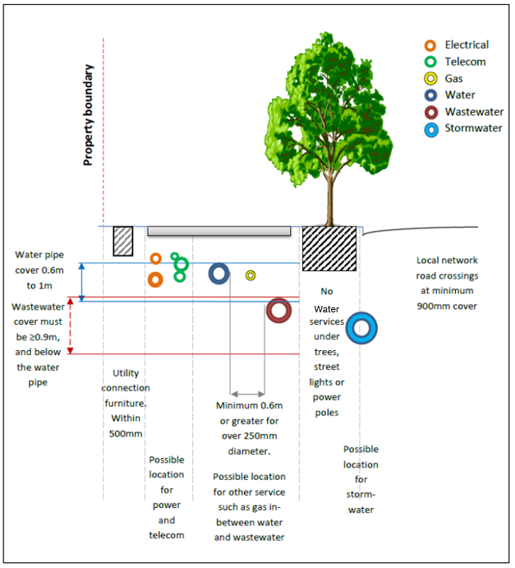
Figure 5-1- Typical cross section layout for public roads

Water mains in road reserves
The location of assets in the road corridor shall meet the requirements of the whole of Section 5 of this NEDS and satisfy the Road Controlling Authority’s particular requirements.

Location in other than public road reserves
A WSE’s water mains shall not generally be located in private property. In exceptional circumstances a WSE may allow it only if an appropriately sized and registered easement is provided in accordance with the Territorial Authority’s and its own rules.

Effect on vegetation
If installation is required under existing trees and vegetation, then trenchless technology should be considered. If this is not practicable, advice from a qualified arborist is required to minimise damage to the vegetation.
No works are to commence within 30m of historic/protected or notable trees without written approval from Council parks staff and if in a road corridor the road controlling authority. The road controlling authority or Council may require that an arborist monitor works in or around these trees. Note: Notable Trees are recorded in district plans prepared under the RMA. Other council policies manage street trees and reserves under the Local Government Act and Reserves Act respectively

Water mains near trees
Locating water mains within the root zone of trees is not allowed.

Contaminated sites
Contaminated sites should be avoided. Where a contaminated site has been confirmed, written approval to proceed shall be obtained from the relevant Council and the WSE. The following issues shall be addressed in the request for approval:
- The nature of the contamination
- Compliance with statutory requirements
- Options to decontaminate the area
- Selection of appropriate pipe materials, coatings and jointing techniques to maintain water quality
- Selection of pipeline materials to achieve the required life expectancy of the water main
- Safety of construction and maintenance personnel
- Special water main maintenance considerations to protect personnel and water quality.
Water mains and connections in the immediate vicinity of petrol stations shall not be constructed of PE or PVC material . Instead the designer shall consider using Ductile iron mains with nitrile rubber ring and gaskets. PE-Al-PE barrier pipe submains, crossovers and laterals shall be installed outside of bulk fuel storage facilities including petrol stations. Length of installation shall include the entire length of the property boundary plus extending a minimum of an additional 15 m on each side.
Any contaminants in the soil, including topsoil on the site, shall be at the lesser levels of the health-based or environmental-related protection values as described below:
- Health-based protection values:
- NES Soil contaminant standards (SCS) for residential land use (no produce, if applicable) as derived in accordance with Ministry for the Environment Methodology for Deriving Standards for Contaminants in Soil to Protect Human Health (Chapter 7). In the absence of a derived NES Soil SCS, then a standard following the hierarchy outlined in the Ministry for the Environment, Contaminated Land Management Guidelines No 2 shall be adopted. Environmental-related protection values:
No free (or separate) phase liquid contaminants and groundwater contaminant concentrations, with the exception of volatile organic compounds, which must be below the Australian and New Zealand Guidelines for Fresh and Marine Water Quality at the level of protection for 80% of freshwater species. Concentrations of volatile organic compounds shall be below typical laboratory screening detection limits (0.5 mg/L or lower).
The following table sets out the acceptance criteria for contaminant free sites:
Table 5-1 – Acceptance criteria for contaminant free sites
Contaminant | Acceptance level (mg/kg)
Arsenic | <24
Cadmium | <7.5
Chromium | <400
Copper | <325
Lead | <250
Mercury | <0.75
Nickel | <105¹
Zinc | <200¹
Benzo(a)pyrene equivalent | <2.15
Pyrene | <1
Total DDT | <0.7
VOCs | Below laboratory detection limit
1 Can use upper limit background concentration in Auckland region (i.e., 320 for Nickel and 1160 for Zinc) if the soil is volcanic source
A site investigation including soil sampling and testing must be undertaken and a report submitted to the WSE in accordance with the requirements of the Ministry for the Environment 2011 Contaminated Land Management Guidelines No. 1 - Reporting on Contaminated Sites in New Zealand. Testing shall be conducted by a NATA/IANZ accredited laboratory.
Soil testing data is required at the position for the proposed water infrastructure. The WSE reserves the right to request additional soil testing at the cost of the developer where the data supplied is considered inadequate or not representative of the site.

Safety in Design
For all designs, but especially those in contaminated ground, a full Safety in Design workshop must be carried out and fully recorded in a register. Any issues raised shall be carried through and dealt with in detailed design and/or construction.

Location markers
The location marking of valves and fire hydrants shall be to SNZ PAS 4509 and as shown on the standard drawings WS-05.

Marking tape
Appropriate marking tape or detection tape shall be installed at the top of the embedment zone, or tied to the pipe during horizontal directional drilling, to aid in the future location of the pipe. Refer to AS/NZS 2032 section 5.3.15.

CROSSINGS

Location of water mains on bridges
The pipe bridge must not be integrated with the bridge support structure. The design must provide for safe and unrestricted access for maintenance, upgrade, or replacement. The pipe shall be positioned clear of the 1% Annual Exceedance Probability (AEP) flood levels. The pipe and supports shall be structurally designed to meet the following conditions (refer Section 7):
- Empty and full static loads
- Any dynamic loads and vibration
- Expansion and contraction
- Seismic action.
Timber supports are unacceptable. Provision shall be made for access and clearances to maintain the pipe, connecting structures, drainage, articulation joints, valves, and associated fittings as necessary.
Unauthorised bridge access (i.e., onto the pipe) shall be prevented with an adequate barrier structure and, if necessary, on-bridge railing for fall protection.
The following pipe material options can be considered:
- Polyethylene pipe: This material must be butt welded and supported inside a full-length carrier pipe of suitable rigidity and durability. Cradles are not acceptable. The carrier pipe must be of suitable internal diameter to allow for future pipe size upgrades and thermal expansion and contraction.
- Steel (lined mild steel or stainless steel): The joints must be welded or flanged. Pipe hangers or supports should be fully welded to reduce corrosion and simplify maintenance
- Ductile iron with flanged joints with hangers or supports that prevent galvanic corrosion and encourage water run-off.
A formal agreement with the bridge owner must provide the WSE with the ability to access, operate and maintain the pipe on the bridge. NZTA Bridge Manual SP/M/022 gives guidance on placement of utilities in cavities on new and existing bridges.

Crossings

General
Water main crossings of roads, railway lines, and underground services shall be at right angles. Ducting and additional protection of the crossing service is subject to the affected authority’s requirements. In any event, the water main crossing shall be sized at minimum 100 NB unless otherwise instructed by the WSE. Mains should be located and designed to minimise maintenance and crossing restoration. The WSE may require extra mechanical protection for the pipes or different pipe materials to minimise the need for future maintenance.

Railway reserves
Water mains shall not be laid within railway reserves unless it is absolutely necessary, in which case the crossing shall be designed to the railway owners requirements and be authorised in writing by the railway owner.

Crossings of waterways or drainage reserves
All crossings of waterways or reserves shall be specific designs to suit the WSE's requirements and be in accordance with the Regional/Unitary Authority rules and policies.
Crossings shall be sized according to the hydraulic requirements and any WSE applied requirements for minimum diameter for future proofing. and as far as practicable, be at right angles to the waterway or reserve. Crossings shall be below waterway invert unless it can be demonstrated that such a crossing is not practicable.
When the pipeline is placed under the invert level of a waterway it may require mechanical protection by concrete encasement or steel or other acceptable pipe duct. Different pipeline materials may need to be used for the crossing.

Overhead power lines and transmission towers
Water mains constructed from metallic materials shall generally not be located close to high voltage transmission lines and other facilities. Special design shall be undertaken if it is necessary to locate water mains close to such facilities.
For any situation where a metallic pipeline is located in proximity of electrical transmission lines, particular attention is drawn to AS/NZS 4853 Electrical hazards on metallic pipelines. Similarly, A Guide to Power System Earthing Practice published by the Electrical Engineers Association is a useful reference (www.eea.co.nz)

VALVES

Valves general
Valves shall be installed to permit isolation of sections of the pipe network for maintenance and operational purposes. The spacing and location of valves shall be such that:
- the number of properties (or equivalent population in areas of multi-unit type apartments) affected by a shutdown is no more than 50
- maximum spacing of 500m
Valves shall be provided:
- Following the typical arrangements shown in drawings WS-02 and WS-03
- Anti-clockwise closing (with the exception of small diameter gate valves or peet valves)
- Both sides of crossings for motorways, arterial roads, and railway and tram crossings
- Adjacent to street intersections (for ease of location)
- At least 2 valves at every tee
- In the footpath, clear of carriageway, where possible
- Within 50 m of a bridge abutment, where distribution mains pass through motorway or arterial road bridge
- Valves shall be flanged jointed and fully supported. No loads shall be passed onto the pipe
- Valves and valve box lids shall be suitably marked and painted as follows:
- Hydrants – yellow
- Isolation valves (typically open) – white
- District zone valves (normally shut) – red

Valving design

Valve siting principles
The siting of valves shall take a holistic view of the existing infrastructure and proposed additions. General principles to be considered shall include:
- Valves shall be sited to provide the control (such as flow, pressure, isolation, and diversion) required by the WSE
- Ready access to valves to enable their safe operation. Account shall be taken of traffic and other site constraints
- Minimisation of inconvenience to the public and avoiding clustering of surface fittings in the footpath at intersections
- Optimisation of the number and location of valves to meet the WSE’s operation and maintenance requirements, safe working, and to minimise the effect of a shutdown on the WSE’s customers.

Valve spacing criteria
Valves to be spaced up to 500m or service up to 50 properties - whichever is less.

Branch mains
Valves shall be located on branch mains adjacent to the through water main. See Figure 5-2.
Where a road crossing is necessary immediately after the tee branch and there is no space available adjacent to the tee, a valve shall be installed on the opposite side of the road.
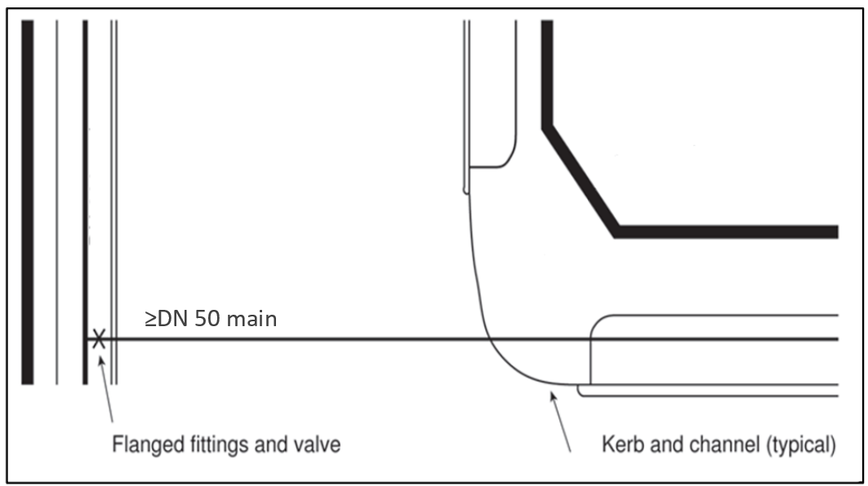
Figure 5-2 - Branch valve adjacent to main

District Zone Valves
District zone boundary valves and hydrants shall be in a paired configuration with a standard fire hydrant located between them. See Figure 5-3. Installation in this manner permits the valves to be checked for leakage. The valve on the low pressure side of the pair will normally be closed in order for the fire hydrant to be used for firefighting purposes with the supply from the higher pressure zone.
District zone boundary valves on rider mains shall be subject to specific design in consultation with the WSE to identify operational requirements.
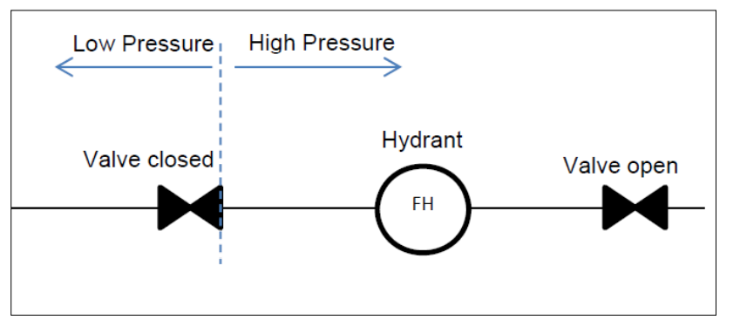
Figure 5-3 - Valve and hydrant combination for district zone dividing values.
The closed valve box shall be foamed to prevent accidental operation and the lid painted red. Kerb marking shall also be red to indicate the normally closed valve.

Secure service connections
Additional valves may be required at a service connection to customers needing greater security of supply such as hospitals and large industrial or commercial developments. Figure 5-4 illustrates typical arrangements to facilitate partial isolation of the main while maintaining supply to the customer.
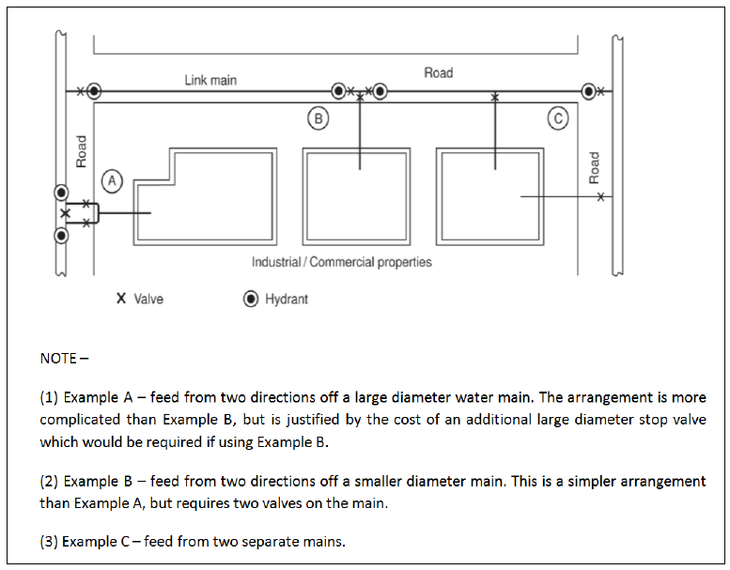
Figure 5-4 - Secure connection

Valve siting principles

Gate valves and sluice valves
- Resilient seated Gate (isolation) valves (also known as Sluice valves) shall be anti-clockwise closing with a false dolly attached and shall be installed on principal mains
- Gate valves (also referred to as peet valves) shall be clockwise closing and shall be installed on rider mains.
Valves shall include a label/tag confirming closing direction.
Buried valves shall be operated from above ground and shall be designed to facilitate the use of a standard key and bar. An extension spindle shall be incorporated as necessary to ensure the top of the spindle is reachable within 500mm, but not be sited less than 100mm from the finished surface level. In-line valves shall be the same diameter as the reticulation main.

Butterfly valves
Butterfly valves shall only be used with the approval of the WSE

Pressure reducing valves (PRV)
Pressure reducing valves (PRV) are outside the scope of this NEDS. Refer to the WSE for requirements and specification.
A PRV is used to reduce the pressure to a desired lower pressure downstream of the valve. The PRV works automatically to maintain the desired downstream pressure. The WSE may require the PRV site to be monitored or controlled through its telemetry system.

Pressure relief valves (PRelV)
Pressure relief valves (PReIV) are outside the scope of this NEDS. Refer to the WSE for requirements and specification.

Pump control valves
Pumping is outside the scope of this NEDS. Refer to the WSE for requirements and specification.

Pressure sustaining valves (PSV)
Pressure sustaining valves (PSV) are outside the scope of this NEDS. Refer to the WSE for requirements and specification.

Air valves (AV)
The scope of this NEDS is limited to reticulation up to 300mm diameter. The WSE should be consulted outside of urban areas for the requirements for ARVs and scour locations.

Installation design criteria
In densely populated urban environments with many service connections an air valve is often not required on a water reticulation main, and hydrants may be positioned at the high points to allow air release during drawdown and filling. However, investigation into the need for air valves (AVs) shall be made for all high points on mains, particularly at points more than 2 m higher than the lower end of the section of water main and particularly if the main has a steep downward slope on the downstream side.
Where the hydraulic head is less than 10m, special consideration shall be given to the type of AV to prevent water leakage from the valve. AVs shall be installed with an isolating valve to permit servicing or replacement without having to shut down the main.
Combination AVs, that is (dual) AVs incorporating an AV (large orifice) and an air release valve (small orifice) in a single unit, are generally the preferred type for distribution and transfer mains, and where required on reticulation mains.
Watermains with only a few service connections or a configuration that leads to air accumulation may require combination air valves to automatically remove accumulated air that may otherwise cause operational problems in the water system.
The configuration of the distribution network for both the change in elevation and the slope of the water main govern the number and location of air valves required.

Air valve location
Air valves shall not be located in major roadways or in areas subject to flooding or in areas of high ground water without specific design to prevent backflow contamination of supply. When required, air valves shall be located:
- At summits (significant high points)
- At intervals of not more than 800 m on long horizontal, ascending, and descending sectors
- On the downstream side of PRVs
- On the downhill side of major isolating valves
- At blank ends
Where the air valve is in a valve chamber, the design shall ensure adequate venting for effective operation and drainage to prevent backflow contamination. Wherever possible the air valve intake should be above the 1% AEP event flood level.

NON-RETURN VALVES
Non-Return Valves (NRV) are outside the scope of this NEDS. Refer to the WSE for requirements and specification.

SCOURS AND PUMP-OUT BRANCHES
The scope of this NEDS is limited to reticulation up to 300mm diameter; therefore it is possible that scours may not be necessary.However, they may be still be required on smaller water supply schemes as well. Refer to the relevant WSE for further guidance outside of urban areas.
There shall be adequate drainage facilities to receive the flow resulting from flushing and draining operations. Some Regional Rules require mixing chambers or manholes for de-chlorination prior to release. Discharge to wastewater reticulation systems may require a Trade Waste Permit. Refer to the relevant WSE for further guidance on scour discharge requirements.
Scours and pump-out branches on significant mains are provided in the distribution network for maintenance purposes. They are designed to allow draining of water from the mains by gravity or use of a mobile pump. Hydrants are preferred for flushing and draining on watermains DN <250.
Scours and pump-out branches shall incorporate appropriate measures to prevent back-siphon into the water supply system, including provision for fitting of any necessary backflow prevention devices.
Scours shall:
- Drain the watermain by gravity or have provision for pump-out within a period of 1 hour, or both
- Have a diffuser fitted at the discharge point if there is a likelihood of environmental or asset damage
- Not be subject to inundation; and
- Scour valve boxes shall be painted red.

Scour size
Scours shall be sized in accordance with Table 5-2.
Table 5-2 – Minimum scour size
Main size DN | Scour size DN
DN ≤200 | 80
200< DN ≤300 | 100

Scour location
Scours shall be located at:
- Low points at the ends of watermains; and
- Low points between in-line valves. Scours shall drain to a point where the discharge is readily visible to prevent the scour valve inadvertently being left open.
Typical discharge locations include:
- An approved pit that is to be pumped out each time the scour is operated (called a pump scour);
- A kerb and channel;
- An open-grated street drainage sump;
- A natural water course (with energy dissipater).
Scours shall not:
- Cause damage when operated;
- Discharge to closed stormwater structures;
- Discharge across roadways;
- Discharge to waterways, unless in compliance with the appropriate consent requirements.

SWABBING POINTS
In reticulation swabs shall generally use hydrants. Where swabbing points are required by the WSE the design shall ensure there is sufficient drainage to deal with the flow from the water main from the flushing operations. Also refer to Part Two Construction, section 18 Swabbing.

HYDRANTS

Purposes
Hydrants are installed on reticulation mains for firefighting and operational purposes. Operational purposes include mains flushing, chlorination, to allow the escape of air during charging, act as an air intake when draining to prevent main collapse and the release of water during dewatering of the water main, where air valves and scours are not installed.
Refer to Section 2.6.2 for backflow prevention requirements and Section 5.15.3 for metering requirements of private fire supplies.

Hydrant siting principles

Hydrants for firefighting
The spacing of hydrants for firefighting shall be in accordance with SNZ PAS 4509.
For road safety reasons, hydrants on State Highways shall be placed outside of the Waka Kotahi NZTA roadside clearance zone and within 2m of the road reserve boundary

Hydrant installation
Fire hydrants shall not be fitted to reticulation mains DN <100 or to transmission mains. For access and operational safety, fire hydrants shall not be located along a vehicle crossing. Where a new vehicle crossing is constructed over an existing hydrant, the hydrant shall be relocated outside the designation of the vehicle crossing.

Marking of fire hydrants
All hydrant boxes and markings shall be painted with yellow road marking paint.
For hydrants on or adjacent to sealed roads additional marking shall include:
- An isosceles triangle of solid colour with sides 600mm and base 450mm. The triangle shall be located on or near the centre of the carriageway, with the apex pointing towards the hydrant.
- A sawcut H, 5 mm wide, 5 mm deep, cut into the kerb opposite the hydrant, with 300 mm of the kerb also marked with yellow road marking paint.
- A circle 1.2m outside diameter and line width of 100mm around the hydrant box. The circle shall be provided in locations where there is a risk of vehicles parking over the hydrant (e.g. where the hydrant is within 2 m of the kerb or edge of the carriageway, or more if there is angle parking).
- A blue raised reflective pavement markers may be installed where deemed suitable instead of b or c where required by FENZ or the WSE. The reflective markers shall be bi-directional and placed close to, and on the fire hydrant side of the centre of the roadway, near the base of the yellow triangle marked on the road.
Marking shall be either b or c, not both. Marking d) will only be required in circumstances where neither b) nor c) are acceptable to FENZ or WSE.
For hydrants on or adjacent to unsealed roads with no kerb marking shall include:
- An NZTA Type C marker post, replacing the two yellow reflectors with blue and repeated on the reverse side. The post shall be located as for the standard edge marking posts in relation to the trafficable portion of the carriageway and in line with the fire hydrant.

Hydrant size
All hydrants shall be a minimum DN 100.

Hydrant spacing
Spacing shall not exceed 135m in residential areas and 90m in commercial and industrial areas whilst fulfilling all the other requirements contained in SNZ PAS 4509:2008. On dead end roads in industrial/commercial areas, clusters of hydrants may be required to achieve required firefighting flows.

Hydrant location
All hydrant locations shall fulfil all the requirements contained in SNZ PAS 4509:2008.

Hydrants for reticulation system operational requirements
Additional to firefighting requirements, hydrants shall be provided at:
- High points on reticulation mains to release air during charging, to allow air to enter the main when dewatering, and for manual release of any build-up of air, as required, where automatic combination air valves (AVs) are not installed;
- Localised low points on watermains to drain the water main where scours are not installed.
Adequate drainage facilities shall be provided to receive the hydrant flows from dewatering and flushing operations.
Air valves are not normally required on reticulation mains in residential areas where the configuration of mains and service connections will usually eliminate small amounts of air accumulated during operation; hydrants should be placed as close as possible to stop valves and high points to facilitate maintenance activities such as cleaning of watermains.

Hydrants at ends of mains
If a scour is not provided, a hydrant shall be installed at the end of every main DN ≥100.

DISINFECTION FACILITIES

General
The disinfection of water mains is usually achieved by injecting a solution containing free chlorine into the water main while charging the main with water through an adjacent valve. The process also requires the discharge of water from the other end of the water main. Also refer to Part Two Construction Section 20 DISINFECTION.

TRENCHLESS TECHNOLOGY
Trenchless technology can contribute significantly to the reduction of carbon in construction and disruption to communities and so should be considered as part of the planning and design of any new reticulation.
Trenchless technology may be appropriate for alignments passing through or under:
- Environmentally sensitive areas
- Built-up or congested areas to minimise disruption and reinstatement
- Railway and road crossings
- Significant vegetation
- Vehicle crossings
Pressure pipes used for trenchless installation shall have either heat fusion welded joints, or suitable mechanically restrained joints, specifically designed for trenchless application, which may include integral restraint seal systems, or other WSE approved pipe jointing method.
The Designer’s project execution plan shall detail the pipe structural limitations for the intended construction method, the location of access pits and exit points and include a risk assessment to other services, abutting surface and underground structures.
Further information on trenchless technologies may be found in ‘Trenchless technology for installation of cables and pipelines’ (Stein), ‘Trenchless technology – Pipeline and utility design, construction, and renewal’ (Najafi), and ‘Guidelines for horizontal directional drilling, pipe bursting, micro-tunnelling and pipe jacking’ (Australasian Society for Trenchless Technology)

SHARED TRENCHING
Where shared trenching is approved the pipe structural calculations shall consider the pipe structural impact and minimum clearances from other services. See Section 5.16.2.

PRINCIPAL AND RIDER MAINS

Principal and rider mains layout
Table 5-3 - Principal and rider mains layout
Area | Configuration
General Residential (Outside of Tier 1) | Principal main on one side of the road and a ridermain on the other.
Tier 1 General Residential, Industrial, commercial, medium and high density residential*, arterial or dual carriageway streets | Principal main on both sides of the road.
All other areas | Principal main on both sides of the road.

No service connections are allowed to trunk mains >DN250, in which case a principal or rider main is required in accordance with section 3.1.
To facilitate future development, water- mains shall be laid across the full road frontage of the site at the developer’s cost.

Rider mains and duplicate principal mains
A rider main shall be laid along the road frontage of all lots not fronted by a principal main.
Duplicate principal mains are required to provide adequate fire protection in the following cases:
- Arterial roads or roads with a central dividing island
- Roads with split elevation
- Roads with rail or tram lines
- Urban centres
- Parallel to large distribution mains that are not available for service connections
- Commercial and industrial areas
- Where required by SNZ PAS 4509
- High density residential areas

CONNECTION OF NEW MAINS TO EXISTING MAINS

General
In specifying connection detail the designer shall consider:
- Pipe materials, especially potential for corrosion;
- Relative depth of mains;
- Standard fittings;
- Pipe restraint and anchorage;
- Limitations on shutting down major mains to enable connections; and
- Existing cathodic protection systems.
Connections from the end of an existing main shall be designed to address any differing requirements for the pipes being connected, particularly restraint, spigot/socket joint limitations, and corrosion protection. The Designer shall consider the potential for insufficiently restrained/ anchored stop valves near the connection.
All connections shall have a branch connection isolation valve. Hot tapping of watermains shall not be completed without the WSE’s approval.
All connections to the existing reticulation shall be made by the WSE or a WSE Approved Contractor and in accordance with the WSE’s processes. Should a bulk supply point (BSP) be required refer to the WSE for its specific design requirements.
Connection of watermains to the public system may only be made with demonstration of compliance with the WSE’s disinfection processes, or if not available Section 20 of this NEDS and all the testing requirements of the WSE’s construction standards or policies have been fulfilled.

TERMINATION POINTS

Permanent ends of water mains
Termination points or dead ends should be avoided to prevent poor water quality. Alternative configurations such as a continuous network, link mains, looped mains, and the use of reticulation mains smaller than DN150, particularly in no-exit roads, should be considered (see Figure 5-5, Figure 5-6 and Figure 5-7).
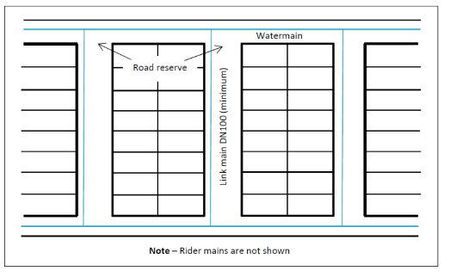
Figure 5-5 - Elimination of termination points
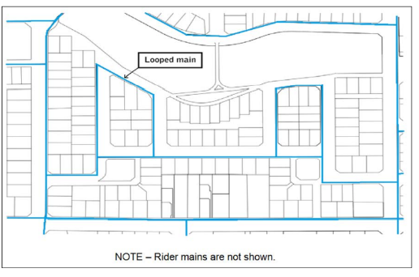
Figure 5-6 Looped principal mains
Rider mains (also known as submains in some areas), DN <100, may be used to supply the furthest properties beyond the water main. The DN 100 main shall be laid to a point where all properties are provided with the fire protection required by SNZ PAS 4509.
A method of flushing shall be provided at the end of the rider main and water main, which shall be suitably anchored. Refer Figure 5-7 for an example of a flushing point on a rider main. There must also be a testable backflow prevention device fitted to the flushing valve.
Note – The gate valve shall be in a normally closed position in a red painted lockable valve box and kerb marking.
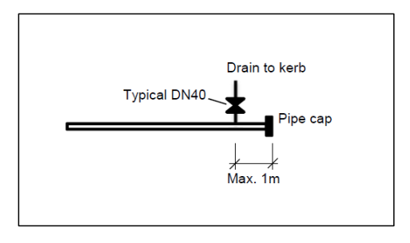
Figure 5-7 - Permanent end flushing point for rider mains

Temporary ends of water mains
Water mains shall be laid to within 1 m of the boundary of a subdivision where the main is to be extended in the future.
Temporary dead-end mains shall terminate with a hydrant followed by a gate valve. These shall be part of the holistic layout design to avoid unnecessary fittings not required for operations or maintenance. The valve and hydrant shall be suitably anchored so that the future extension can be carried out without the need to disrupt services to existing customers.
Where a development is staged, mains shall be constructed to terminate approximately 2 m beyond the finished road construction to ensure that future construction does not cause disruption to finished installations.

Flushing points
Any requirement for flushing points shall be imposed by the WSE for their operational requirements. Often they may not be required, however scours and pump-out branches on significant mains may be provided in the distribution network for maintenance purposes. They are designed to allow draining of water from the mains by gravity or use of a mobile pump. Hydrants are preferred for flushing and draining on watermains DN <250.
Scours and pump-out branches shall incorporate appropriate backflow prevention measures commensurate with the level of risk to the drinking water supply (refer Section 2.6.2)..
There shall be adequate drainage facilities to receive the flow resulting from flushing and draining operations.
Scours shall:
- Be spaced and located to drain the watermain by gravity or have provision for pump-out within a period of 1 hour, or both
- Have a diffuser fitted at the discharge point if there is a likelihood of environmental or asset damage
- Not be subject to inundation; and
- Scour valve boxes shall be painted red.

PROPERTY SERVICES

General
The general requirements for service connections are as follows:
- Property service connections shall have suitable backflow prevention installed. See Section 2.6.2.
- The point of supply is as defined under Section 2.2.1 and WS-01.
- Only one service connection from the public watermain is allowed per lot; and
- Superlots with over 50 dwelling units where pipework will remain private should be fitted with a second service connection if practical, but should ensure sufficient fire flows are met, the supplies are fitted with backflow prevention, and that accurate metering over the range of flows is installed. The internal layout design should make provision for flexible system isolation. The 50 dwelling unit threshold is to support the WSE customer service in the event of water outages.
- A second connection for larger lots is at the WSE’s discretion and should demonstrate:
- Zone classification is not affected
- Service connections are not interconnected within the property
- Isolation for maintenance and emergencies is not adversely affected
- Mixed land use type may require that the service connection and backflow prevention be separately sized and metered between commercial and domestic use.
- Multiple private connections to dwellings on a single property, or where a subdivision does not provide a dwelling with direct public road frontage, may be supplied through a single bulk site meter and backflow prevention under a body corporate (or similar legal instrument) arrangement or with a manifold meter bank arrangement associated with the property. Private connections are made downstream (property side) of the bulk supply meter or manifold.
- A meter bank shall not house more than six individual water meters. Where more than six individual meters are required for dwellings located along a right-of-way or private road, a bulk site meter installation and backflow prevention shall be used in conjunction with private check meters, and a body corporate (or similar legal instrument) arrangement.
- Right-of-ways or private roads greater than 135m from the public watermain to the furthest dwelling must have a bulk site meter arrangement in conjunction with private check meters, and a body corporate (or similar legal instrument) arrangement. Adequate fire protection in accordance with NZS 4509 will also be required.

Multiple Dwellings
A property may have multiple dwellings, or separate living units constructed within dwellings. Metering is required to the individual separable unit. The single bulk site meter arrangement has a reduced maintenance obligation on individual housing units and should be managed through a body corporate (or similar legal instrument), or in the case of a multi-storey apartment building a building management arrangement. The WSE will provide service for separate meter readings and individual billing to customers.

Service line connections
- The service connection onto the water main is made with a tapping saddle. Connection saddles, pipe and pipe fittings shall be as required by the WSE’s material supply standards. The WSE may require the service line to be placed in duct if it is laid at depth or complying with local requirements. The property service lead shall be minimum 20NB. The standard sizes shall be 20mm, 25mm, 40mm, 50mm, 80mm, 100mm and 150mm
- The service connection shall be tapped from the top of the water main, rising directly vertical to a minimum cover of 450mm. A 90ᵒ elbow shall be installed at the top of the vertical tapping and the lead graded to a cover of maximum 250mm at the meter box adjacent to the property boundary. Refer drawing WS-18
- Where a service connection passes under a driveway or other hard services, it shall be installed through a duct of suitable strength to support the driveway loading
- The isolation valves must be of an acceptable type. Quarter turn valves are generally not accepted for isolation
- Manifolds must be to the WSE standard design or approved equivalent. See the NEDS’s drawing WS-18

Under pressure connections to PE mains
When the tapping is made onto a PE pipe the use of an electrofusion fitting is preferred, but compression fittings may be used if agreed with the Entity.

Fire suppression connections
All private fire supplies shall be metered. If serving a sprinkler system the meter shall not be mechanical. Also a backflow prevention device must be installed. Fire suppression supplies must be sized and designed by a qualified Fire Engineer.
Whilst the WSE does not bill the customer on fire supplies, the purpose of a water meter is to identify leakage or unauthorised use of the fire supply water within the private property.

Metering
Applications for new water meters must be made to the WSE.
The WSE retains sole ownership of water meters and single bulk site meters at the point of supply and is responsible for the ongoing maintenance of associated fixtures and fittings.
The WSE is not responsible for any private check meters.
All new or redeveloped residential and non-residential units, whether individually titled or not, must have individual manifolds installed for each individually occupied unit or premises. Where the property is managed by a legal entity such as a body corporate a bulk site meter at the boundary is required.
Meters must be located in the road reserve next to the property boundary and be readily accessible at all times. Meters shall not be installed in confined spaces. Properties, such as in a CBD, where meters cannot be located within the road reserve must be approved by the WSE. The design shall take into consideration the following:
- The shortest possible pipe length inside the property and must be readily accessible for maintenance
- Each meter must be readily accessible for reading, maintenance, or replacement (boxes need to be sized appropriately)
- Meters must not be located inside actual units/apartments or within ceiling cavities
- Integrated remote reading devices must be installed when a meter is located behind a door or gate (locked or unlocked), fence or within an area protected by security systems. The remote reading device must be easily accessible to a meter reader. The remote reading device must be compatible with the WSE devices. Smart meters may be installed as an alternative if agreed with the WSE.
Meters, excluding private check meters shall only be installed by the WSE’s approved contractors in accordance with the WSE’s standard details.
- Water meters shall comply with the requirements of the WSE’s material supply standard.
- The meter size for the development will be determined by the WSE. In-line meter on fire supplies must be endorsed by the fire design engineer. Demand flow requirements must be provided when the water connection is applied for.
- For separate fire suppression a water meter shall be installed (refer drawing WS-20).
- For combined fire suppression and water meter supplies a meter shall be installed. Depending on the watermain size a bypass meter may be required for low flow accuracy. The WSE must have access to read this meter.
- Domestic and commercial use within a property shall be separately metered. Metering shall be combined for fire suppression and commercial with a separately metered domestic supply.
- Appropriate backflow prevention shall be installed for (c), (d), (e) and (f) above.
- A customer may wish to attach logging or remote telemetry to a water meter to assess consumption patterns or manage resource use; where this is authorised by the WSE no liability will be taken if the meter is changed, or data is unavailable for any period of time.
- The WSE reserves the right to manage connections to its assets and may require that privately owned equipment connected onto the meter be removed at any time.

Coupling to meters
- Fittings, couplings, and pipe componentry shall comply with the requirements of the WSE’s material supply standards and the arrangements as shown in the drawing set in Appendix A.
- The minimum upstream and downstream connection clearances of the meter manufacturer shall be allowed for.

Private water supply pipes
The private internal plumbing system’s design, installation, and maintenance (both in its component parts and its entirety) must comply with the Building Act 2004 and the New Zealand Building Code

OBSTRUCTIONS AND CLEARANCES

Clearance from structures and property boundaries
Pipes in trenches adjacent to existing buildings and structures shall be located clear of the ‘zone of influence’ of the building foundations as shown in Figure 5-8.

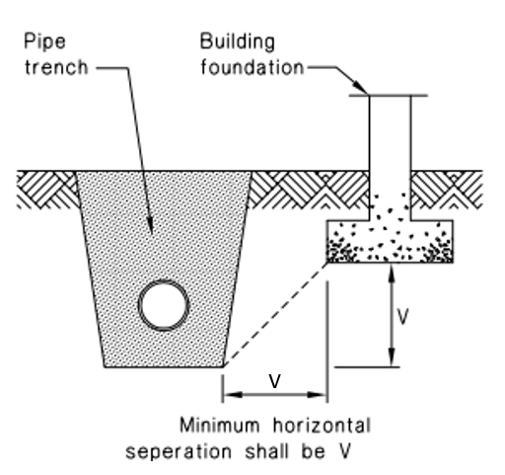
Figure 5-8 - Pipe trench minimum distance from building foundation
If this is not possible, a specific design shall be undertaken to cover the following:
- Protection of the pipeline
- Long term maintenance access to the pipeline

- Protection of the existing structure or building
- Consideration to building overhangs and clearances
- Building over water mains is not permitted.
The protection shall be specified by the designer for evaluation and acceptance by the WSE. Table 5-4may be used as a guide for minimum clearances for access to watermains.

Table 5-4 – Minimum clearance from outside edge of pipe to wall, building or property boundary
Pipe diameter DN | Clearance to wall or building (mm)
<100 | 600
100 – 150 | 1000
200 -250 | 1500
Note:
The minimum distance shall allow for future pipe repair and replacement without disturbance to any fence, wall or adjacent foundation, so shall vary with depth and WSE requirements

Underground obstructions and services

General
Water mains that are public and installed in the proximity of other services shall comply with the WSE's minimum clearance requirements. The specific design may require a greater clearance.

Clearance requirements
The minimum vertical and horizontal clearances are shown in Table 5-5
Table 5-5 – Clearances between watermains and underground services
Utility  (Existing service) | Minimum horizontal  clearance (mm) (Fig 5-8 ‘X’) |  |  | Minimum vertical  clearance⁽¹)  (mm) (Fig 5-8 ‘Y’)
Utility  (Existing service) | New main size |  |  | Minimum vertical  clearance⁽¹)  (mm) (Fig 5-8 ‘Y’)
Utility  (Existing service) | DN ≤250 | DN >250 |  | Minimum vertical  clearance⁽¹)  (mm) (Fig 5-8 ‘Y’)
Water mains DN ≥ 600 | WSE may consider specific clearances for larger mains due to operational reasons.
Transmission water mains 600 > DN ≥375 | 600 |  |  | 500
Water mains DN <375 | 300⁽²⁾ |  |  | 150
Gas mains | 300⁽²⁾ |  |  | 150
Telecommunications conduits and cables | 300⁽²⁾ |  |  | 150
Electricity conduits and cables | 500 |  |  | 225
Wastewater and Stormwater pipes | 1000/600⁽⁴⁾ |  |  | 500⁽³⁾
Kerbs | 150 |  |  | 600
Notes:
All clearances are measured as the inside open spacing between the external walls of services.
1) Vertical clearances apply when water mains cross another utility service, except in the case of wastewater when a vertical separation shall always be maintained, even when the main and wastewater pipes are parallel. The main should always be located above the wastewater pipe to minimise the possibility of backflow contamination in the event of a main break.
2) Clearances can be further reduced to 150 mm for lengths up to 2m when passing installations such as poles, pits, and small structures, providing the structure is not destabilised in the process or that the structural integrity of the trench is compromised.
3) Water mains shall always cross over wastewater and stormwater drains.
4) When the wastewater or storm water pipe is at the minimum vertical clearance below the water main (500 mm), maintain a minimum horizontal clearance of 1000 mm. This minimum horizontal clearance can be progressively reduced to 600 mm as the vertical clearance is increased to 750 mm.
5) Clearance from kerb and channel shall be measured from the nearest edge of the concrete.
6) Where a main crosses the other services, it shall cross at an angle as near as possible to 90%

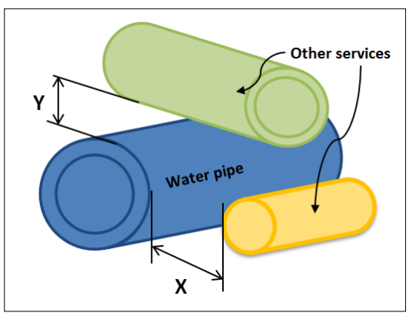
Figure 5-9 – Service clearance measurements

Clearance from transmission towers
Water mains constructed from metallic materials shall generally not be located close to high voltage transmission lines and other facilities. Special design shall be undertaken if it is necessary to locate such mains close to such facilities.
For any situation where a metallic pipeline is in proximity of electrical transmission lines, particular attention is drawn to AS/NZS 4853 Electrical hazards on metallic pipelines. Similarly, A Guide to Power System Earthing Practice published by the Electrical Engineers Association is a useful reference (www.eea.co.nz)

Deviation of water mains

General
Deviation of a pipeline around an obstruction can be achieved by deflection of the pipeline at joints, to the angular deflection limits stated by the pipe joint manufacturer and with suitably restrained fitting bends. Permitted angular deflection varies with pipe material, pipe wall thickness, pipe PN class, joint type, design, and geometry. Some joint types are specifically designed to accommodate angular deflection. PVC and PE pipes may also be curved along the pipe barrel, between joints, to a radius of curvature not less than that stated by the pipe manufacturer. Curved water mains require the WSE's approval and may not be allowed due to pipe joint stresses, performance in a seismic event or operational constraints. POP202 – PVC and PE Pressure Pipe Installation on Curved Alignments give advice on this topic that the designer may consider.

SYSTEM PRESSURE MANAGEMENT

GENERAL
Water supply reticulation is generally planned and designed to use gravity to convey water, designed to provide for the customers' water demands within the pressure ranges shown in Table 2-5. However, where variations in topography limit the viability of a gravity system or where pressures fall outside the required pressure ranges, other means of ensuring appropriate pressures need to be employed.
If the minimum pressure is insufficient during delivery of diurnal and/or seasonal demands, in-line pressure booster pumping stations (hereinafter called "boosters") may be used to increase the hydraulic gradient to the areas that have inadequate pressure. The decision to construct a booster may also result from a requirement to supply water from a different supply zone or because of system head loss that prevents a section or sections of the network from sustaining the required minimum operating pressure.
Some WSEs may require the use of individual private booster arrangements which supply water at a single lot level in place of a booster for the entire water system. The installation, maintenance and power costs of these individual boosters are typically the responsibility of the individual lot Owner. The requirements for these types of private booster arrangements are provided by the local WSE and are not covered by this NEDS.
In some circumstances (see 6.4 Pressure Sustaining Valve Installations) a pressure sustaining valve installation may be used to limit the minimum pressure that is experienced in part of a water supply network. However, this might adversely impact downstream flows and pressures.
If the maximum pressure is of concern, pressure reducing valve (PRV) installations may be used to limit the pressure and/or control the range of pressures experienced.
Similarly, it may be necessary for privately owned PRVs to be installed on individual water services to limit the maximum pressure to that specified for some on-property plumbing fixtures.

IN-LINE PRESSURE BOOSTER PUMPING STATIONS
Booster pumping stations require specific engineering design and are not therefore included in the scope of this NEDS. However, the WSE’s design philosophy will:
- Clearly define the type of pump and pumping scenario in order to provide an optimal design for the system
- That pumping systems meet the water peak demand, consented requirements or pre-determined rate as determined in consultation with Councils
- Be based on peak hour demand e.g., PHD, when maximum storage is available
- Be based on the consented rate or the supply source instantaneous flow rate available whichever is larger, for systems with no or minimal storage
- Accommodate initial and future operating conditions. Pumps should be specified to operate in the vicinity of their optimum efficiency points
- Not negatively impact other water customers

PRESSURE REDUCING VALVE INSTALLATIONS
Pressure reducing valves (PRV) are outside the scope of this NEDS. They require detailed engineering design and operational planning. Refer to the WSE for requirements and specification.
Where a development's water supply pipework cannot be designed to deliver below the maximum allowable supply pressure, or the range of supply pressure during the day is more than 40m, then the WSE should be consulted on the possibility of using a pressure management device.
A PRV is used to reduce the pressure to a desired lower pressure downstream of the valve. The PRV works automatically to maintain the desired downstream pressure. The WSE may require the PRV site to be monitored or controlled through its telemetry system.

PRESSURE SUSTAINING VALVE INSTALLATIONS
Pressure sustaining valves (PSV) are outside the scope of this NEDS. They require detailed engineering design and operational planning. Refer to the Entity for requirements and specification.

STRUCTURAL DESIGN

GENERAL
Seismic resilience of water infrastructure is vital to the communities they serve. This section provides guidance to ensure continuous water supply after an event has occurred.
For installation conditions beyond those shown on the drawings, the pipeline installation, including non-pipeline elements such as pump station chambers, shall be specifically designed to resist structural failure. The design shall be in accordance with AS/NZS 2566.1 including the structural design commentary AS/NZS 2566.1 Supplement 1 and NZS 1170.5 including Supplement 1. Details of the final design requirements shall be shown on the drawings.
Pipe bridge design shall be subject to specific structural design of the pipe and supports for empty and full static loads, any dynamic loads, and full seismic provisions. Also see Section 5.5 Crossings.

STRUCTURAL CONSIDERATIONS
Pipelines shall be designed to withstand all the forces and load combinations to which they may be exposed including internal forces, external forces, temperature effects, settlement, and combined stresses. The water main design shall include the selection of the pipeline material, the pipe pressure class, and selection of appropriate bedding material to suit site conditions. Consideration must be given to the future state or possible interactions with the trench that could affect the bedding material’s ability to continue functioning as designed, for example very fine self-compacting material may affect the cost of retaining the trench during replacement or other construction work near the trench.

INTERNAL FORCES
Pipelines shall be designed for the range of expected pressures, including transient conditions (surge and fatigue) and maximum static head conditions. These criteria are discussed in sections 3.2 and 4.1.5. In the case of transient conditions, the amplitude and frequency shall be estimated or modelled. The allowance for surge included in the maximum design pressure shall not be less than 20m. If any distribution mains are subject to negative pressure, they shall be designed to withstand a transient pressure of at least 8m below atmospheric pressure. A surge safety factor of 2 may be applied to the normal operating pressure to estimate the surge pressure in lieu of a detailed surge analysis.

EXTERNAL FORCES

General
The external forces to be taken into account shall include:
- Trench fill loadings (vertical and horizontal forces due to earth loadings);
- Surcharge;
- Groundwater, including the potential for floatation;
- Dead weight of the pipe and the contained water;
- Other forces arising during installation;
- Traffic loads;
- Temperature (expansion/contraction);
- Seismic forces;
- liquefaction forces.
The consequences of external forces on local supports of pipelines shall also be considered.

Pipe cover
Pipeline cover shall be designed with depth to the top of the pipe measured to the final surface level:
- In berms a minimum cover of 600mm and up to a maximum of 1000mm
- Where located in the front 1m width of the berm (next to the road surface) the minimum depth is 900mm
- In carriageways a minimum 900mm up to a maximum of 1200mm; or
- As otherwise agreed or required by the WSE and the Road Controlling Authority.

Embedment zone dimensions
The designed trench width shall be the minimum width to allow pipes to be safely laid and all embedment material properly and sufficiently compacted.

Trench width
Pipe trench width design shall be based on manufacturers recommedations or pipe structural calculations and shall maintain minimum clearances from other services. See 5.16.2.

Buoyancy
The pipeline shall not be liable to buoyancy when empty and shall be designed with a factor of safety against flotation of 1.25.

GEOTECHNICAL CONSIDERATIONS

General

Geotechnical investigations
The Designer shall take into account any geotechnical requirements determined during the investigations for the development. All geotechnical log reports shall be uploaded to the New Zealand Geotechnical Database; https://www.nzgd.org.nz
Where required, standard special foundation conditions shall be referenced on the drawings.
Special design requirements may apply in any area susceptible to land instability or soil liquefaction. For indicative information refer to http://data.gns.cri.nz/geology.
Geo-professionals are to satisfy themselves of the correctness of the information and apply current knowledge when meeting any such special requirements.

Earthworks Geotechnical Information:
- In some instances the WSE may provide geotechnical site investigation reports or a geotechnical baseline report (GBR). This information shall not be considered as complete and shall be supplemented as necessary for the site specific activities.
- All additional investigation locations shall be surveyed and immediately after the investigations are completed backfilled and sealed.

All additional geotechnical information obtained shall be uploaded to the relevant regional Geotechnical Database.Pipe selection for special conditions
Pipeline materials and jointing systems shall be selected and specified to ensure:
- Structural adequacy considering ground conditions and water temperature
- Water quality, considering the chemical concentration and temperature of the water, the influence of applied stresses and lining material
- Compatibility with aggressive or contaminated ground (consider HAIL sites)
- Suitability for the geotechnical conditions
- Compliance with the WSE’s requirements.

Water mains in engineered or controlled fill
The designer shall take into account any geotechnical requirements determined during the investigations.

Water mains in non-engineered fill
Water mains shall not be placed in non-engineered fill

Construction of Water Mains in engineered fill
The designer shall take into account any geotechnical requirements determined during the investigations.
Where the route of a main requires filling or construction of an embankment (e.g., to achieve required lines, grades, and cross-sections), a geotechnical specialist shall investigate the site and design and supervise construction of the embankment, the trench and bedding for the pipeline. Relevant construction requirements shall be included in the Specification and/or Design Drawings.

CONCRETE ENCASEMENT

General
Where trenchless construction techniques are impractical (Refer to Section 5.10) and open trench construction methods are employed, concrete encasement shall be considered as an alternative embedment material where:
- There is a need to protect a main from external loading, typically where the main is laid in a major roadway or in a shallow trench
- There is a need to reduce the need for future maintenance activity, where the main is deemed by the WSE to be inaccessible (e.g., laid in a major road, deep trench, under additional fill or other infrastructure)
- The soil bearing capacity and trench foundation are inadequate
- To resist flotation
- The risk of erosion is high (such as through water courses).
Proposals for concrete encasement and/or any alternative options shall be subject to discussion with and approval by the WSE. Concrete encasement shall be structurally designed as a beam to withstand anticipated external loadings where the encased length of pipeline incorporates joints or the soil bearing strength is below 50 kPa.
When subjected to external loading (sometimes exacerbated due to greater rigidity), the pipe and encasement together are required to carry the imposed load. External loading may be due to heavy vehicle loading, construction in fill, different foundation materials, structures located over the main, etc.
Generally, the following types of pipe and fittings may be concrete encased:
- Welded steel pipe and fittings
- Ductile iron, GRP and PVC pipe, subject to each encased length being designed as a beam and the termination arrangement of each end of the pipeline within the encasement being as approved by the WSE.
- Welded PE pipe and fittings.
The following shall not be concrete encased:
- Cast iron, wrought iron and AC pipes.
- Flanged joints.
- Sections of any main containing a service connection, hydrant, or valve (including air valves).

Encased steel pipelines
All concrete encased steel pipe joints shall be fully welded i.e., plain ended with welded collar or butt welded and slip-in type welded joint. No service connections or off-takes shall be provided on the encased section of pipeline.
Steel pipelines to be concrete encased do not require external coating. Uncoated steel pipe that is to extend beyond the concrete encasement shall be fully protected using a Zn/Al metal spray coating and/or heat shrink polyethylene sleeving and/or an approved bitumastic tape wrapping system or other approved by the WSE. Protection shall extend from at least 150 mm within the concrete encasement to the position of full pipe protection beyond the encasement.

WATER MAINS IN UNSTABLE GROUND
Wherever practicable, water mains shall be located outside the influence of a potentially unstable area. If it is not possible to do so, the Designer, jointly with the geotechnical specialist, shall take every action possible to remove, or at least minimise the potential for damage to a water main caused by movement of unstable ground.

ABOVE-GROUND WATER MAINS
The design of above-ground water mains shall include the design of pipeline supports, maintenance and access requirements, control of unbalanced thrusts and pipe thermal movements, and shall address exposure conditions, such as corrosion protection, UV protection, freezing of watermains, and temperature de-rating effects on materials.
In such situations the pipe materials, support, and restraint for the pipes and fittings shall be detailed on the drawings.
Refer to Section 5.5 for other requirements.

PIPELINE ANCHORAGE

General
Anchorage shall be provided at bends, tees, reducers, valves, changes in pipe material and dead ends where necessary.
In-line valves, especially those DN 100 or larger, should be anchored to ensure stability under operational conditions. Refer to the NEDS drawing set, document number WS-02.

Thrust blocks

General
The design of thrust blocks shall be based on the maximum test pressure and be considered at all tees, bends, dead ends and reducers. Generally fully welded PE pipes and fittings do not require thrust blocks on change of direction.
Thrust blocks shall be designed to resist the total unbalanced thrust and transmit all loads to the adjacent ground. Calculation of the unbalanced thrust shall be based on the maximum test pressure, or as otherwise specified by the WSE.
Restraint joint systems, specifically designed to resist the total unbalanced thrust, and support all thrust load, may be used for watermains up to 250 mm DN, instead of thrust blocks. These may include approved mechanical restraint coupling joints, or integral restraint seal systems. Manufacturers recommendations should be followed on any restraint system.
Where restraint joint systems are used thrust blocks shall be installed to isolate forces at any connection to pipework with un-restrained joints such as when making connections to AC, PVC and CI pipelines.
Typical contact areas for selected soil conditions and pipe sizes are shown in the NEDS drawing set, WS-12 to 14.
Thrust blocks for temporary infrastructure shall be designed to the requirements for permanent thrust blocks.
The designer should consider the suitable location of mechanical joints for maintenance, access, and inspection. Under some scenarios mechanical fittings are often not appropriate and may be declined by the WSE. Inappropriate scenarios include, but are not limited to, the use of non-restrained couplings or dismantling joints on PE pipes or use of fittings for purposes other than that which they are designed of e.g. use of a universal coupling as an articulation joint

Anchor blocks
Anchor blocks are designed to prevent movement of pipe bends in a vertical direction. They consist of sufficient mass concrete to prevent pipe movement.

Restrained elastomeric seal joint water mains
No information available in existing NZ codes. Refer to AS 1646.1

Restraint requirements for special situations
Commercially available mechanically restrained jointing systems may be used to avoid the need for thrust and anchor blocks subject to the approval of the WSE. However in some situations the WSE may still require the use of thrust and anchor blocks. The use of certain mechanical joint for ordinary pipe joints are prohibited, see advice Section 7.9.2.1. Refer to the WSE’s material supply standards for acceptable products.

Above-ground mains with unrestrained flexible joints
Water mains laid above-ground with flexible joints shall be provided with anchorage capable of restraining the main from movement at any point.

Buried steel mains with welded joints
Buried steel mains with continuous welded joints shall be considered self restraining.

Above-ground steel mains with welded joints
In such rarely approved situations restraint shall be provided against temperature induced movement as well as hydrostatic forces and other self and imposed loads.

Ductile iron and steel mains with flanged joints
Ductile iron and steel water mains with each and every joint flanged shall be considered to be self-anchoring.

PE mains
PE mains are generally prone to shrinkage and creep which occurs in trenchless methods of construction, and in open trenching.
The ends of PE mains shall be restrained with concrete thrust restraints. Where puddle flanges are to be used, suitable electrofusion fittings may be attached at each end of the pipeline as an alternative. Puddle flanges shall not be extrusion welded onto the PE pipe.

BULKHEADS AND TRENCHSTOPS

Bulkheads for pipes on steep grades
Generally pipelines shall not be laid traversing steep grades, however when unavoidable, bulkheads, or anti-scour blocks, shall be detailed on the design drawings and shall be in accordance with Appendix A drawing WS-15. Spacing of bulkheads shall be as determined by Table 7-1.
Table 7-1 – Spacing of bulkheads for pipes on steep grades
Grade (%) | Requirement | Spacing (S) (m)
15-35 | Concrete bulkhead | S = 100/Grade (%)
>35 | Special design | Refer to WSE
Note:
On grades flatter than above where scour is a problem, sandbags may be used to stabilize the trench backfill.

UNFORESEEN GROUND CONDITIONS
In the event of unforeseen ground conditions being encountered during construction, the structural design shall be reviewed and appropriate amendments made to the Design Drawings. Any changes shall be notified to the Entity and agreed in writing with the Entity prior to the continuation of construction.

SEISMIC DESIGN
All pipes and structures shall be designed with adequate flexibility and special provisions to minimise risk of damage during earthquake. Historical experience in New Zealand earthquake events suggests that suitable pipe options, in seismically active areas, may include rubber ring joint PVC pipes PE pipes, ductile iron or steel pipe. Specially designed flexible joints shall be provided at all junctions between pipes and rigid structures (such as reservoirs, pump stations, bridges, and buildings) where pipe flexibility alone is not adequate to accommodate movement. Where structures are closely spaced such as at pump stations (not in the scope of this NEDS), base isolation of the area may be considered where minor actions are expected. Connecting to the base isolation area requires a flexible connection.
Guidance for pipe seismic design method and philosophy can found in “Seismic Guidelines for Water Pipelines”, American Lifelines Alliance, 2005, or “Guidelines for Seismic Design of Buried Pipelines”, NICEE, 2007, or Underground Utilities – Seismic assessment and design guidelines, Water NZ or, for PE pipelines, Seismic Design Guidelines are in AS/NZS 2033:2023 Appendix B General
Seismic resilience shall be considered for all new and upgraded infrastructure. This includes pipelines, structures, pump stations and any associated fixtures and fittings. Where the infrastructure consists of a number of connected structures (e.g. a pump station with detached valve chamber) each building and structure shall be given individual seismic assessment and design or the entire area shall be base isolated.
Seismic designs shall ensure the provision of adequate flexibility and special provisions to minimise risk of damage during earthquakes.
Seismic resilience and design shall consider direct damage to assets from shaking as well as damage caused by settlement, liquefaction or lateral spread of the ground supporting or surrounding the asset. Seismic design shall consider:
- Magnitude of the design earthquake
- Ground condition
- Proximity to faults
- Required level of resilience
Design of seismically resilient solutions shall follow either the Waka Kotahi NZ Transport Agency Bridge Manual or AS/NZS 1170:2004 – Structural Design Actions, whichever is most appropriate for the asset type and situation. For some asset types the following are also relevant:
- Supporting NZS 3106:2009 – Design of Concrete Structures for the Storage of Liquids
- NZ Building Code
- NZS 4219:2009 – Seismic Performance of Engineering Systems in Buildings
Following the NZ Building Code November 2019 updates, local and regional authorities must prepare liquefaction hazard and hazard management maps. These maps classify liquefaction by the likelihood and severity of damage and the uncertainty/precision of the classification.
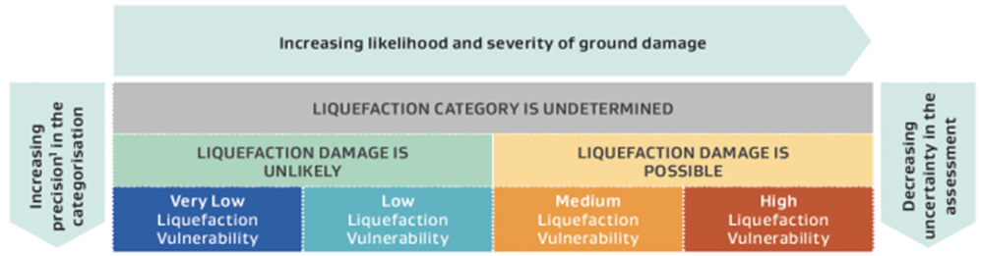

The following documents provide additional information and guidance for pipe seismic design method and philosophy. Where conflicts exist between this NEDS and these supporting documents this NEDS shall take precedence.
- Opus International Consultants. “Underground Utilities – Seismic assessment and design guidelines”. Water NZ. 2017.
- https://www.waternz.org.nz/Resources/Article?Action=View&Article_id=1206·
- Eidinger, J. Maison, B. Cheng, L. Collins, F. Conner, M. Davis, C. Matson, M. O’Rouke, T. Tang, A. Wesling, J. “Seismic Guidelines for Water Pipelines”. American Lifelines Alliance. 2005.
- https://www.americanlifelinesalliance.com/pdf/SeismicGuidelines_WaterPipelines_P1.pdf
- Indian Institute of Technology Kanpur. “IITK-GSDMA Guidelines for Seismic Design of Buried Pipelines”. National Information Center of Earthquake Engineering. 2007.
- http://www.iitk.ac.in/nicee/IITK-GSDMA/EQ28.pdf

Buried Linear Assets
Buried linear assets are underground pipelines and associated fixtures including, but not limited to, valves, hydrants, sumps, anchor blocks and thrust blocks.
Seismic resilience of buried linear assets focusses on the ability to resist liquefaction, lateral spread or settlement. Seismic resilient designs shall aim to:
- For pressure pipelines, remain in full operation without significant deformation or leakage
Seismic resilient design shall be completed for buried linear assets constructed in areas where:
- Liquefaction category is undetermined
- Liquefaction damage is possible
- High liquefaction vulnerability
- Medium liquefaction vulnerability if the pipe serves 500 or more people, a facility for vulnerable people (e.g. a rest home) or a facility of significance to the community (e.g. a hospital).
Seismic resilience of pressure pipelines may be achieved by:
- Selecting ductile iron pipe with seismically resilient restrained joints (joints meeting ISO 16134 class S-1 for expansion/contraction, class A for pull-out resistance and a minimum joint deflection of 3 degrees)
- Selecting polyethylene pipes with welded joints
- Selecting PVC flexibly jointed pipes
- consider jointing mechanism such as socket length and use of double rubber gaskets

Above Ground and Non-Linear Structures
Above ground and point structures may be linear (e.g. an above ground pipeline or a pipeline attached to a bridge), non-linear buried structures (e.g. pump station wet well) or non-linear above ground structures (water supply pump stations). Seismically resilient design of these structures shall consider both the effects of the shaking/ground acceleration and damage arising from liquefaction, lateral spread or settlement.
Design of seismically resilient solutions shall use the standards, Codes and design guides covered in Section 7.12.1.
Importance levels of structures shall comply with AS/NZS 1170.0 tables 3.1 and 3.2. Apart from minor ancillary buildings at larger three waters facilities, above ground and non-linear structures will be IL3 or IL4.
Seismic resilient design for resilience against ground acceleration shall be completed for all above ground and non-linear structures.
Seismic resilient design for resilience against liquefaction, lateral spread or settlement shall be completed for above ground and non-linear structures constructed in areas where:
- Liquefaction category is undetermined
- Liquefaction damage is possible
- High liquefaction vulnerability
- Medium liquefaction vulnerability
Seismically resilient designs shall aim to ensure:
- No damage limiting impacting the ability of a structure to provide the intended use and service life following an earthquake with a return period set by the serviceability limit state level 1 (SLS1).
- Minor damage requiring repairs for the structure to provide the intended service life but no impact on use of the structure following an earthquake with a return period set by the serviceability limit state level 2 (SLS2). For a reservoir this shall be defined as the reservoir (inclusive of the roof) retaining its contents with no leakage following a SLS2 return period event.
- The structure can be expected to have lost structural integrity, become unstable or lost equilibrium while retaining a small residual load bearing capacity that prevents local or global collapse following an earthquake with a return period set by the ultimate limit state (ULS). For a reservoir ULS shall be defined as the reservoir (inclusive of the roof) suffering limited cracking and leakage with no collapse or serious impact on the structure’s stability following a ULS return period event.
SLS1, SLS2 and ULS return periods shall depend on network and importance level as per Table 7-2 below.
Table 7-2 – Network and importance level
Network | Importance Level of Structure | SLS1 | SLS2 | ULS
Water Supply | IL4 | 1/25 | 1/1000 | 1/2500
Water Supply | IL3 | 1/25 |  | 1/2500
Water Supply | IL2 | 1/25 |  | 1/500
Wastewater or Stormwater | IL4 | 1/25 | 1/500 | 1/2500
Wastewater or Stormwater | IL3 | 1/25 |  | 1/2500
Wastewater or Stormwater | IL2 | 1/25 |  | 1/500

Connections Between Structures and Buried Assets
Specially designed flexible joints shall be provided at all junctions between pipes and rigid structures (such as reservoirs, pump stations, bridges, and buildings) irrespective of ground conditions.
Flexible joint design depends on liquefaction vulnerability and criticality. Some acceptable connection solutions are provided in the Table 7-3 below, however other solutions may be accepted by the WSE if the designer can prove they achieve the required outcome:
Table 7-3 – Acceptable connection solutions
Criticality | Undetermined Liquefaction Category AREAS, LIQUEFACTION Damage Possible Areas, Medium or High Liquefaction Vulnerability Areas | Very Low or Low Liquefaction Vulnerability Areas
Failure will affect 500 or more people, vulnerable facilities (e.g. a rest home) or significant facilities (e.g. a hospital) | Specialist design or flanged flexible joints designed for seismic resilience Cost-benefit analysis and Three Waters Entity approval required. | Self-restrained articulated joints
Failure affects less than 500 people and no vulnerable or significant facilities | Rocker pipe assemblies with addition of a fuse joint (an easily repairable weak spot in the system, designed to be the point of failure). Three Waters Entity approval required. | Rocker pipe

DESIGN REVIEW AND APPROVAL

STAGE 2 ENGINEERING PLAN APPROVAL
Water infrastructure, including all private connections, require approval from the WSE, Council and where any of the work falls within state highway road reserve, also requires prior approval of NZTA.
For those water connections and developments requiring Stage 2 approval under the WSE’s Development Code a submission must be made to the WSE according to the details herein.
The NEDS set a level of design for particular types of infrastructure based on operational area and associated risk. The design standards provide the minimum criteria for establishing baseline standard design drawings, interface design between standardised components, establishing the correct sizing of components to complement the baseline parameters of standard drawings and the basis for developing bespoke designs. This document falls within the design standards category and must be read with the relevant drawings and standards for asset capture, materials supply and construction.

DESIGN REVIEW
Once the detailed design has been completed, the Designer shall undertake a review to ensure the design complies with the requirements specified by the WSE in the Concept Plan, the concept design (refer to clause 1.2.2 Stage 1 Concept Plan Approval) and the requirements detailed in this NEDS. Compliance shall cover at least the following:
- Community impact adequately addressed
- System components and configuration meet the Entity’s occupational health and safety requirements
- Size(s) and grades of water mains throughout the portion of the proposed reticulation system meet Concept Plan requirements
- Pipe materials are suitable for the particular application and environment
- Water main layout and alignment meet WSE requirements
- Route selection meets Concept Plan requirements
- Topographical and environmental aspects have been addressed
- Easements as appropriate are specified
- Trenching and other geotechnical aspects have been considered
- Provision is made for future extensions, as appropriate
- Types and locations of control valves and any other necessary valves meet WSE requirements
- Life cycle costs are minimized
- Any departures or changes from the concept plan are highlighted and justified

Documentation

Reports
Unless otherwise directed by the WSE, the Designer shall provide the following documents upon completion of design:
- Safety in Design Report—details of risk assessment and outcomes used to justify the adopted item configuration.
- Design drawings and specifications as detailed below.
- Draft Operation and Maintenance Manuals—Operations and maintenance manuals in accordance with the WSE’s requirements.
- Design Report—a copy of all calculations, clearly set out and complete with assumptions and references. If requested by the Water Entity at any time before or upon completion of design.
- Approvals and Conditions—any copies of approvals and conditions from the local and regional authority including all resource consents, building consents, landowner consents and utilities and roading authority approvals.
- Draft new asset register meeting the WSE’s requirements
The design shall be signed-off by a suitably qualified Chartered Professional Engineer, who may be required to additionally provide a signed Compliance statement if required by the WSE.

Design Drawings

Design Drawings shall be prepared in accordance with the WSE’s requirements. Except where otherwise notified, the requirements are as set out in this Section.
Drawings shall be numbered in accordance with the WSE’s requirements.
The information to be shown in the Design Drawings shall include, but not be limited to, that detailed below. The information includes that required for production of As-Built drawings by facilitating, as far as possible, the ready incorporation or updating of such information in the Design Drawings.
Design Drawings generally shall include at least the following:
- A locality plan giving overall layout and location of the works and any access route
- Layout of roads, easements and lots
- A detailed plan of the site showing all associated structures with all known buried and above-ground services and property/site information
- Layout plan/s of the works detailing :
  - Horizontal alignment of all proposed pipelines, hydrants and valves
  - Pipe material and type (including material, pressure and joint type as necessary)
  - Pipe Diameter, Level and grade
  - Chainages and offset distances from kerb line
  - Location of all building sites to be provided with fire protection
  - Position of all property connections relative to property boundaries and the depth at the property boundary
  - Notes specifying that detectable tape is to be laid on top of the pipe embedment or 1 m below the surface for all wastewater systems and pressure mains
  - Location of nearby utility services and stormwater drains
  - Major features (e.g., creeks, railway lines, power transmission lines)
  - Valve details – location, type, size
  - Thrust and Anchor block details
  - Lengths of pressure main between valves
- Long sections of any pipelines 250mm NB and larger showing existing and proposed pipelines, cables and ducts crossing the alignment
- Additional geological, construction and safety requirements
- Geotechnical data, special foundation conditions, dewatering requirements
- Pipe trench and embedment details
- Pipe bridge details
- Any particular corrosion protection requirements
- Hydrostatic test pressure; and
- A reinstatement plan and detail of the work area
- Any special details and other information required by the WSE.

Specifications
Specifications for a project shall be established by the Designer to define the precise standards of performance to achieve the project objectives, including:
- Precise standards of performance for construction work, products and materials, equipment and other items
- Linkage between the project detailed design, the construction requirements, approved products and materials and adopted standard drawings of the WSE.
Specifications make it possible to express expected values when work or items are purchased or contracted for, and they provide means of determining conformance with expectations after purchase or construction.
Standard Specifications may be available from the Entity on request but shall be accompanied by particular specifications detailed project specific requirements.

RECORDING OF AS BUILT INFORMATION
Asset information shall be progressively captured and supplied in accordance with the requirements of The WSE’s data and asset information standards and section 24 of this NEDS and the Entity’s Development Code.

NOT USED

PART TWO – CONSTRUCTION

Appendices
Appendices No. | Description
Appendix A | Water Standard Drawings
 | Drwg No | Drawing Title
 | WS-01 | Water Supply Customer Connection Layouts
 | WS-02 | Water Supply Intersection Layout
 | WS-03 | Water Supply Looped and Linked Main
 | WS-04 | Water Supply Valve and Hydrant Markings
 | WS-05 | Water Supply Valve Marker Post
 | WS-06 | Water Supply Hydrant Detail on New Main Flanged Tee
 | WS-07 | Water Supply Hydrant Detail on Existing Main Socketed Tee
 | WS-08 | Water Supply Sluice Valve ≥ DN80
 | WS-09 | Water Supply Gate Valve ≤ DN50
 | WS-10 | Water Supply Trench Re-Instatement Details
 | WS-11 | Water Supply Trench Bedding – Soft Ground
 | WS-12 | Water Supply Thruct Block – Bend/Elbow
 | WS-13 | Water Supply Thrust Block - Tees
 | WS-14 | Water Supply Thrust Block – Inline/Taper
 | WS-15 | Water Supply Pipeline Waterstop
 | WS-16 | Water Supply EF Tapping Saddle Connection
 | WS-17 | Water Supply Commercial Meter and Backflow Connection DN25-DN40
 | WS-18 | Water Supply DN20 Metered and Unmetered Service Connection
 | WS-19 | Water Supply Customer Connection Restricted Supply
 | WS-20 | Water Supply Fire Suppression Supply and Separate Water Supply ≤ DN50
Appendix B | Water Design Guide Matrix
Appendix C | Safety in Design Risk Register
Appendix D | Omissions & Opportunities Register
Appendix E | Concrete construction checklist
Appendix F | General Requirements for Site Butt Fusion Jointing
Appendix G | Electrofusion Welding Check Sheet
Appendix H | Compliance Requirement Check Sheet
Appendix I | Pipe Butt Weld Record Log Sheet
Appendix J | Pipe Electrofusion Weld Record Log Sheet
Appendix K | PE Weld testing Information Requirements

Appendix A - Water Standard Drawings
Reference 1.2.3 for status of these drawings.

- 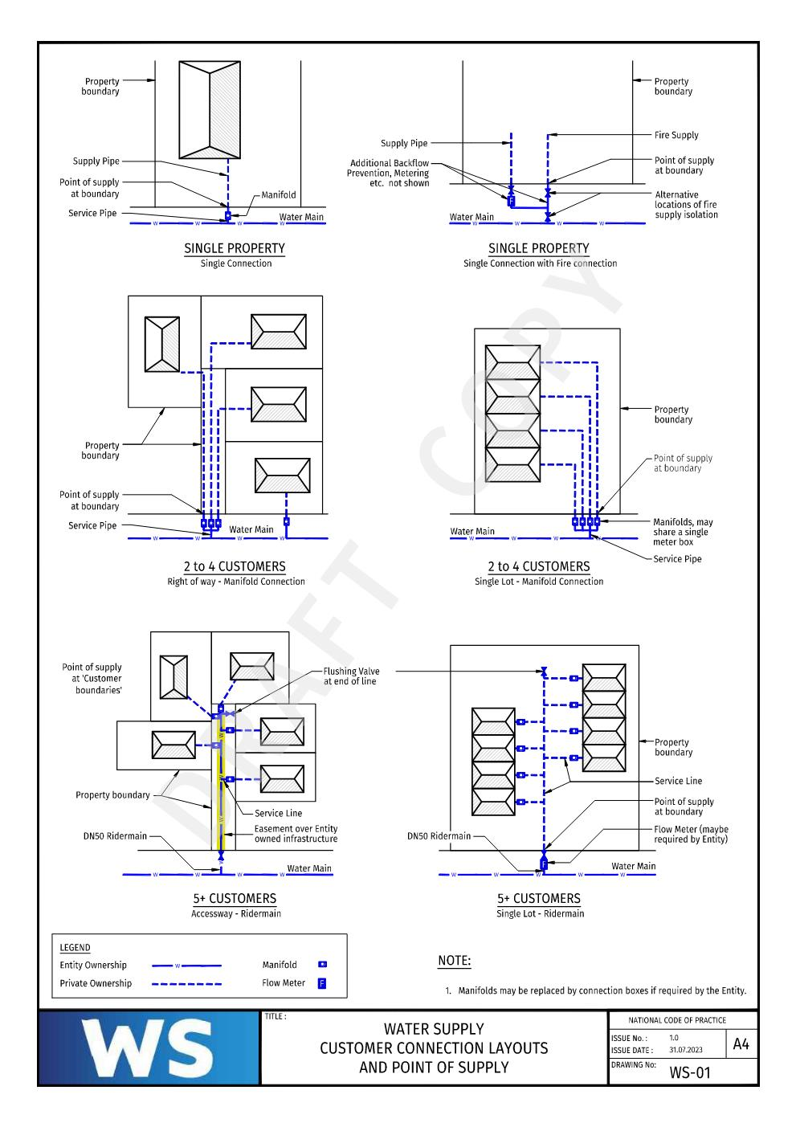
- 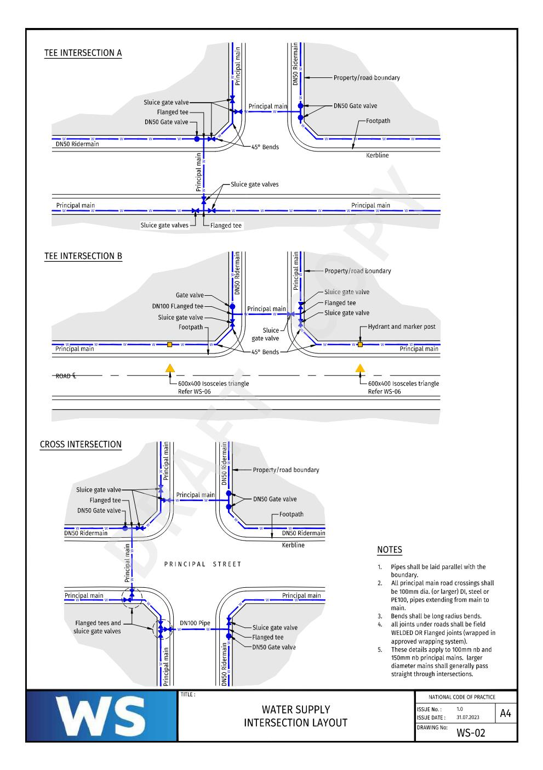
- 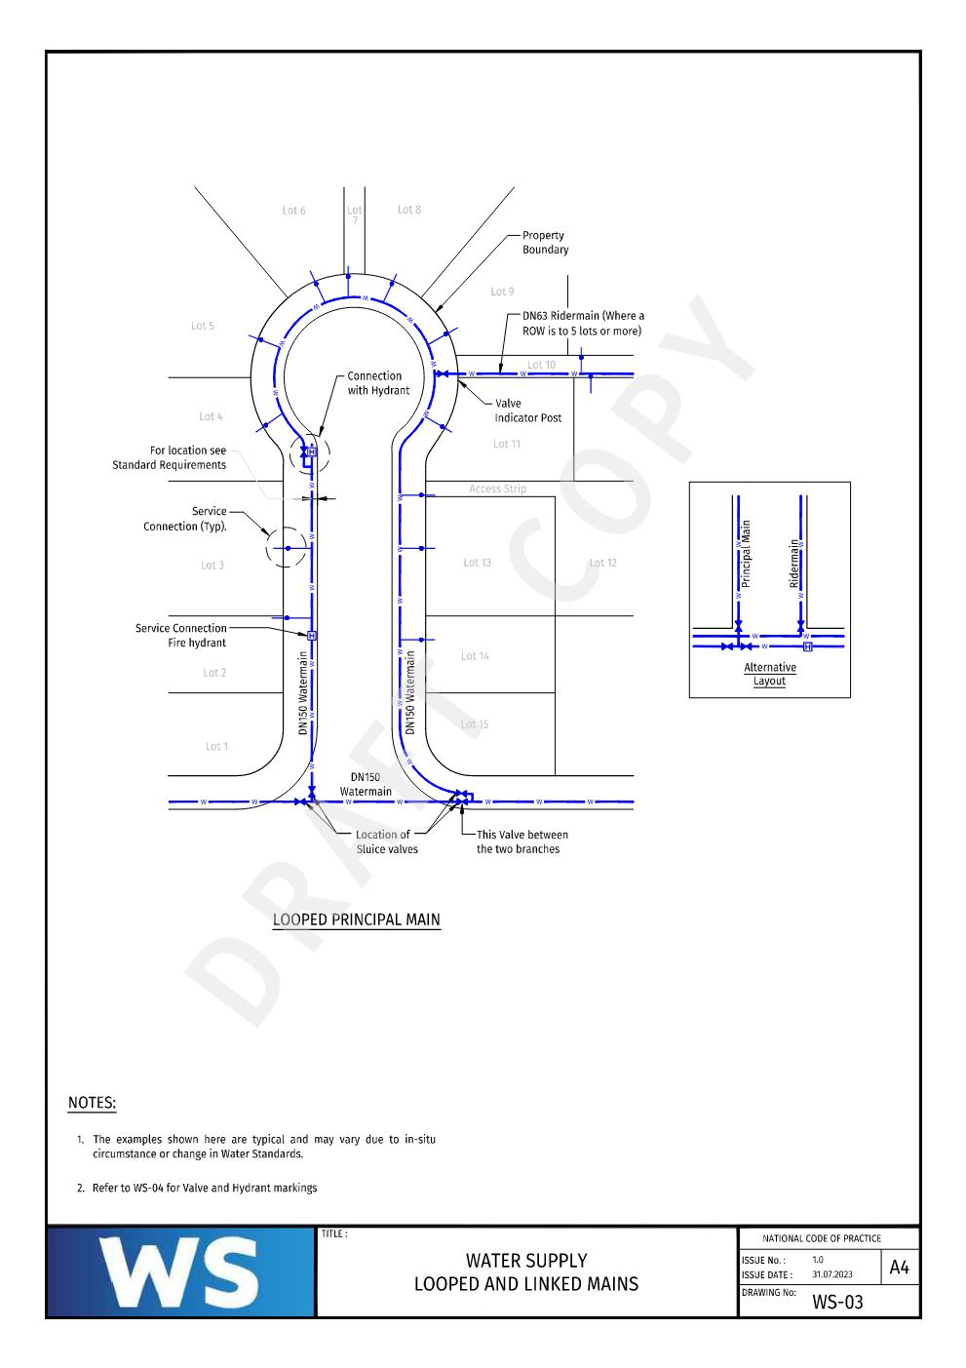
- 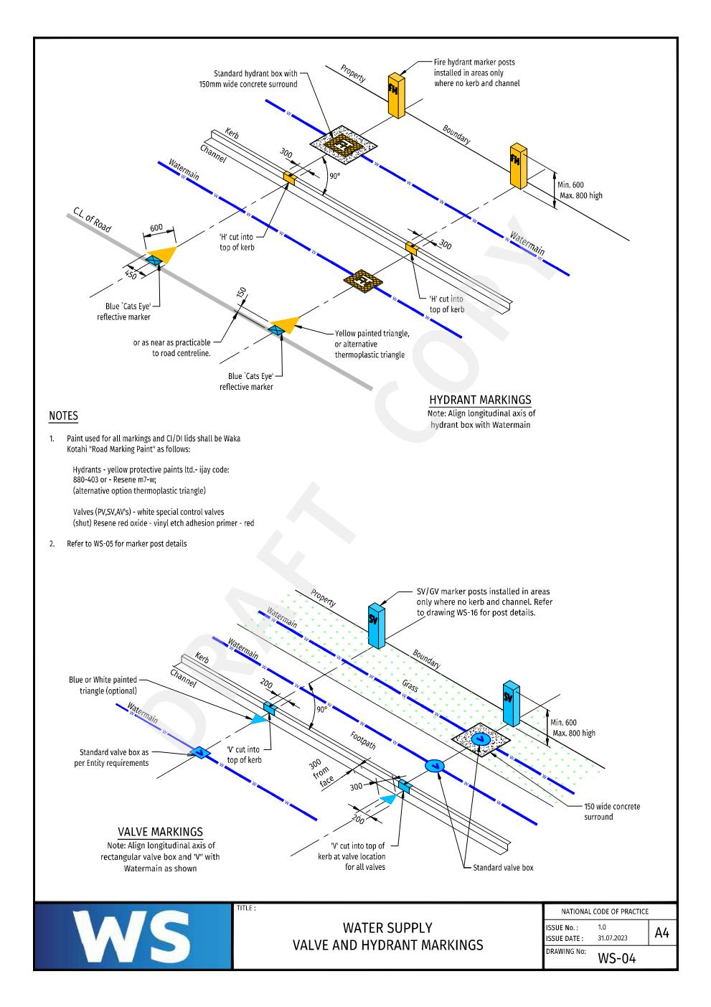
- 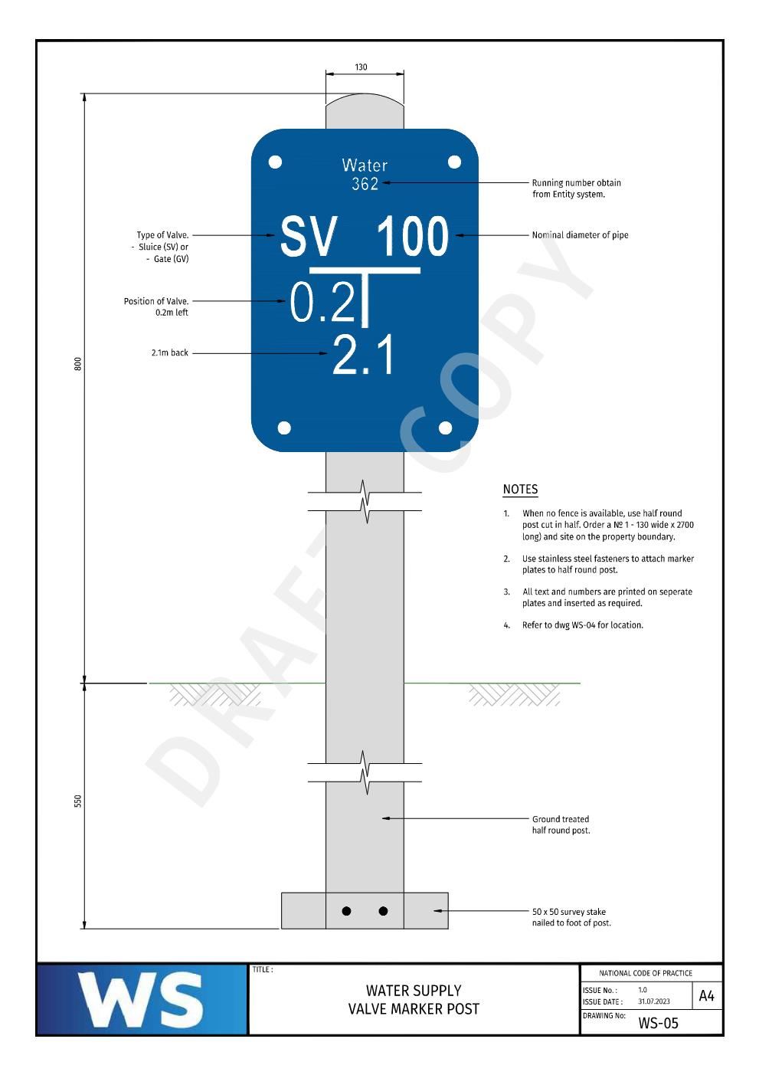
- 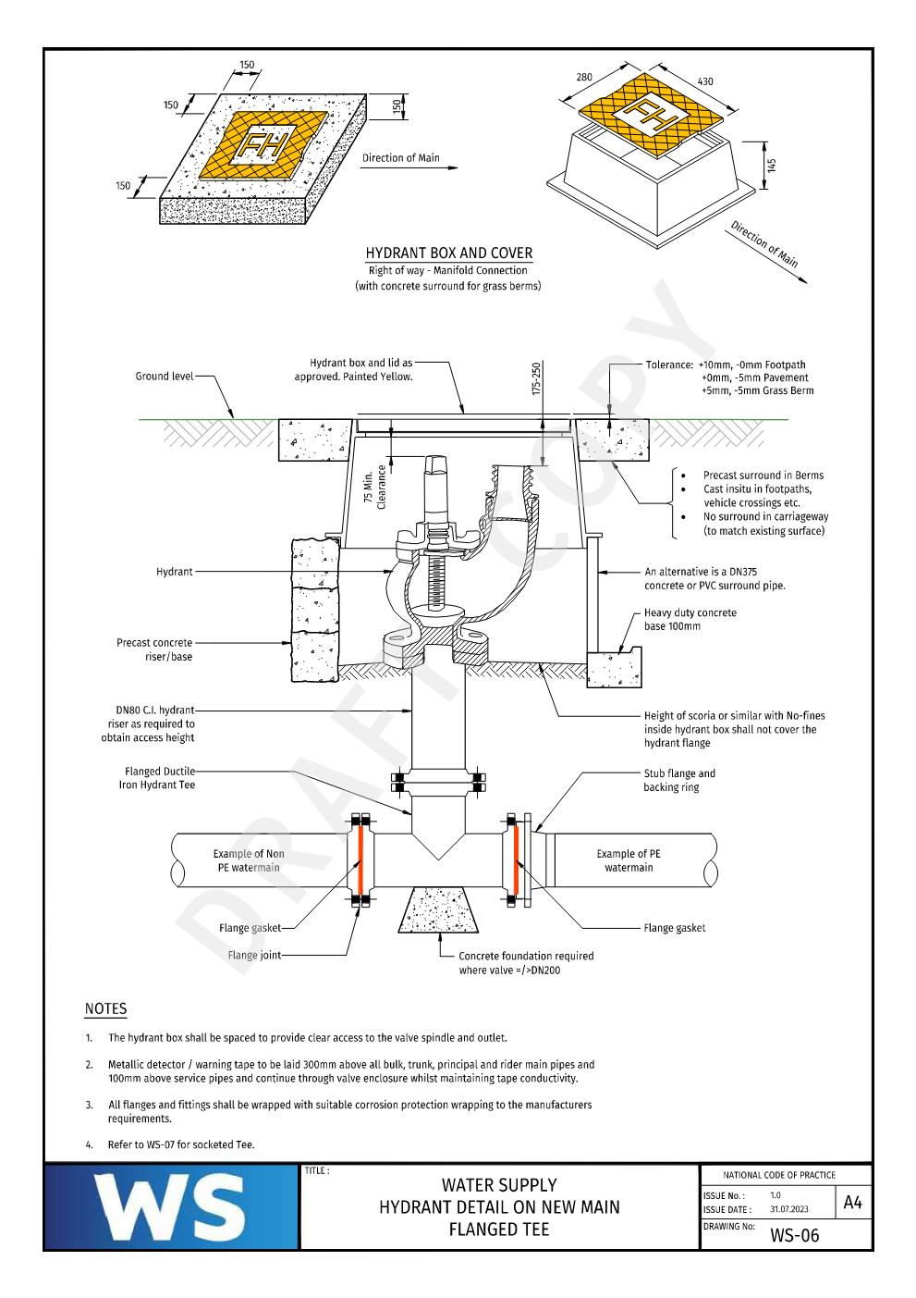
- 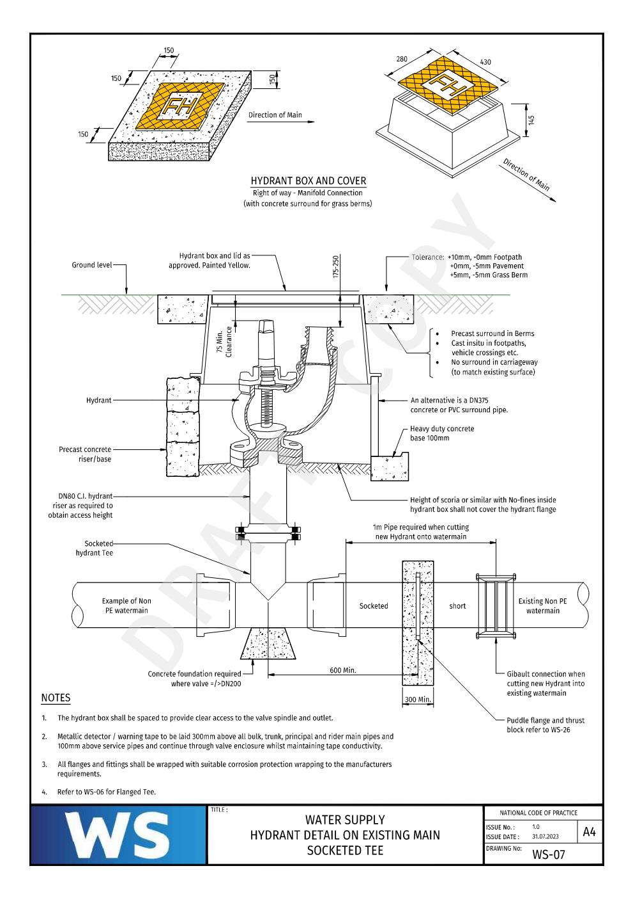
- 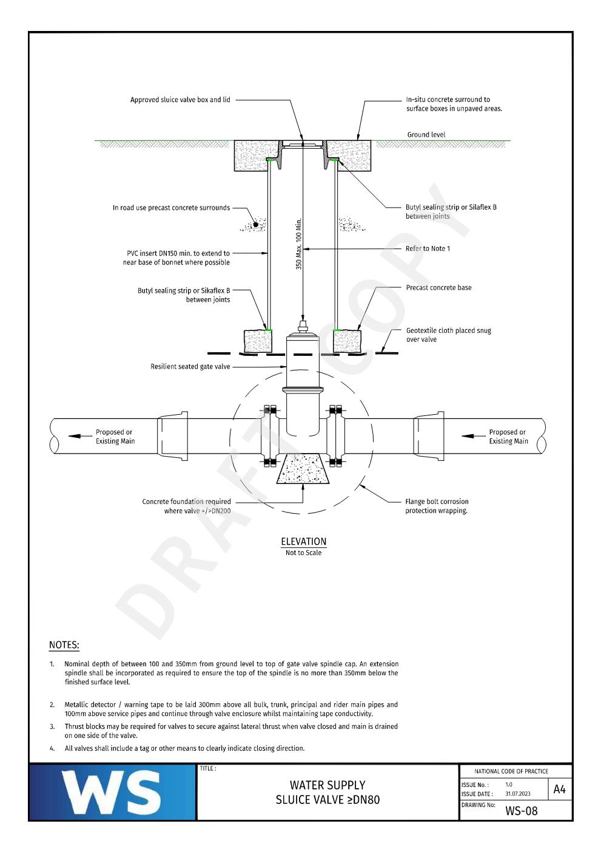
- 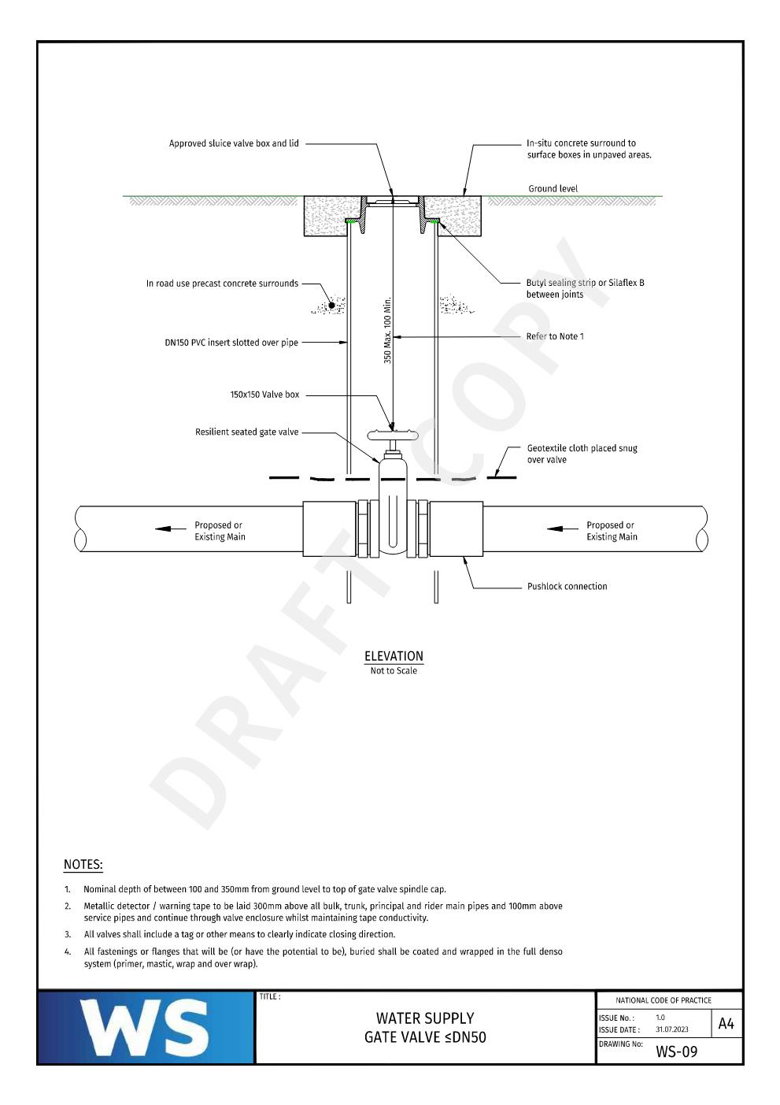
- 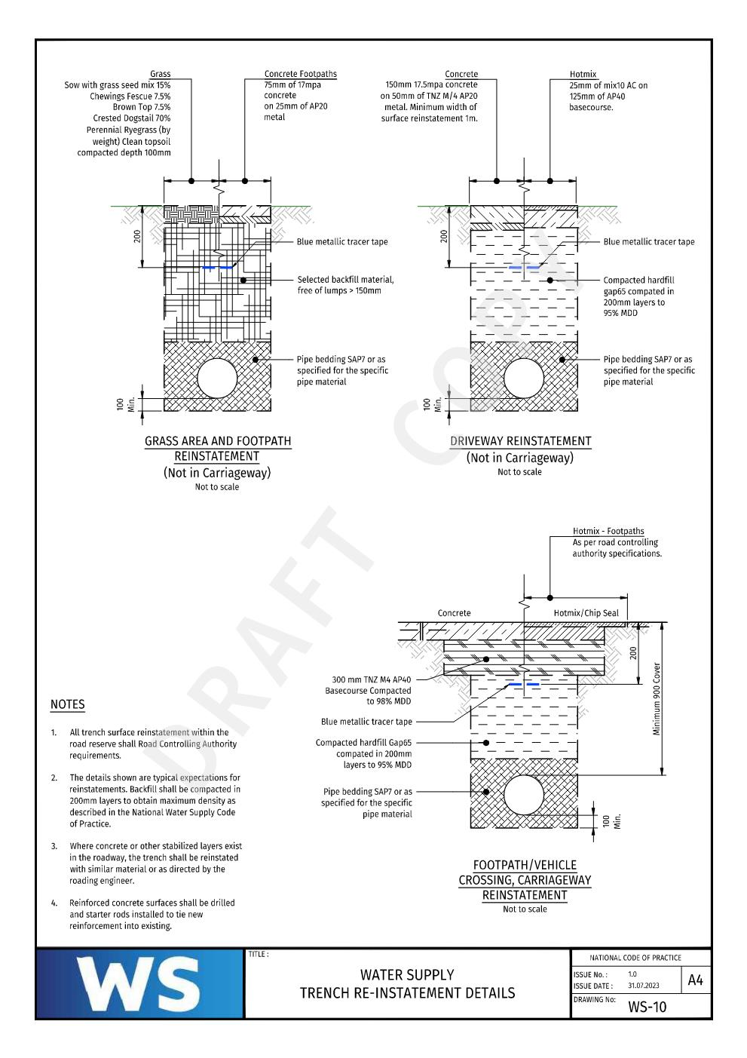
- 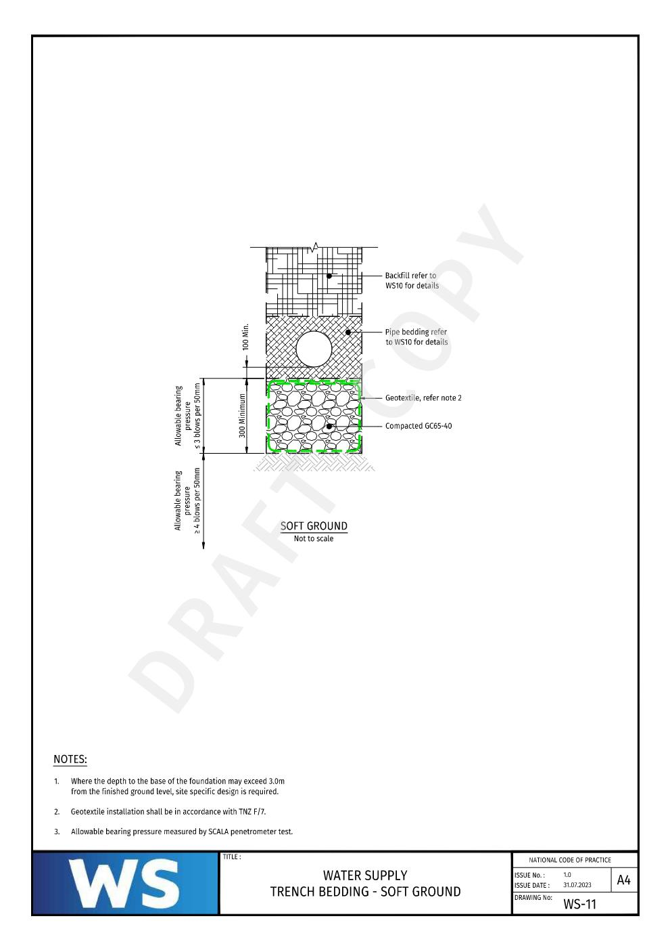
- 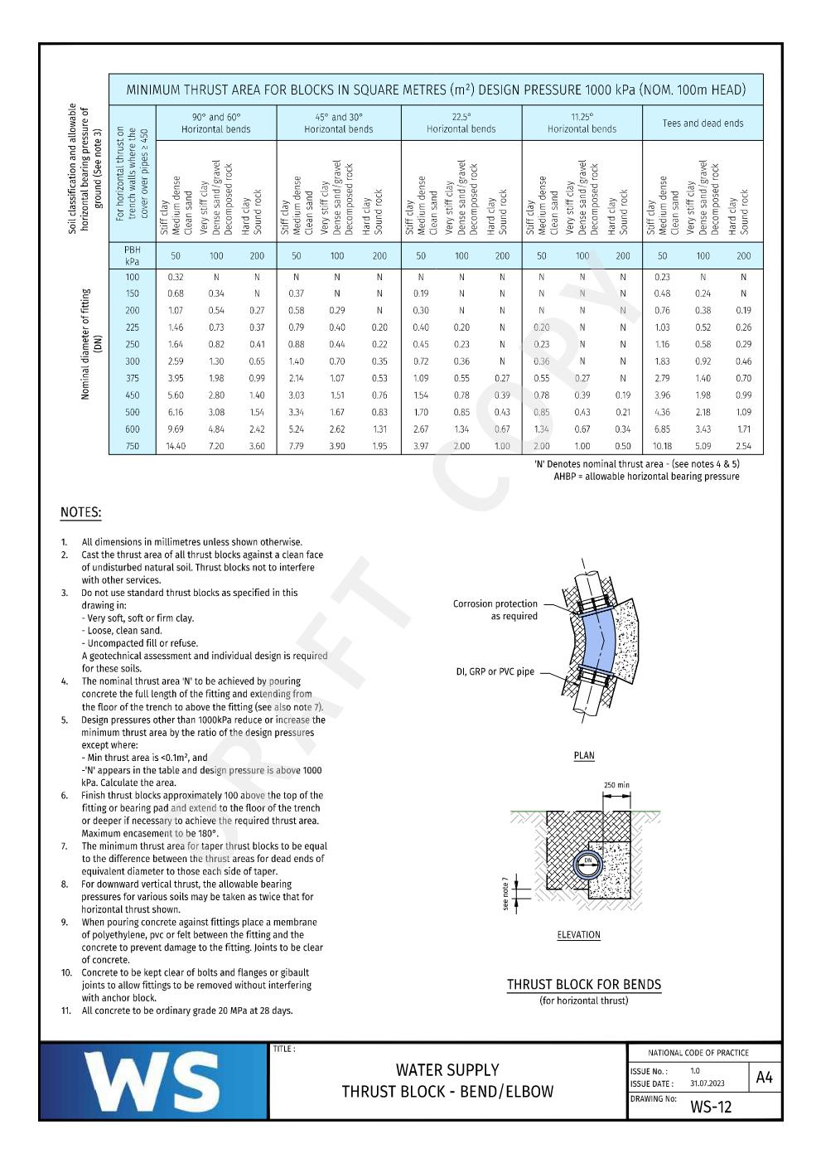
- 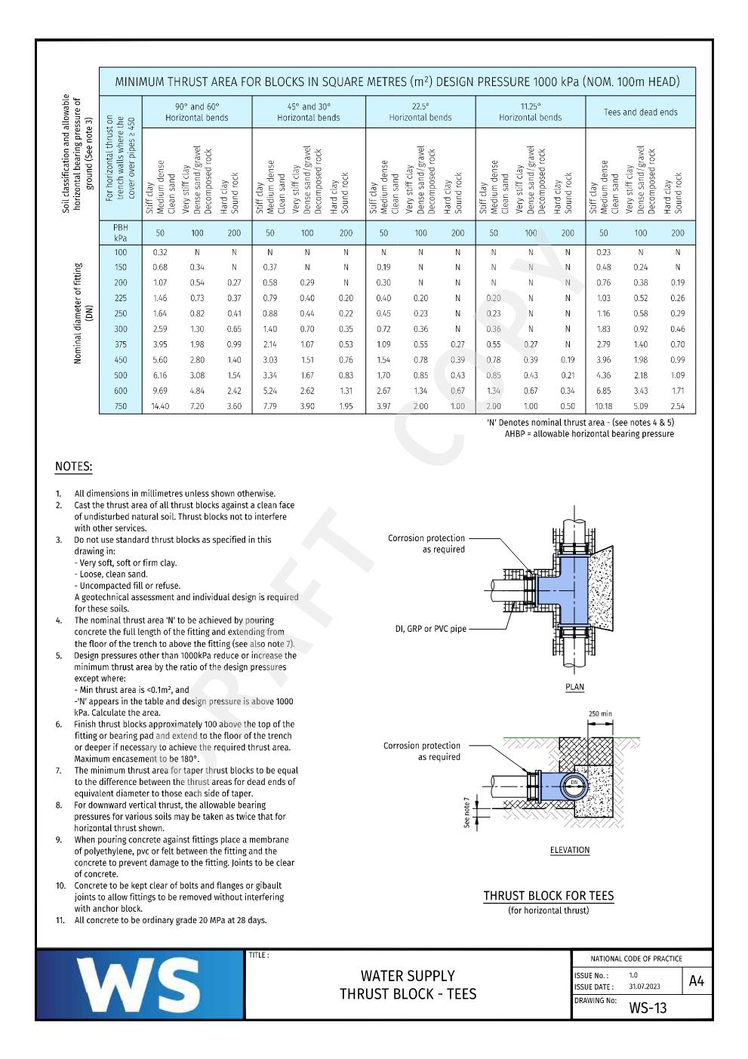
- 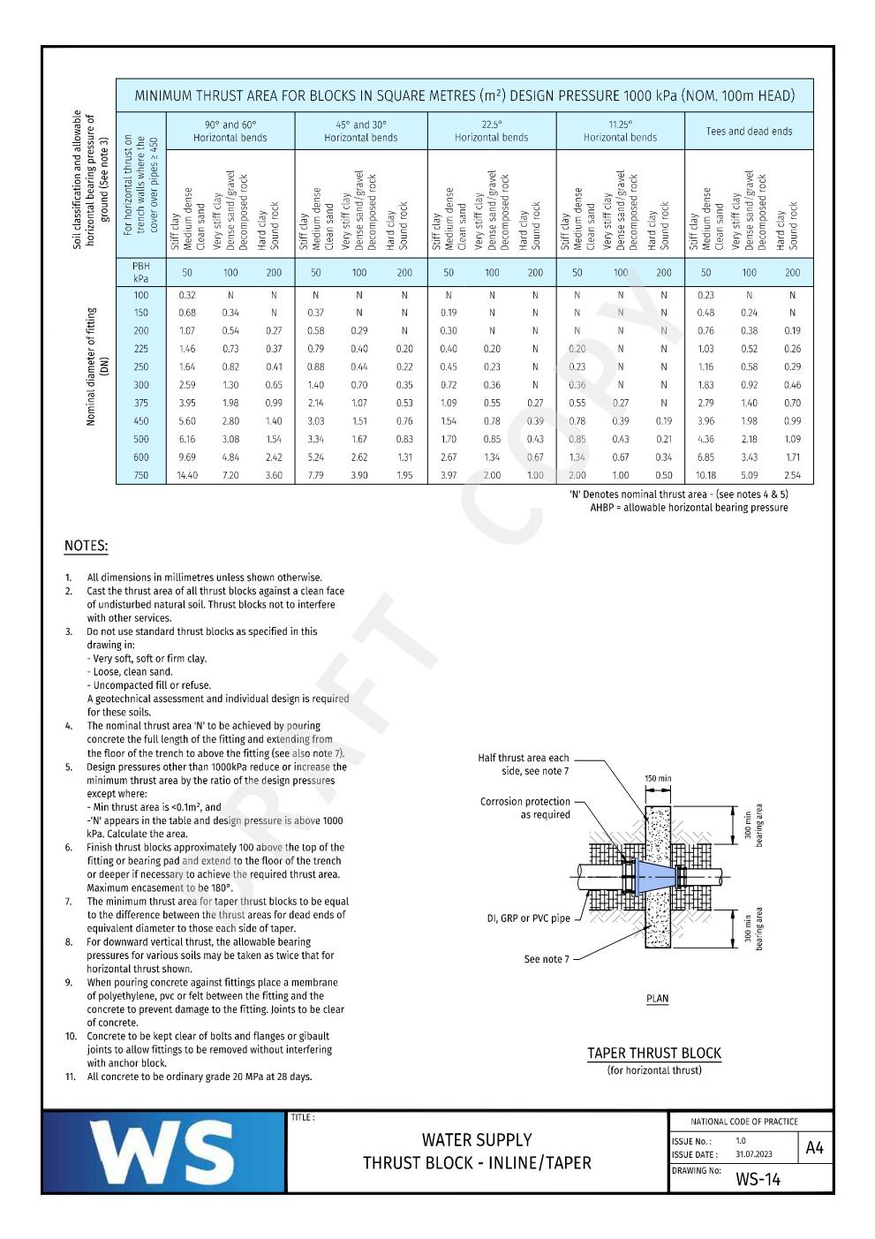
- 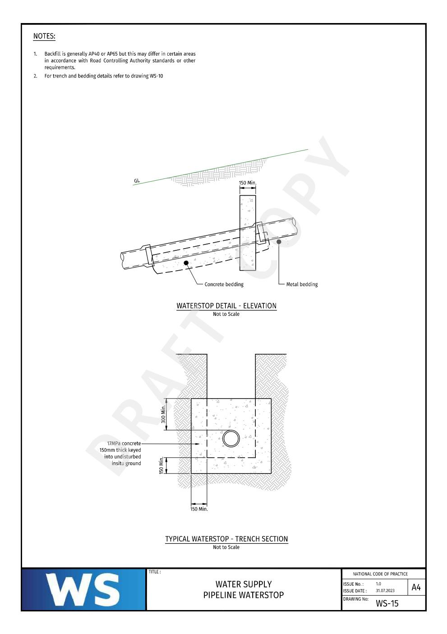
- 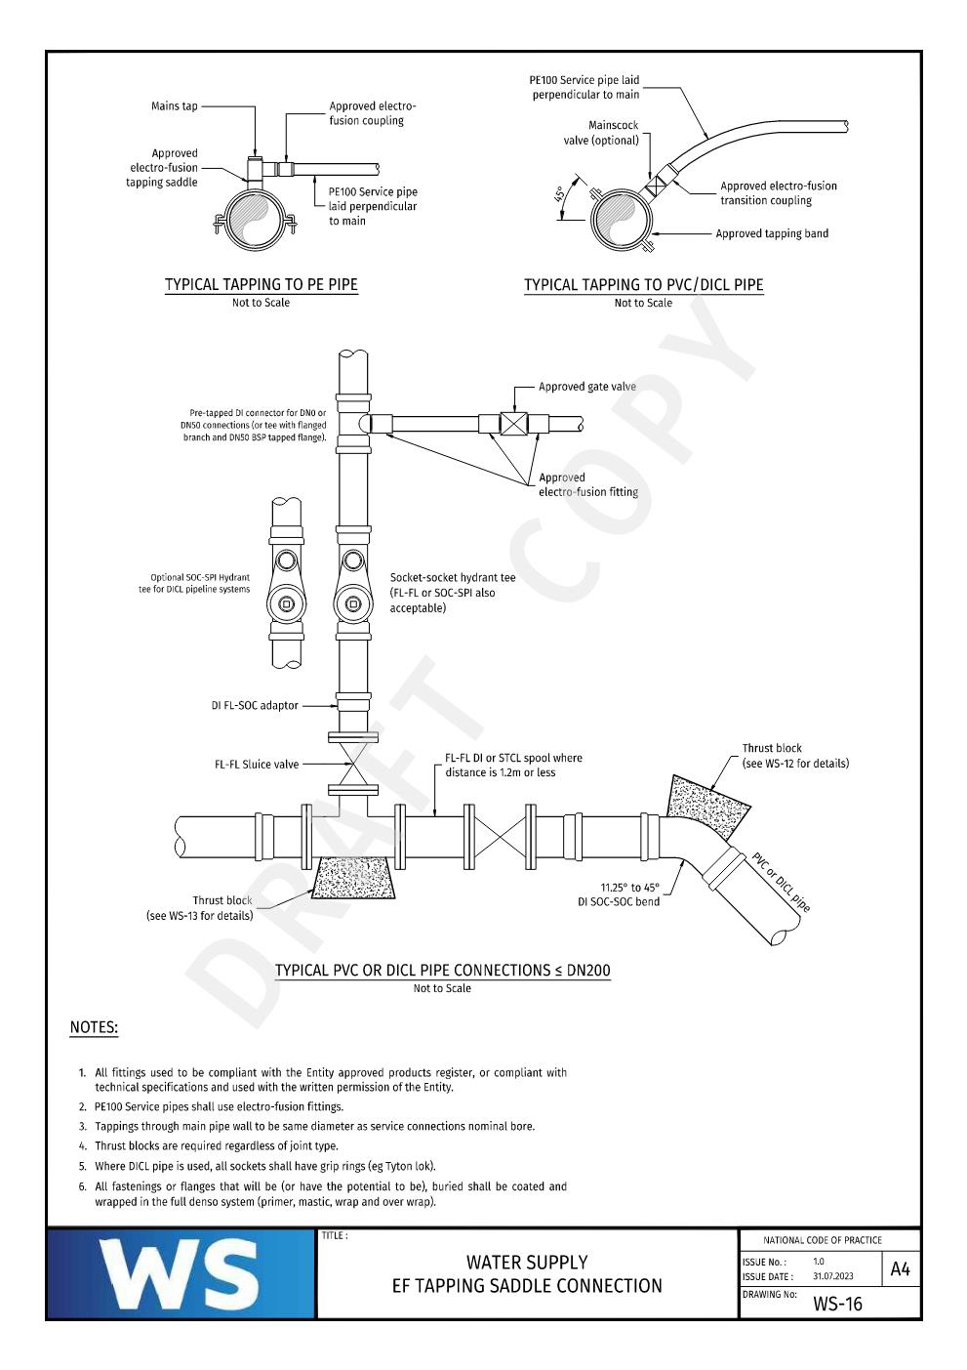
- 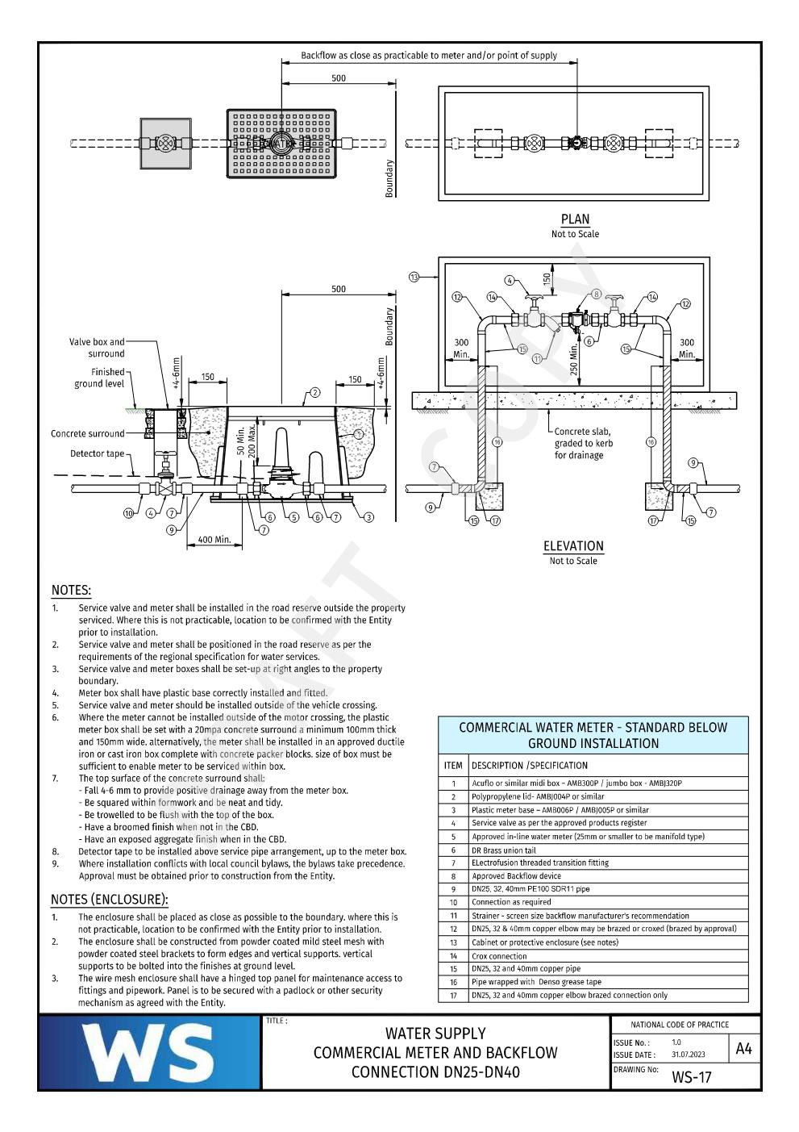
- 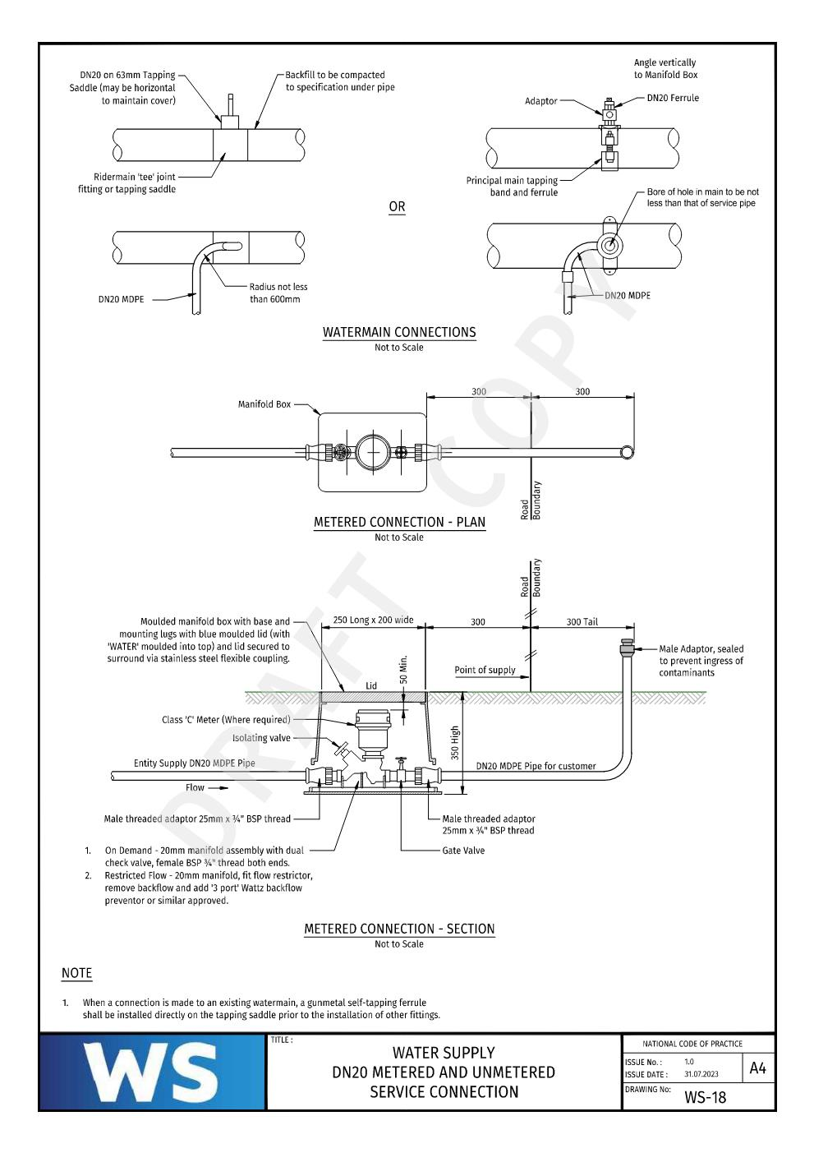
- 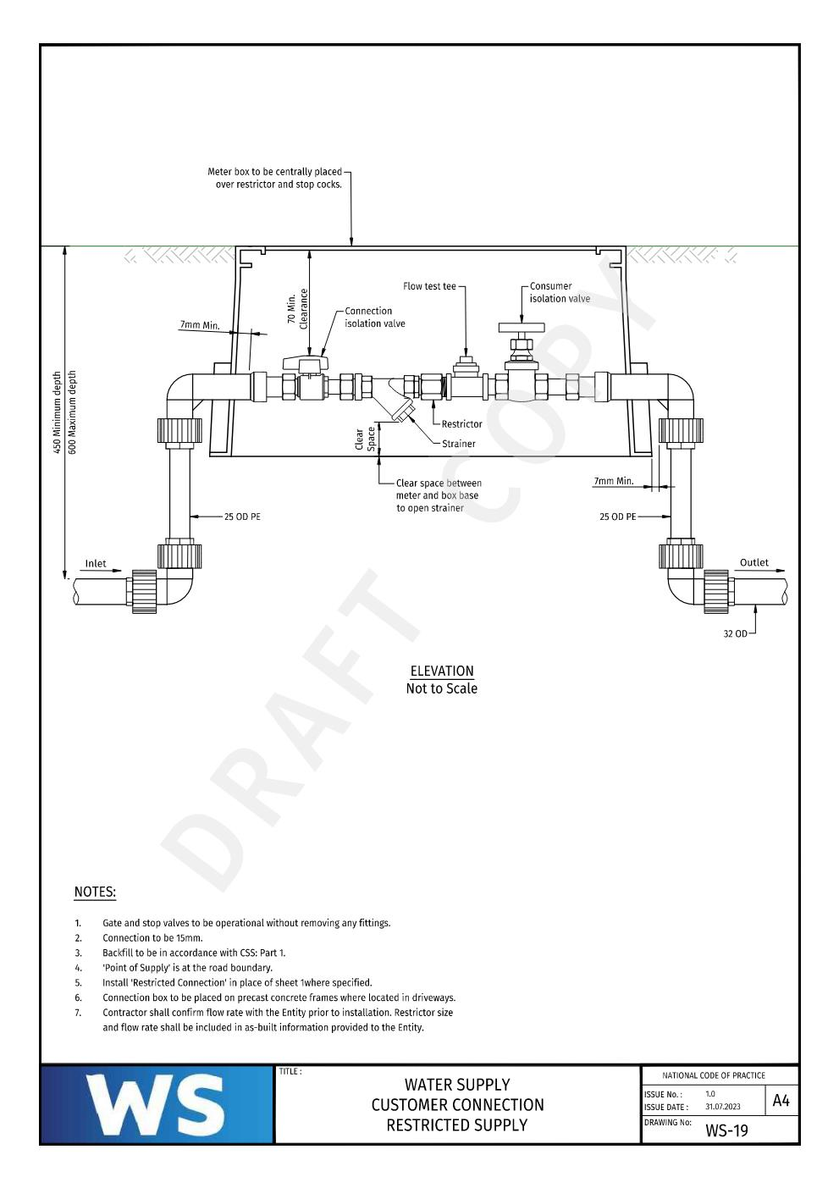

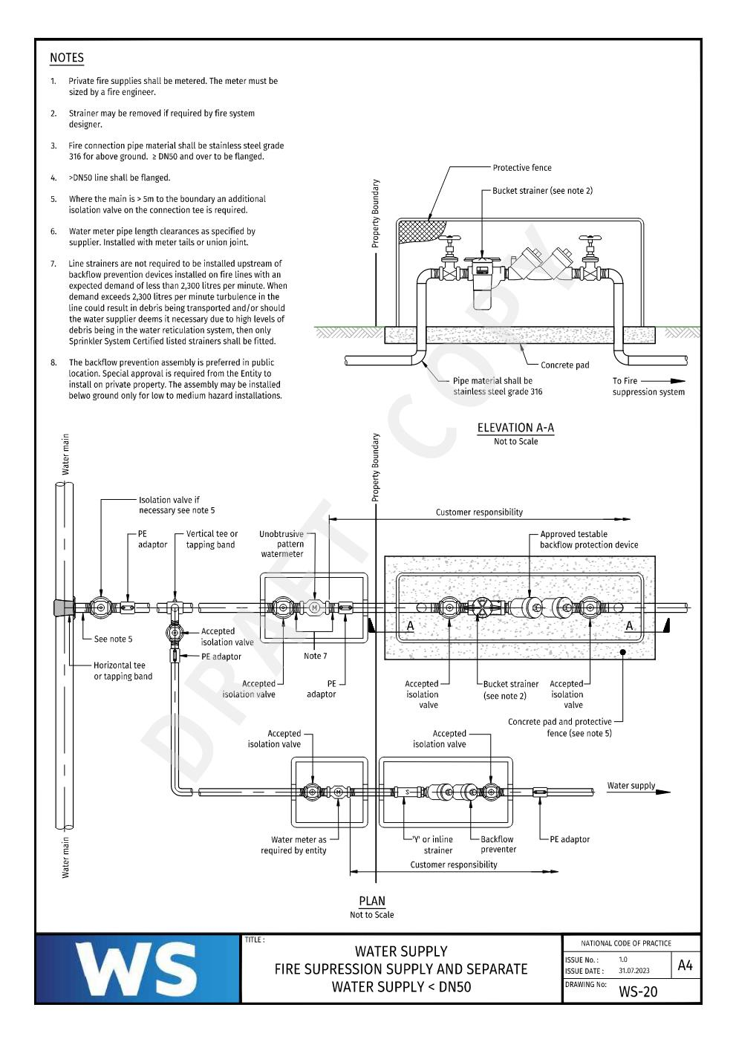

Appendix H - Compliance Requirement Check Sheet

Appendix I - Pipe Butt Weld Record Log Sheet

Appendix J - Pipe Electrofusion Weld Record Log Sheet

Appendix K - PE Weld testing Information Requirements

