

Network Environmental Performance Measures 2025/26
Reporting FAQ
This document answers some common questions about reporting for the 2025/26 Network Environmental Performance Measures (NEPM) collection. It should be read alongside the Network Environmental Performance Measures and Guide 2025.

Submission date and process
When is the 2025/2026 template due for submission?
No later than 5pm on 30 September 2026.
How do I submit my completed template?
Email the completed template to measures@taumataaorwai.govt.nz as an attachment after completing your internal Quality assurance and sign out procedures. We suggest naming your template “Organisation Name – NEPM 25/26” or similar. You will receive a confirmation email within 24 hours of completing your submission.
What if I have issues with the submission process or questions during the reporting period?
Email us at measures@taumataarowai.govt.nz we will endeavour to answer your query as soon as possible. The guidance published on our website (Network environmental performance reporting | The Water Services Authority - Taumata Arowai) is also available.
Can I have an extension?
If extenuating circumstances mean your template may be submitted late, contact us as soon as possible.

Water Services Providers – Local Water Done Well
Governance changes under Local Water Done Well including the establishment of new water organisations may affect your reporting obligations. Check the Water Services Act for the definition of a network.
Where new arrangements have taken effect, it is our expectation that councils and water organisations work together to provide us with data for the reporting period.
Changes to the structure of a water service provider does not change reporting obligations and our expectation is the water organisations and owner councils will cooperate if required to ensure requirements are met. As the reporting period is 1 July 2025 to 30 June 2026, we would like suppliers to use their original account name and ID.

Optional measures for 25/26
Do I have to fill out the measures marked “optional”?
No. This year we have added a few measures that are optional to fill out and are subsidiaries of existing measures. There is no consequence to leaving these blank.

Self-supplied buildings (SSB)
Do I need to report on self-supplied buildings this year?
No. For the 2025/26 reporting round, self-supplied buildings do not need to be included in your submission. This reflects current practice and will be formally confirmed in the Measures and Guide document at its next scheduled review, expected next year.

Units versus connections
What is the difference between a connection and a unit?
A connection represents a physical point where a property or customer is connected to the network. A unit represents an individual dwelling or occupiable premises served by that connection. A single connection may serve multiple units, such as an apartment building.
Why do some measures use connections while others use units?
Different measures are designed to reflect different aspects of service delivery. Measures relating to customer impacts often use units served, while infrastructure and asset measures may use connections.
How should I report multi-unit properties?
Example: Apartment block with 1 water connection and 20 apartments = 1 connection, 20 units.
Which measure should I prioritise if units and connections do not align?
Report each measure according to its specific definition. Do not convert units to connections, or connections to units, solely to complete a measure.

Pipe length calculations - drinking water
What pipe length should be reported in the drinking water network measure?
Report the total operational length of reticulation pipe associated with the network being reported. The reported length should reflect the assets used to provide services to customers during the reporting year.
Should transmission mains be included?
No. Transmission pipelines should be excluded from network length measures unless specifically requested by the measure definition. Network length measures are intended to reflect the distribution or collection network serving customers, rather than bulk conveyance assets.
Should customer-owned pipework be included?
No. Customer-owned pipework, including pipes located beyond the network boundary and under private ownership, should not be included.
Should duplicated pipes be counted separately?
Yes. Where two or more operational pipes exist along the same route, each pipe should be counted. Report total pipe length, not route length.
Example: a 1 km corridor containing two parallel water mains should be reported as 2 km of pipe
Should abandoned or decommissioned pipes be included?
No. Only operational assets that formed part of the network during the reporting period should be included.
What if my GIS and asset management system report different lengths?
Use the best available source and apply a consistent methodology across reporting years. Where significant changes result from improvements in data quality or network remeasurement, explain this in the comments field where available.
Should treatment plant pipework be included?
No.

Pipe length calculations - wastewater
What wastewater pipework should be included in network length measures?
Report the total operational length of wastewater pipes used to collect and convey wastewater from customers to treatment or disposal facilities.
Should gravity mains be included?
Yes. All operational gravity wastewater mains should be included.
Should rising mains and pressure mains be included?
Yes. Operational rising mains and pressure mains should be included in reported wastewater network length.
Should wastewater laterals be included?
Only include laterals if they are owned and maintained by the reporting entity. Customer-owned laterals should be excluded.
Should treatment plant pipework be included?
No. Internal pipework located within wastewater treatment plants should be excluded. Network length measures are intended to capture the collection network rather than treatment assets.
Should outfalls be included?
No. Marine outfalls, river outfalls and other discharge infrastructure downstream of the treatment process should be excluded unless specifically identified as part of the wastewater network in the reporting entity's asset records.
Should transfer mains between pump stations and treatment plants be included?
Yes, where they form part of the operational wastewater network used to convey wastewater to treatment.
Should abandoned or redundant pipes be included?
No. Only operational wastewater assets should be reported.

Wastewater process emissions
Do I need to report on wastewater process emissions this year?
No new field has been added to the 2025/26 template for wastewater process emissions. This measure is still under development. It may form part of a future update to the Measures and or be picked up through a separate wastewater data collection exercise. We will let you know well ahead of time if reporting requirements change.

Reporting on consents
This year's template asks for more detail about the consents linked to your networks, on both the DW Consents and WW Consents worksheets. Four new columns have been added to each: consent sub-type, sub-consent number, consent description, and grant date.
What's the difference between consent type and consent sub-type?
Consent type is the broad category of consent. Consent sub-type is a more specific classification within that type. The sub-type dropdown will only show options relevant to the type you've already selected for that row, so enter the type first. The sub-type is an optional field this year. Please note that the consent type and sub-type categories for the NEPM may be different from the way your resource consent is categorised on its cover page. If there are any differences, please defer to the NEPM categories when reporting on your consents.

Drinking water consent types and sub-types
Consent type | Sub-type
Water permit (water take) | Surface water take
Water permit (water take) | Groundwater take
Water permit (water take) | Coastal water take
Water permit (other) | Diversion
Water permit (other) | Dam
Water permit (other) | Other
Discharge to water | Treatment process output (backwash, sludge, slurry, etc)
Discharge to water | After final treatment process (e.g. scour valve within distribution network)
Discharge to water | Other
Discharge to land | Treatment process output (backwash, sludge, slurry, etc)
Discharge to land | After final treatment process (e.g. scour valve within distribution network)
Discharge to land | Other
Bore permit | Well drilling and construction
Coastal permit | Discharge to coastal water
Coastal permit | Other
Discharge to air | Discharge to air
Land use | Construction
Land use | Other
Other | Works within a river / stream
Other | Other

Consent type | Sub-type
Water permit (water take) | Surface water take
Water permit (water take) | Groundwater take
Water permit (water take) | Coastal water take
Water permit (other) | Diversion
Water permit (other) | Dam
Water permit (other) | Other
Discharge to water | Treatment process output (backwash, sludge, slurry, etc)
Discharge to water | After final treatment process (e.g. scour valve within distribution network)
Discharge to water | Other
Discharge to land | Treatment process output (backwash, sludge, slurry, etc)
Discharge to land | After final treatment process (e.g. scour valve within distribution network)
Discharge to land | Other
Bore permit | Well drilling and construction
Coastal permit | Discharge to coastal water
Coastal permit | Other
Discharge to air | Discharge to air
Land use | Construction
Land use | Other
Other | Works within a river / stream
Other | Other

Wastewater consent types and sub-types
Consent type | Sub-type
Coastal permit | Wastewater discharge
Coastal permit | Occupation
Coastal permit | Construction / disturbance
Coastal permit | Other
Discharge to water | Wastewater discharge
Discharge to water | Other
Discharge to land | Wastewater discharge
Discharge to land | Biosolids
Discharge to land | Other
Discharge to water and land | Wastewater discharge
Discharge to water and land | Other
Overflows | Discharge to water
Overflows | Discharge to land
Overflows | Discharge to water and land
Discharge to air | Discharge to air from WWTP
Discharge to air | Discharge to air from network or pump station
Discharge to air | Other
Land use | Construction
Land use | Other
Other | Works within a river / stream
Other | Water take / diversion
Other | Other
What if my consent doesn't fit neatly into one sub-type?
Use the closest match, and if nothing fits, select "Other" as the sub-type and use the consent description column to explain. A good example of this is drinking water consents relating to works within a river or stream. These are not a standalone consent type. They sit under consent type "Other", sub-type "Works within a river / stream", as shown in the table above.
What is a sub-consent number, and when do I need one?
Some resource consents are issued as one file covering several separately authorised activities, each identified by its own number. Where that's the case, use the base file number as the consent reference number, and the individual activity number as the sub-consent number, with one row per activity.

Worked example: Whangarei wastewater treatment plant
Northland Regional Council file number 004352 (also written AUT.004352) authorises five separate activities for the Whangarei wastewater treatment system. Each would be entered as its own row:
Sub-consent number | Consent type | Sub-type | Consent description
01.06 | Coastal permit | Wastewater discharge | Discharge of treated wastewater via mechanical treatment plant and wetland system to Limeburners Creek
02.03 | Overflows | Discharge to water | Discharge of UV-disinfected wastewater directly to Limeburners Creek during extreme wet weather
03.01 | Discharge to land | Wastewater discharge | Discharge of contaminants to land within the wetland treatment system area
04.01 | Discharge to air | Discharge to air from WWTP | Discharge of contaminants, primarily odour, to air
05.01 | Coastal permit | Occupation | Placement and occupation of a structure in the coastal marine area
Note: while row 02.03 is statutorily granted as a coastal permit, for the purposes of the NEPM this would be categorised under the “Overflows” consent type, with the sub-type being a discharge to water. This is because we are seeking to build a greater understanding of overflows and have therefore set up an individual category for these consents. Whether a consent is for an overflow is typically specified in the consent description. In this case, “during extreme weather” is the key wording in the consent description which indicates the activity is for wastewater overflows.
Note: on grant date, where a consent has been amended since it was first granted, use the date of original grant This particular consent was amended twice since its original grant in March 2012, most recently in July 2015.

Worked example: Rabbit Island biosolids consents
Tasman District Council granted four separate consent numbers to Nelson Regional Sewerage Business Unit in a single decision, all sharing one grant date and one consent holder. Unlike the Whangarei example, these aren't a base number with sub-numbers. Each is its own full reference number:
Reference number | Consent type | Sub-type | Consent description
RM200638 | Discharge to land | Biosolids | Discharge of biosolids onto land
RM200639 | Discharge to air | Other | Discharge of contaminants into air from application of biosolids to land
RM200640 | Land use | Other | Operation and maintenance of the Biosolids Application Facility
RM200641 | Discharge to land | Other | Discharge of washdown water and stormwater to land from the Biosolids Application Facility
This example is also a good illustration of the previous question. Three of the four consents here land in "Other" because the activity doesn't match the more specific sub-types on offer, such as biosolids-related air discharge or facility operation and maintenance rather than construction.

Other changes to note this year
- Paste behaviour: pasting data into cells, including from another spreadsheet, can strip validation rules without warning. Where possible, enter data directly or use Paste Special to paste values only. A reminder note has been added to the User Guide tab within the template.
- Mutual exclusivity checks: A measure cannot be filled out for both the data point and reason not available field. If a cell is highlighted red, check whether the paired field should be cleared instead.
- Overflow monitoring methodology: "Mixed" has been added as an option on the WW Organisation tab, for networks that use more than one monitoring method.
Appendix: source consent documents
The two worked examples above are drawn from real, publicly available resource consents. The pages below reproduce the relevant cover page from each, followed by a colour-coded breakdown showing how each authorised activity maps to a consent type and sub-type.
Whangarei wastewater treatment plant
Source: Northland Regional Council, file AUT.004352, section 127 change, document date 6 July 2015.
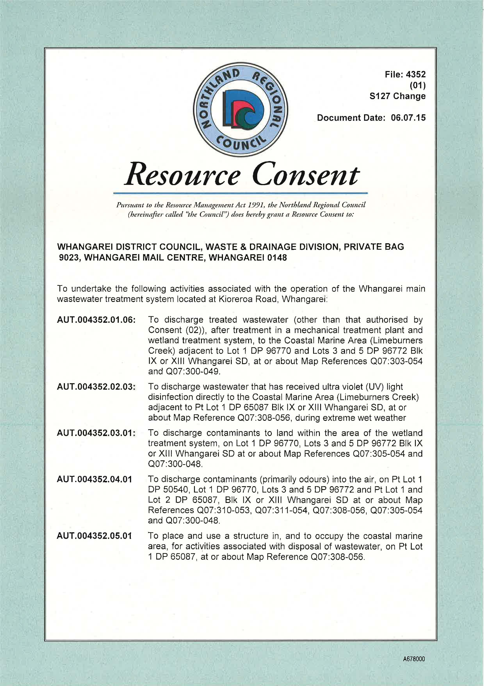

Consent expiry date
Document date specified refers to a S127 variation, and is therefore not the consent grant date
Consent type and sub-type are indicated through key words provided in consent description (refer table on next page)
Each activity has its own consent description
Sub-consent reference number is unique for each activity:
- 01.06
- 02.03
- 03.01
- 04.01
- 05.01
Resource consent reference number is AUT.004352 for all activities
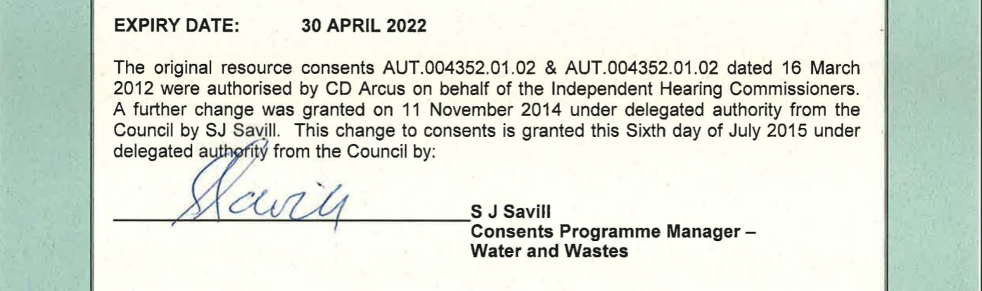
Consent grant date

Whangarei: how the activities map to consent type and sub-type
Reference | Activity (as described in the consent) | Consent type | Sub-type
01.06 | Discharge treated wastewater (mechanical plant + wetland system) to Limeburners Creek | Coastal permit | Wastewater discharge
02.03 | Discharge UV-disinfected wastewater directly to Limeburners Creek during extreme wet weather | Overflows | Discharge to water
03.01 | Discharge contaminants to land within the wetland treatment system | Discharge to land | Wastewater discharge
04.01 | Discharge contaminants (primarily odour) into air | Discharge to air | Discharge to air from WWTP
05.01 | Place and occupy a structure in the coastal marine area | Coastal permit | Occupation

Rabbit Island biosolids consents
Source: Tasman District Council, decision of Hearing Commissioners, 14 April 2023 (RM200638 to RM200641).
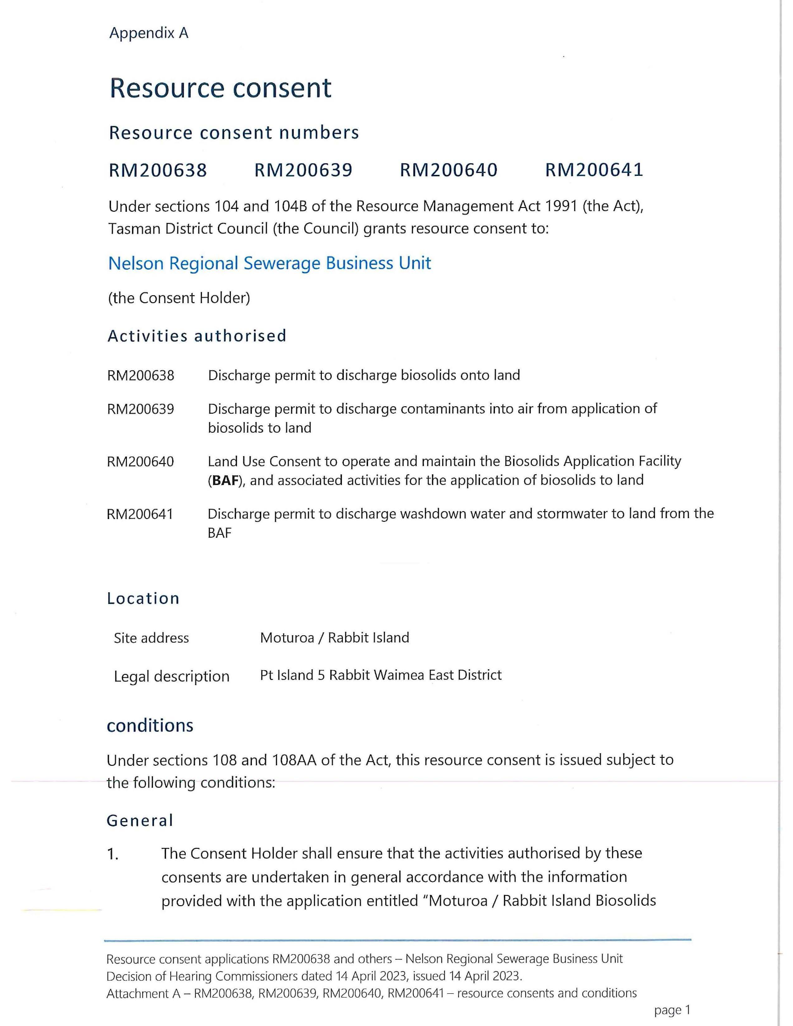
Consent type and sub-type are indicated through key words provided in consent description (refer table on next page)
Each activity has its own consent description
Each activity has a unique consent reference number. There are no sub-consent reference numbers

Rabbit Island: how the activities map to consent type and sub-type
Reference | Activity (as described in the consent) | Consent type | Sub-type
RM200638 | Discharge permit to discharge biosolids onto land | Discharge to land | Biosolids
RM200639 | Discharge permit to discharge contaminants into air from application of biosolids to land | Discharge to air | Other
RM200640 | Land use consent to operate and maintain the Biosolids Application Facility | Land use | Other
RM200641 | Discharge permit to discharge washdown water and stormwater to land from the BAF | Discharge to land | Other

